School Closure Home School Pack
Miss Densley’s Class
Week beginning 15.6.20
I’ve added some more ideas for another week of home learning. I’ve left the ongoing spelling/reading/times tables on there. This week’s English assignment will be on Google Classroom and can be handed in.
Literacy
- Practice the reading/spelling of high frequency words – you can do this in creative ways using different materials (e.g. paint, magnetic letters) and try timing yourself
- Carry on with your reading books – make sure someone asks you lots of questions about them and if you are reading Dockside practice those cover words
- I have included a sheet of general literacy activities and some paper to complete them on
- Here is a link for Oxford Owl’s free ebook library (you will have to create a login but it should all be free): https://www.oxfordowl.co.uk/for-home/find-a-book/library-page/?view=image&query=&type=book&age_group=Age+9-11&level=&level_select=&book_type=&series=#
- I’ve found a lovely free book to download about coming to terms with school shutdown: https://parsleymimblewood.wordpress.com/

- I have attached the next pages from the ‘Amazing Aliens’ workbook below for you to complete.

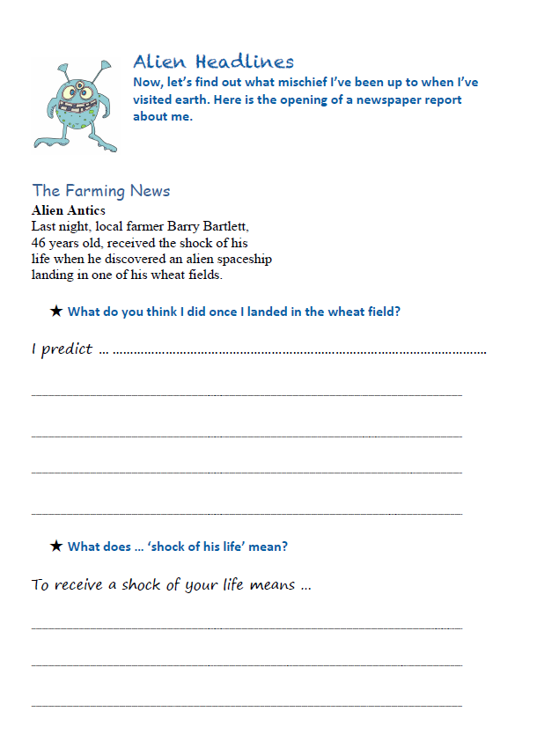

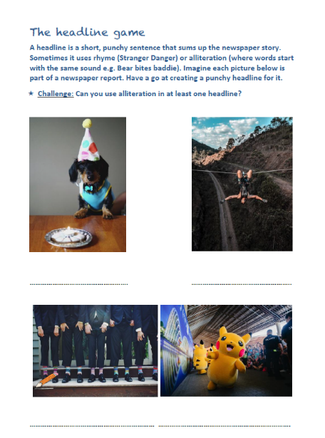
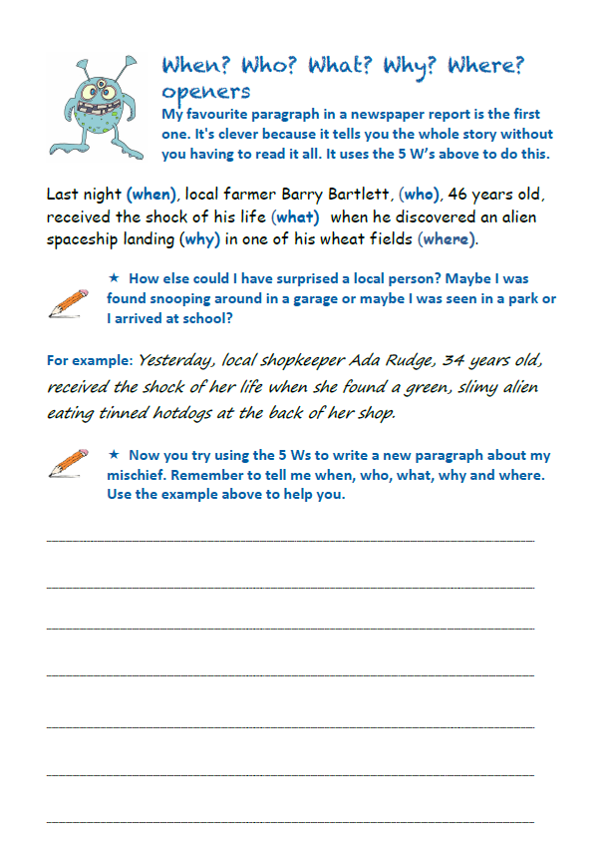
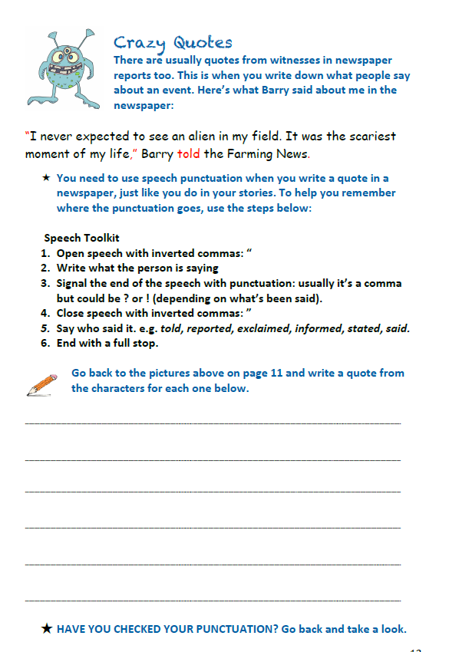
Maths
- Practice your times tables (in class we have practised the 2, 5, 10, 3, 4, 6, 8 and 9). A great tool for this is J2Blast on Hwb (I can see some of you have already had a go at this!)
- Practice telling the time on analogue (clock faces) and digital clocks
- Topmarks is a fantastic website to help with both of these

- This week’s topic is to solve one step equations using letters to present ‘unknowns’ with integer solutions e.g. 6+a=10 and b+b=8. We have done something similar before using ‘fact families’:

I know 6 – 2 = 4 because 4 + 2 = 6
I know 15 ÷ 5 = 3 because 3 x 5 = 15

- The first 2:45 of this video explains how to work them out: https://www.youtube.com/watch?v=30S7WxKcPwg

- Complete the sheet below – the first one is done for you. Don’t forget you need to do the opposite to the other side of the equation (the opposite of + is - ).

Good websites to help with any of the above include Letters and Sounds for phonic practice, Topmarks, Crickweb for problem solving practice, Twinkl, Espresso, Hwb, BBC Bitesize and Primary Resources.

Here are some more great links I’ve found for home learning: https://www.tes.com/teaching-resources/teacher-essentials/home-learning
www.collins.co.uk/learnathome
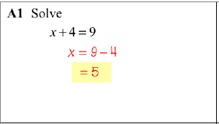
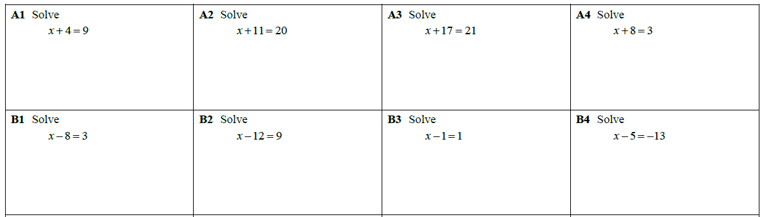

- If you fancy a challenge you may like to try the following questions. You can carry on watching the link above up to 4:05 to explain how to do these. The first one is done for you. Don’t forget you need to do the opposite to the other side of the equation (the opposite of x is ÷ ). 5x means 5 times x and 30 means 30 divided by 5.
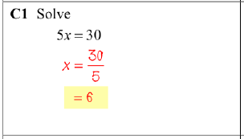
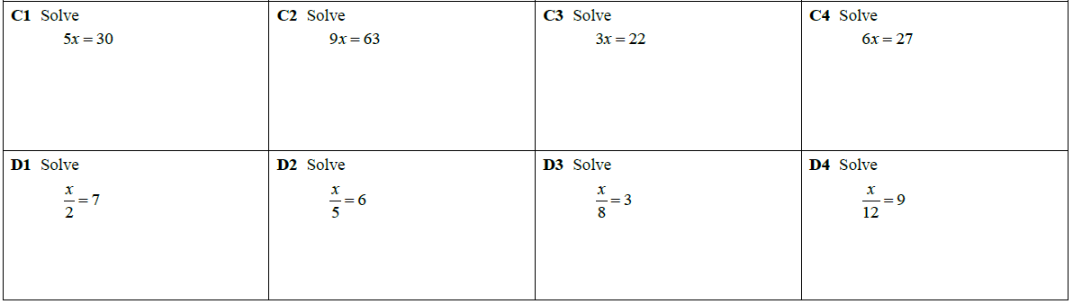
5
24
21
History
Using the same Powerpoint as last week on the Trojan War I would like you to have a look at the story of the Trojan Horse and have a go at writing a diary entry (see sheet below). You can choose to be either a Greek or a Trojan. Write a diary entry for the night of the Trojan Horse attack. You could write one entry before the horse enters Troy and one after.
WIN List (What I Need):
- Write in first person (I went, I did this) as if you were the character
- Give details about: Who? What? Why? When? Where?
- Use past tense (I ran along the street)
- Try to make it personal and include some opinion/how you are feeling

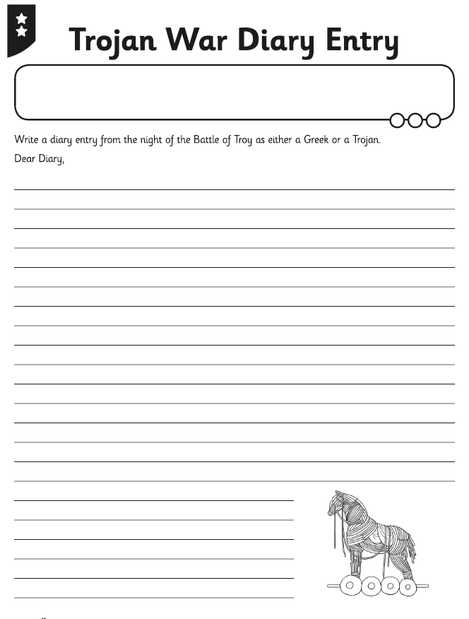

Welsh
Have a look through the slides below and practice the vocabulary for the activities you might do throughout the day. I have included the translations on this page in case the pictures aren’t clear.
Ask someone in your house to read and act out the dialogues below (I have included the translation underneath). If you can’t find anyone to act it out with you could use 2 teddies or Lego characters.
Also here’s the link for the Cyw website where there are lots of activities for you to explore: https://cyw.cymru/en/

Deffro – Wake up
Codi – Get up
Ymolchi - Wash
Cael brecwast – Have breakfast
Mynd i’r ysgol – Go to school
Cael cinio – Have lunch
Mynd adre – Go home
Gwylio’r teledu – Watch television
Mynd i’r gwely – Go to bed

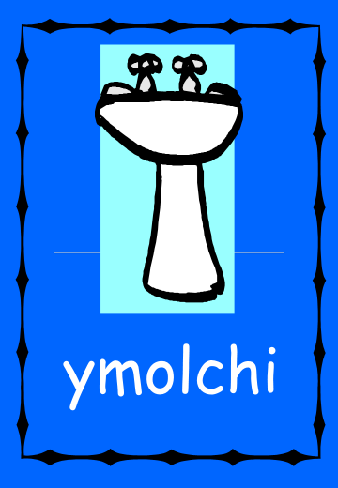
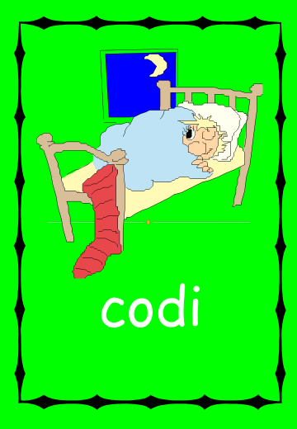
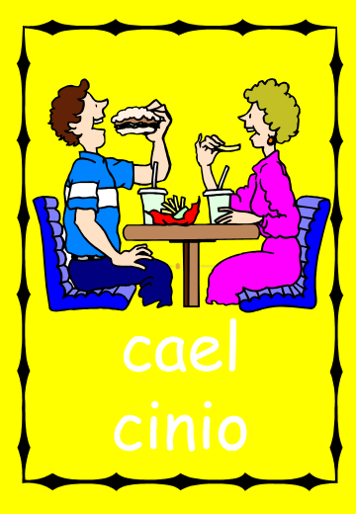
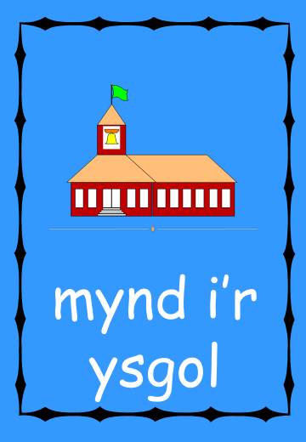
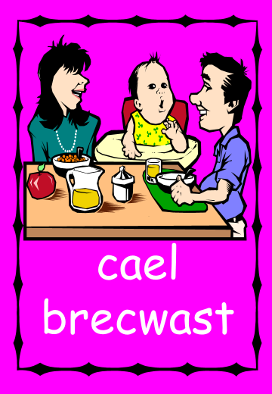
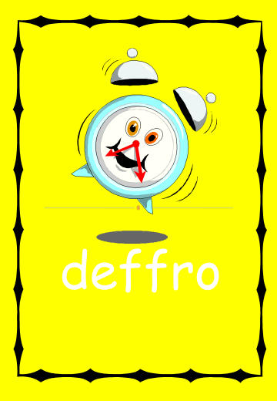
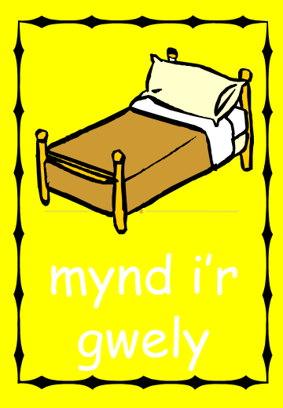
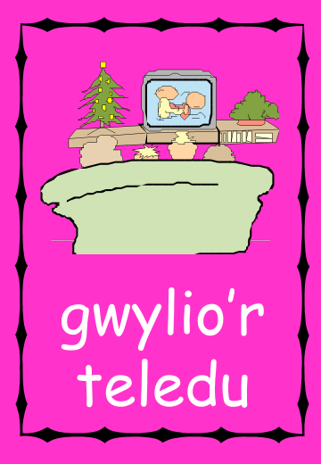
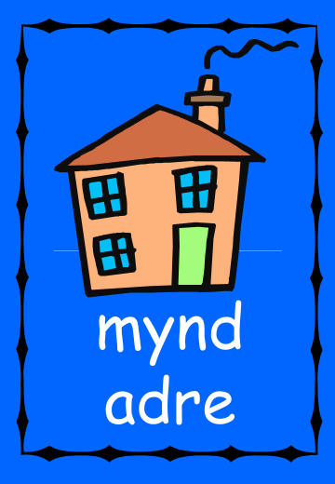

Deialogau

Nia: Faint o’r gloch ydy hi, Mam?
Mam: Hanner awr wedi tri. Pam?
Nia: Dw i’n mynd i nofio gyda Catrin am bedwar o’r gloch.
Mam: Dw i’n mynd allan am chwarter i bedwar. Wyt ti eisiau lifft i’r ganolfan hamdden?
Nia: Ydw, plîs. Diolch, Mam.

~~~~~~~~~~~~~~~~~~~

Gareth: Wyt ti eisiau dod i’r sinema, Tom?
Tom: Faint o’r gloch wyt ti’n mynd?
Gareth: Am chwech o’r gloch. Mae’r ffilm yn dechrau am chwarter i saith.
Tom: O, na. Dw i ddim yn gallu dod. Dw i’n mynd i chwarae pêl droed am hanner awr wedi chwech.

~~~~~~~~~~~~~~~~~

Dad: Sam, mae’n amser codi. Mae hi’n wyth o’r gloch!
Sam: O’r gorau, Dad.
Dad: Sam, Mae hi’n amser codi. Mae hi’n chwarter wedi wyth!
Sam: Iawn, Dad.
Dad: Sam! Mae hi’n hanner awr wedi wyth! Amser codi!
Sam: O’r gorau, Dad.
Dad: Mae hi’n chwarter i naw, Sam! Amser mynd i’r ysgol!
Sam: Na, Dad. Mae hi’n ddydd Sadwrn. Does dim ysgol.
Dad: O. Sori, Sam.

Dialogues

Nia: What time is it, Mum?
Mam: Half past three. Why?
Nia: I’m going swimming with Catrin at 4 o’clock.
Mam: I’m going out at quarter to 4. Do you want a lift to the leisure centre?
Nia: Yes, please. Thanks, Mum.

~~~~~~~~~~~~~~~~~~~

Gareth: Do you want to come to the cinema, Tom?
Tom: What time are you going?
Gareth: At 6 o’clock. The film starts at quarter to 7.
Tom: Oh, no. I can’t come. I’m going to play football at half past 6.

~~~~~~~~~~~~~~~~~

Dad: Sam, it’s time to get up. It’s 8 o’clock!
Sam: OK, Dad.
Dad: Sam, it’s time to get up. It’s quarter past 8!
Sam: Fine, Dad.
Dad: Sam! It’s half past 8! Time to get up!
Sam: OK, Dad.
Dad: It’s quarter to 9 Sam! Time to go to school!
Sam: No, Dad. It’s Saturday. There’s no school.
Dad: Oh. Sorry, Sam.

ICT
This week I would like you to describe some of the positive and negative aspects of the use of technology. This is particularly relevant due to us relying on it more at the moment, being at home.
For those of you accessing Google Classroom I have posted the assignment for you to complete on there as a shared document so you can see everyone else’s comments.
I would like you to make two columns/lists: positive aspects of technology and negative aspects of technology. Try to include at least 3 points in each list. I am sure you can think of a lot more.
Some possible areas to think about could include: communication, health, relationships, commerce (buying and selling things) and learning. Focus on the ease in which we can all share digital content e.g. video, photographs, text, audio. How has technology improved the ways in which we live our lives? How many times does digital technology play a part in a typical day? Alarm clock, microwave, TV, DAB radio, tablet/smartphone, in school etc. What would you miss if you had to go without technology for a day?
You can see the beginning of my lists below to start you off.

Positive impact
- I can stay in touch with friends and family who live far away
Negative impact
- Spending too much time on social media could affect your self-esteem

Here is a useful link about online safety on Hwb – lots of relevant information for parents/carers and activities to complete: https://hwb.gov.wales/zones/online-safety/news/articles/42ae160b-7ab4-4510-8792-c70ef861c6d5

Try to include a bit of physical activity every day. Joe Wicks has proved really popular on his YouTube channel – you can have a look here: https://www.youtube.com/channel/UCAxW1XT0iEJo0TYlRfn6rYQ
Here is another useful link with ideas for keeping fit: https://www.twinkl.co.uk/resources/twinkl-move?utm_source=newsletter&utm_medium=email&utm_campaign=newsletter_2020-05-17_GB-WLS_KeyStage2&utm_content=custom9

Happy home learning! Hope you are all keeping safe and well,

Miss Densley

