
W/C 15th June 2020
Hello,
I just wanted to say a big ‘Thank You’ to all the children and families who have logged onto Google Classrooms. I have really enjoyed seeing and hearing about all your hard work over the last few weeks.
I especially liked looking at the animal pictures. Please see this as a way of communicating with your friends as well. If you want to post pictures or comments on the class stream, your friends will be able to see them and respond. If you want to message me privately, please click on any activity and you can send me a private message this way.
Over the last few weeks we have covered a lot of the curriculum (time, money, temperature, place value, apostrophes, high frequency words, speech marks, rhyming words), PHEW!
This week, I would like to revisit addition and subtraction, and see how you put your writing skills into action. You are all at different stages and if you find the work a bit hard, please message me and I will do my best to help. There are some more activities in our Google classroom you could try. If you have not yet joined Google classroom please do, it is very important for you to be able to use online learning resources and it is part of our digital competency framework.
Stay well x
Mrs Jones

Numeracy
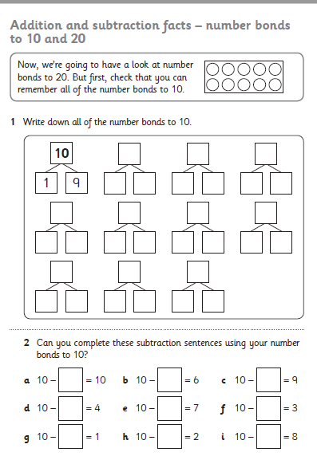
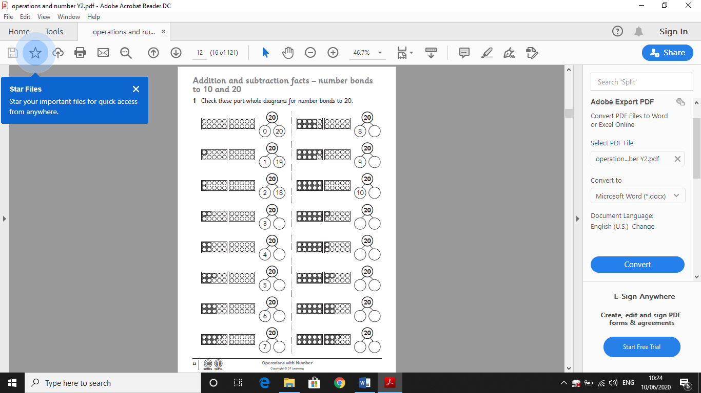

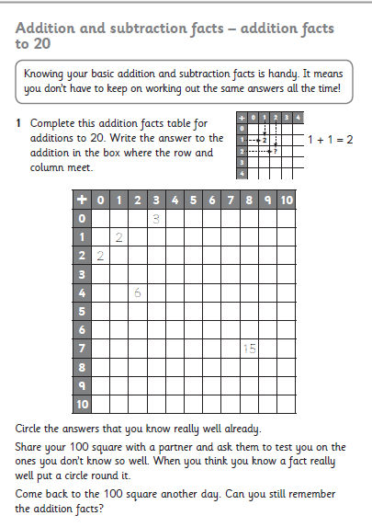
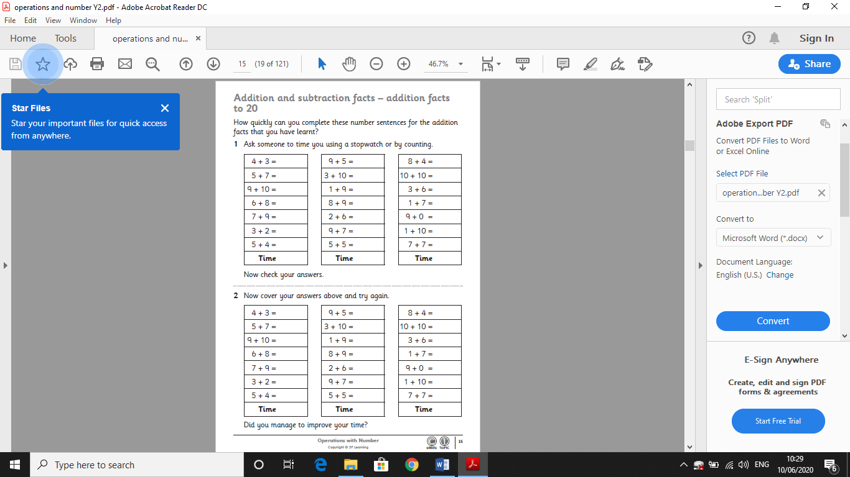
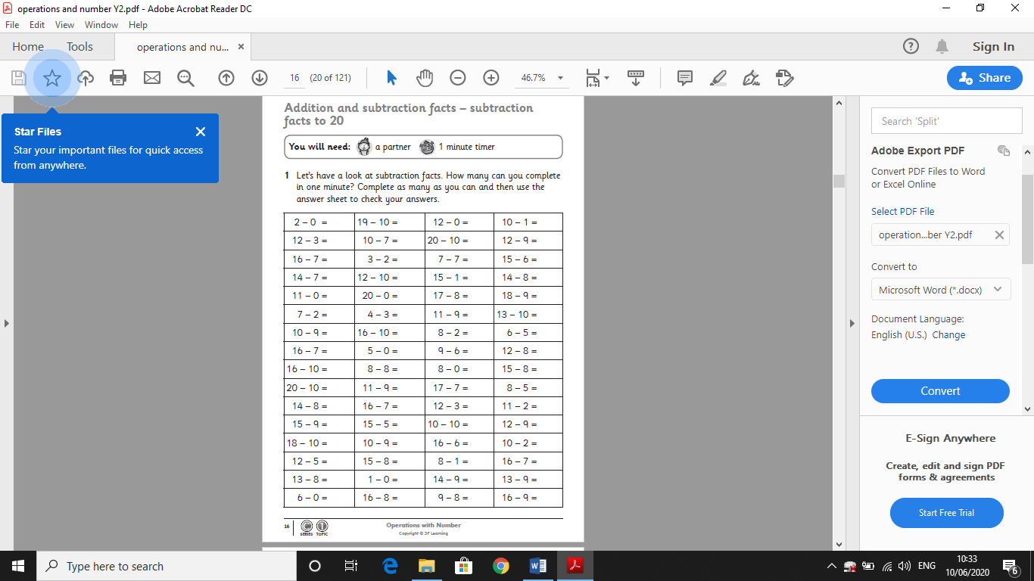
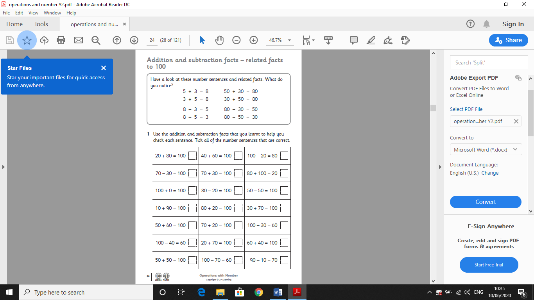
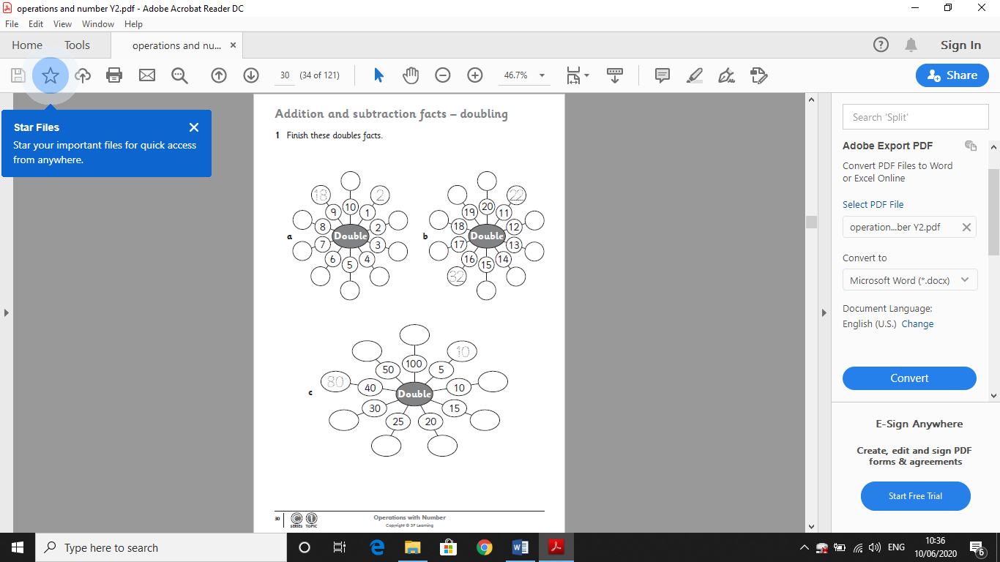
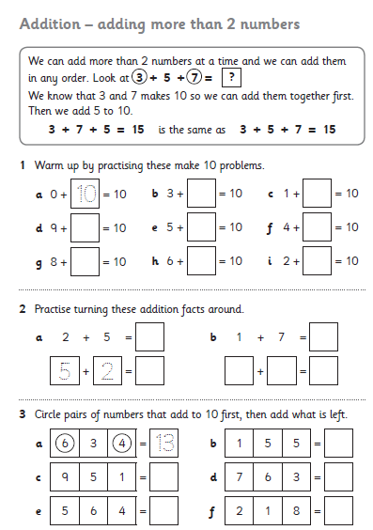
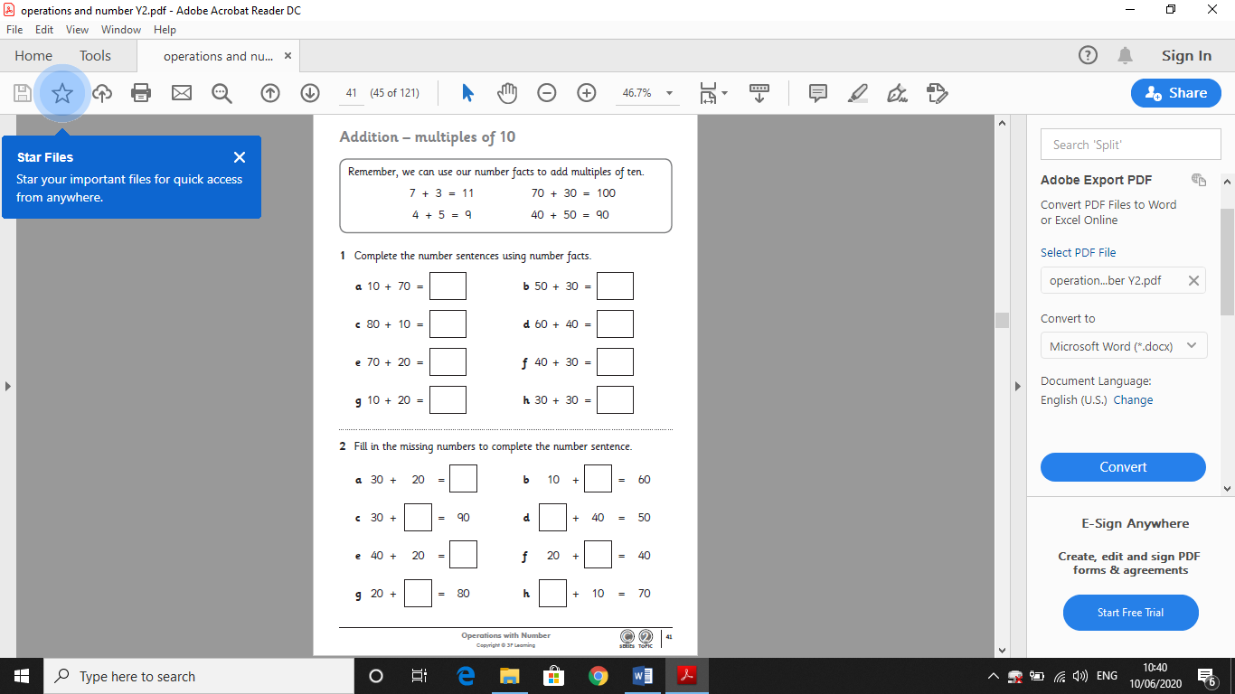
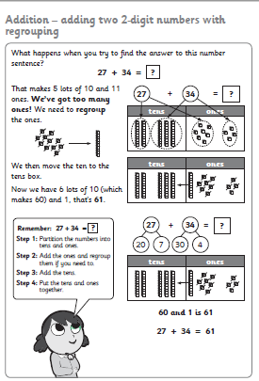
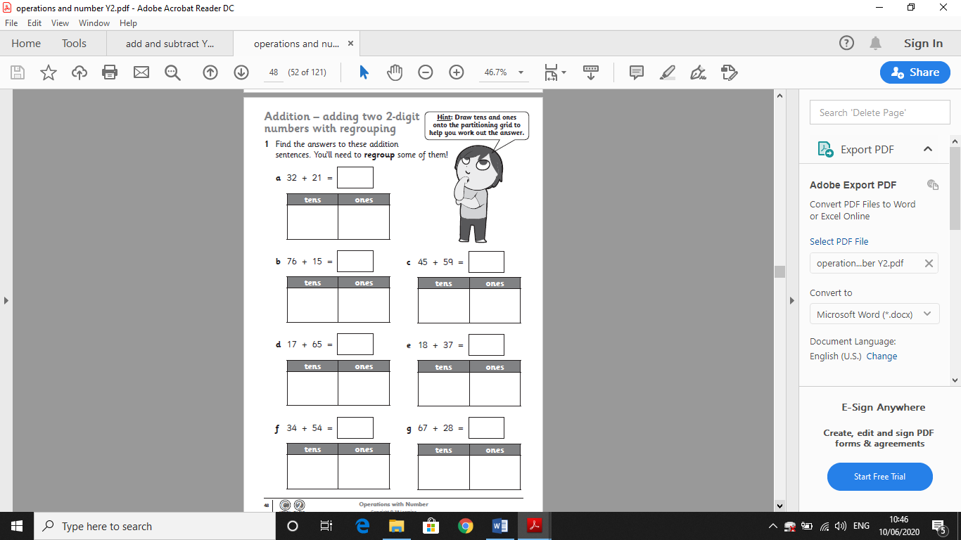
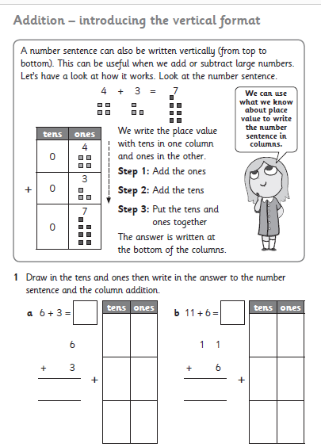
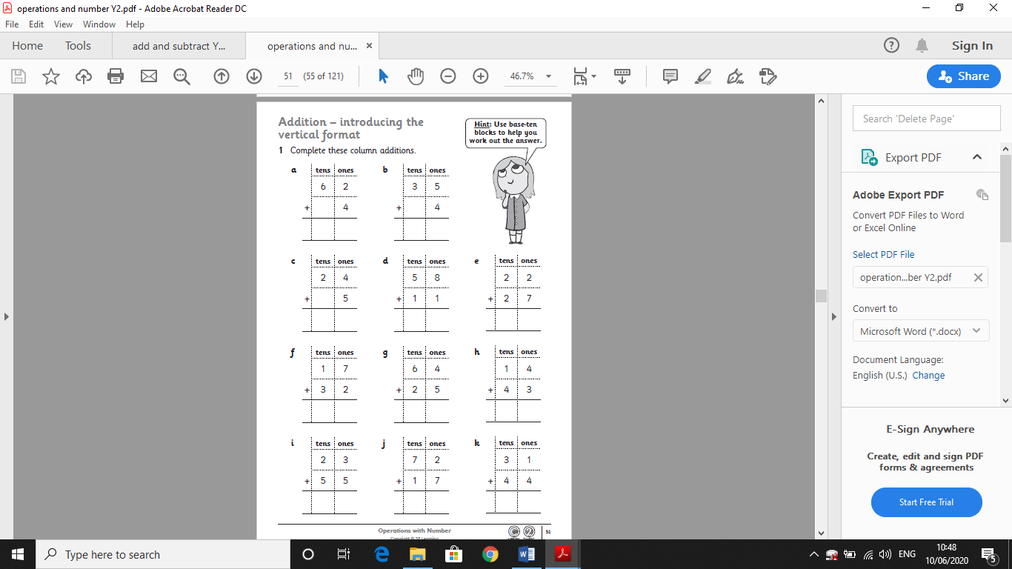
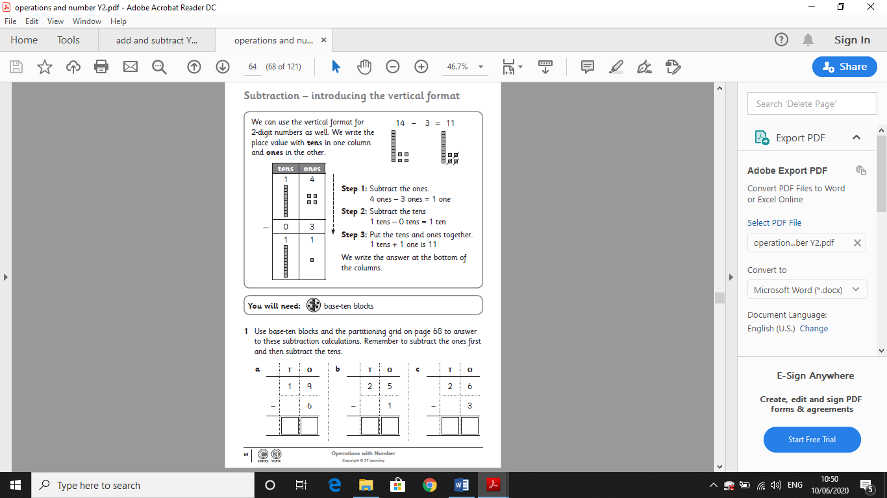
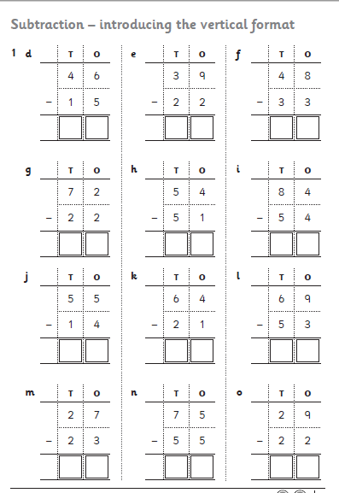
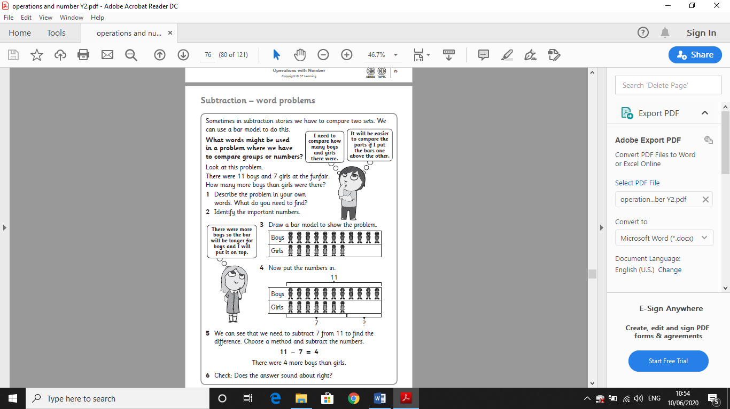
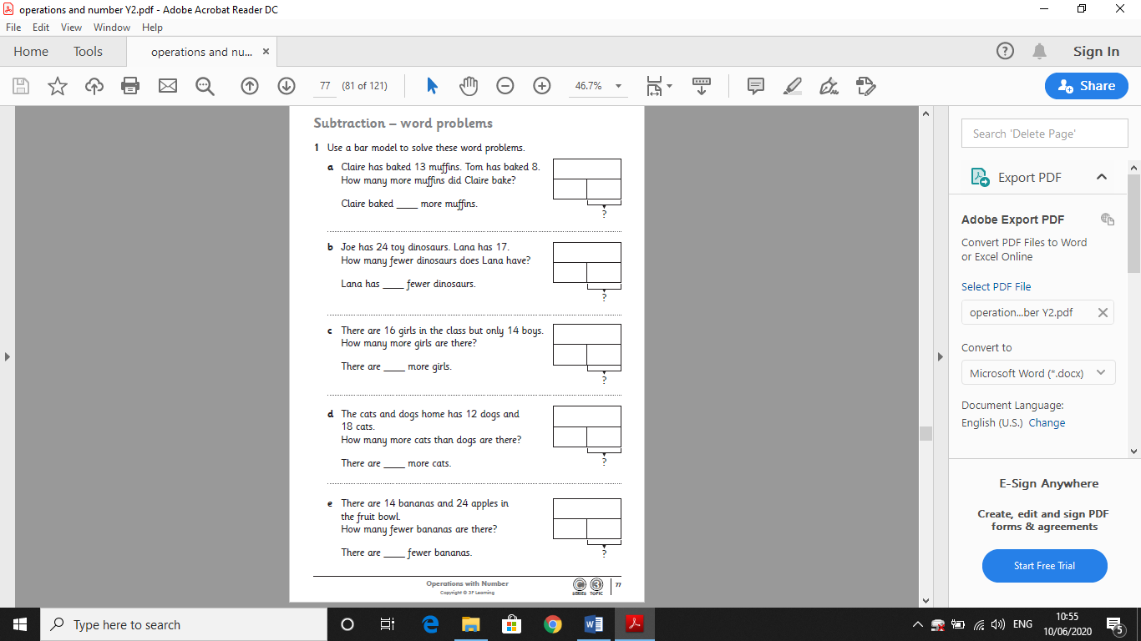
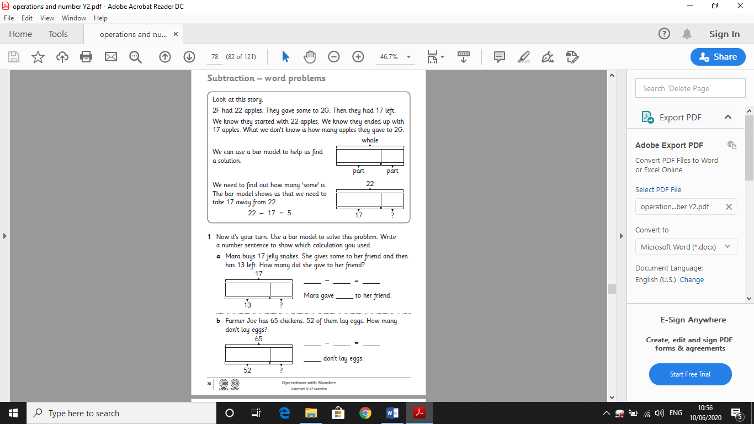
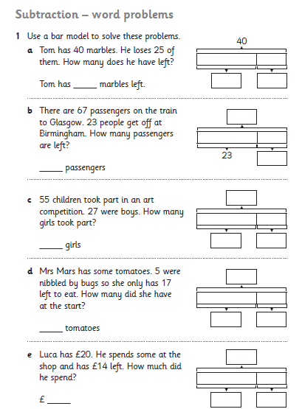

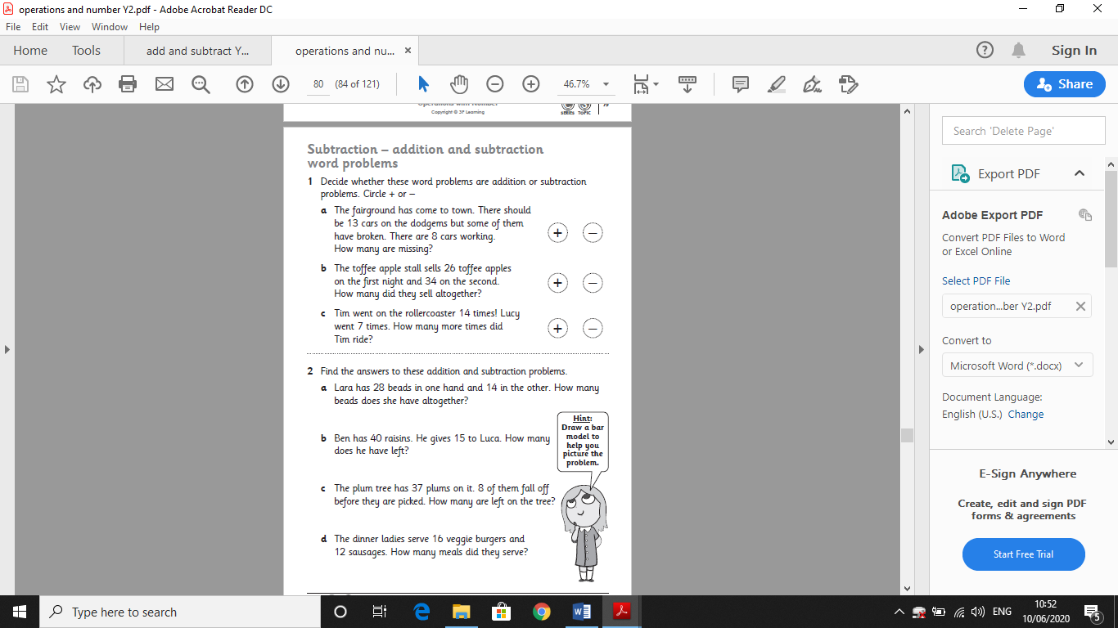
Literacy
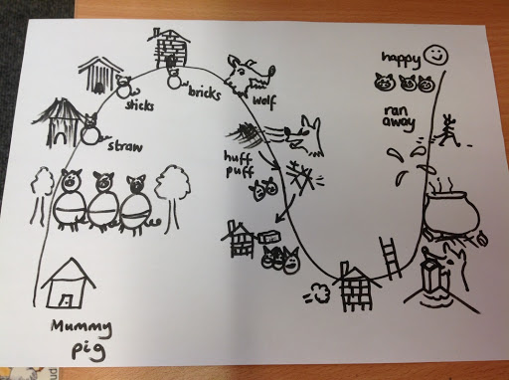
Have a look at the story map above. Can you tell what the story is by looking at the pictures?
This week your task is to re-write the story using the story map. Look at the Success Criteria table. Make sure you check your work against each criteria. You can choose to handwrite the story or type it. You can either take a photograph and upload it on Google classroom, or you can use the google word document attached online or use ‘Word’.

Success Criteria | Tick if included
Use Capital letters for Names (Big Bad Wolf).
Use Capital letters at the beginning of sentences and full stops at the end of sentences.
Use describing words (Describe the Wolf or the pigs, describe the houses they built).
Use apostrophes to shorten words (I’ll huff and I’ll…)
Use speech marks to show who is talking (…”not by the hair of my chinny chin chin,” said the …
Use neat handwriting, and space your writing out correctly.

Next Set of High Frequency words to learn.
SET 11
off
call
ask
down
very
children
just
their
house
I’m

