Williamstown Primary

Home School Learning Pack Year 3 W-C 15/6/2020

Useful Websites
TWINKL- free code 1 month = PARENTSTWINKLHELPS
BBC BITESIZE TOPMARKS- Hit the button
SCHOLASTIC HWB
Hello Year 3, I hope you are all safe and well, still working hard but also having as much fun as possible
Here is your new pack for this week including English work, spellings, and maths challenges!
Remember to keep reading, stay safe and keep in touch with your friends when you can
Miss Thomas x

Positive Relationships

Within our topic we are also going to look at positive relationships and healthy friendships. Your task this week is to create a mindmap of people who are special to you. I would like you to choose 6 people who are special to you, these could be family, friends, teachers, sports coaches its up to you.

Within your mind map I would like you to include:
Who each person is.
Why they are special to you.
What do you like most about them.
Why you have chosen them.

You can also draw a little picture by the side of each one if you want to :)

Comprehension
Within our topic we are also going to focus a little on plants and animals and how they grow and keep healthy. Complete this butterfly comprehension by reading the text and answering the questions in full sentences where possible.

This is a chilli challenge and you can choose mild medium or hot. Remember:
MILD will have a ONE star text and question sheet.
MEDIUM will have a TWO star text and question sheet.
HOT will have a THREE star text and question sheet.

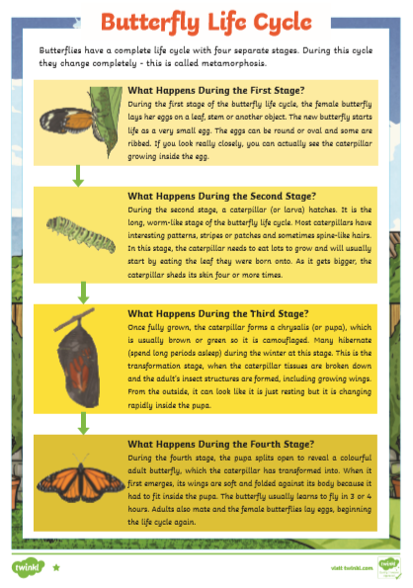
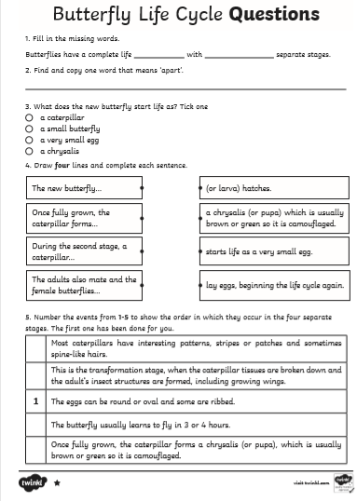
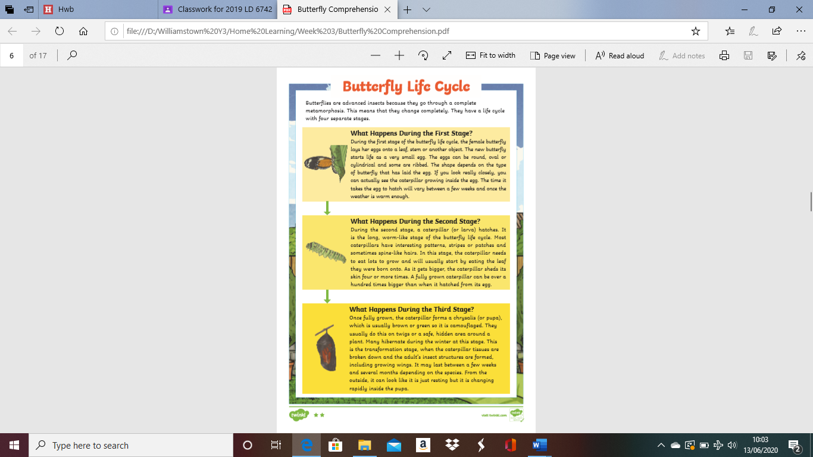
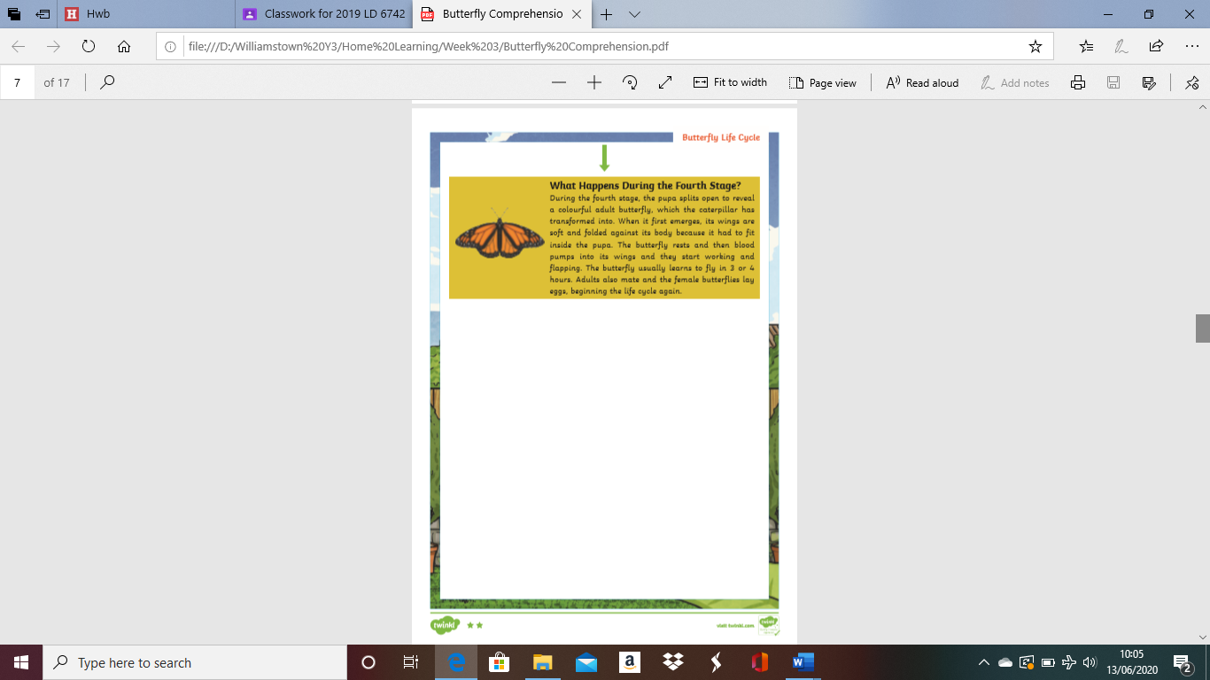
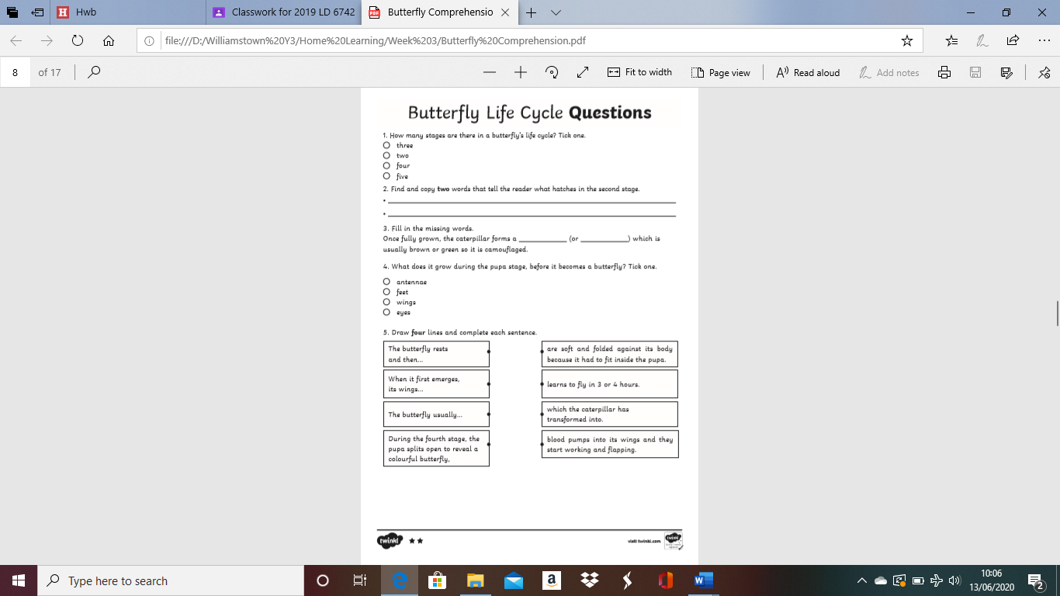
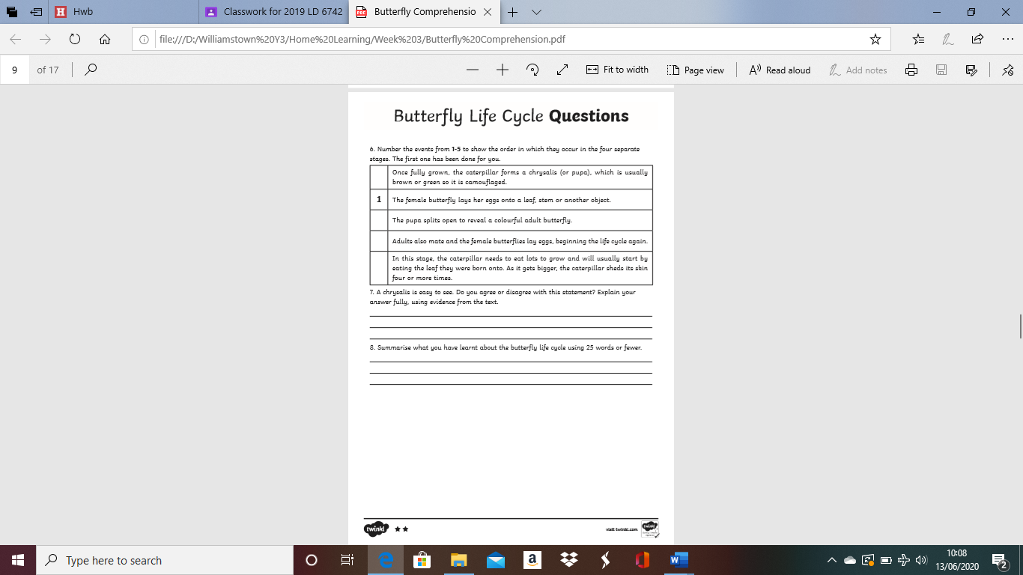
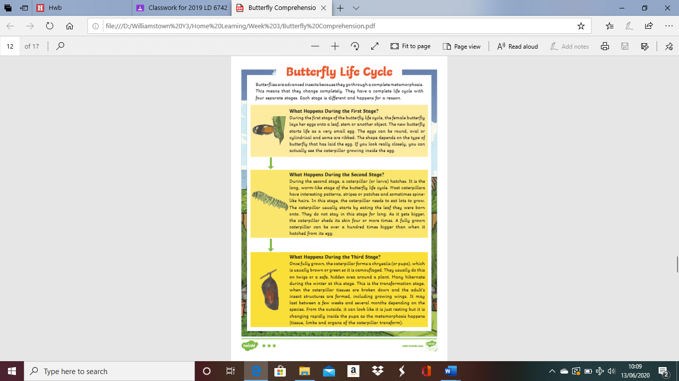
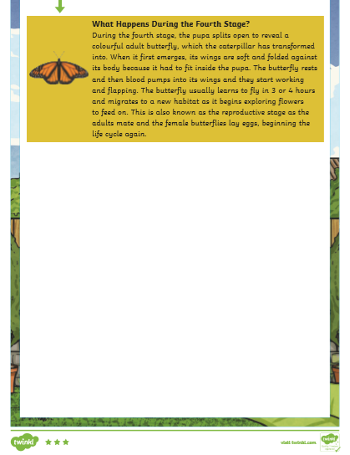
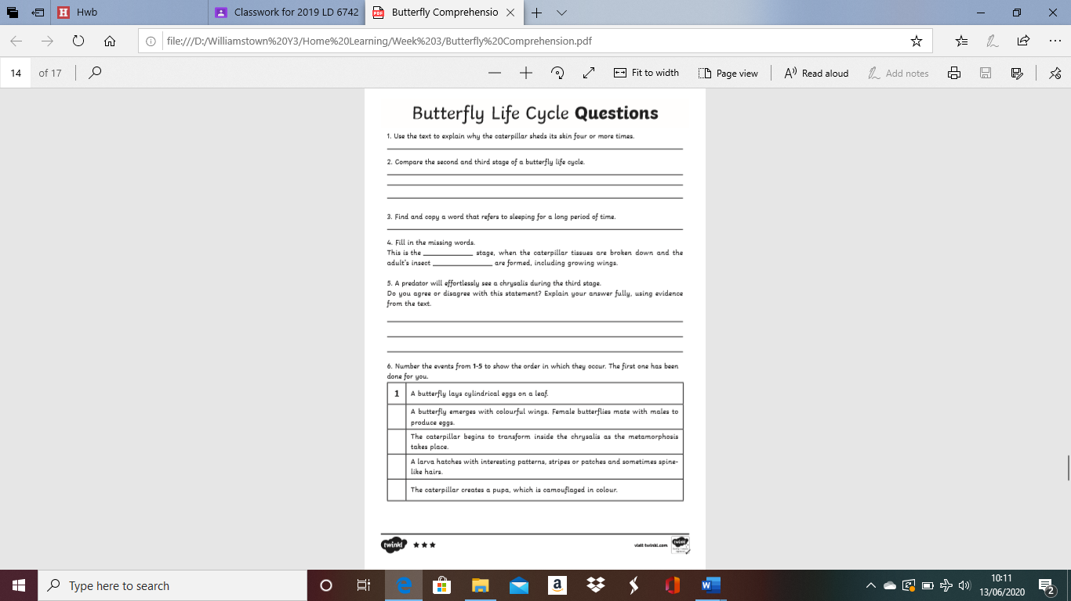
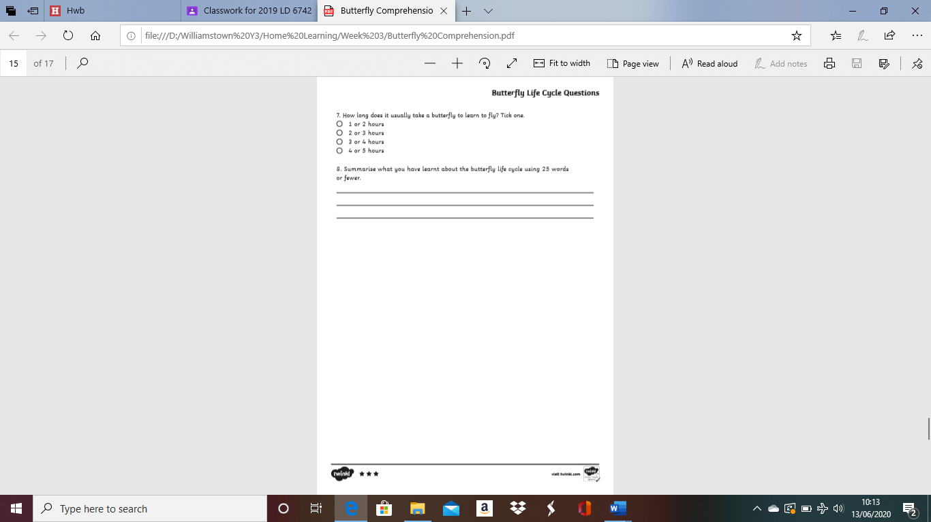
Fruit Shape Poem
Complete one fruit shape poem using the template below. You can choose which template you want to use. Your fruit shape poem must be written based on what 'Keeping Healthy' means to you.

Remember to include adjectives, wow words and some RHYMING words in your poems, use your rhyming word challenge from last week to help you.

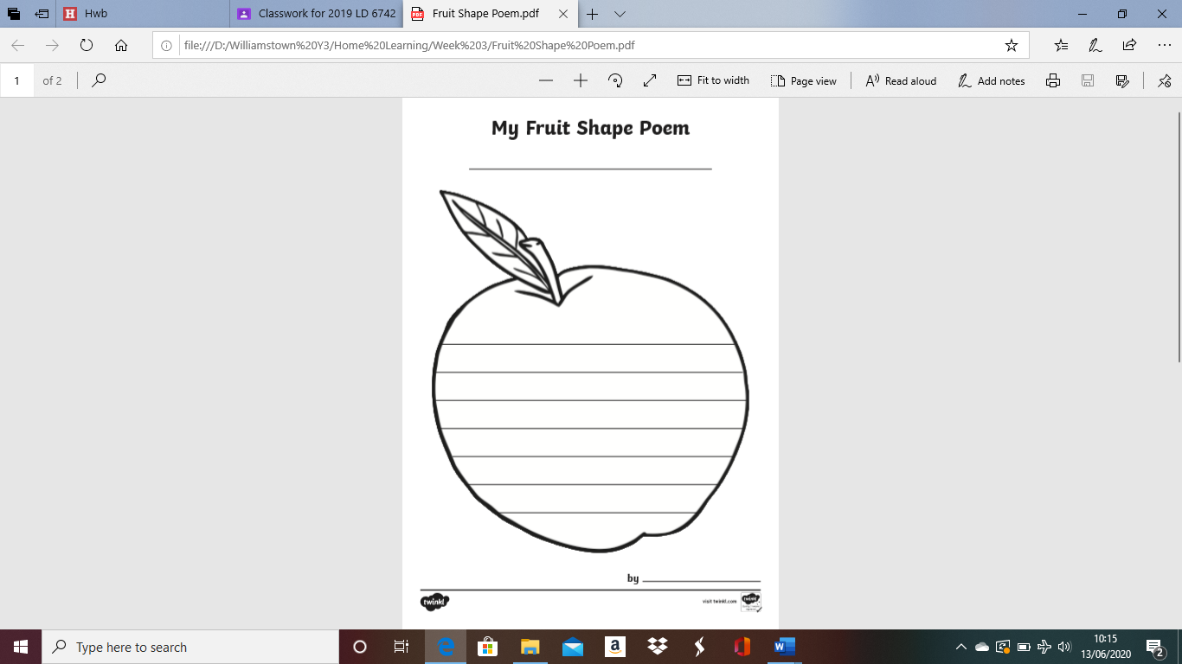
I would love to use some of these in school once we eventually return! :)
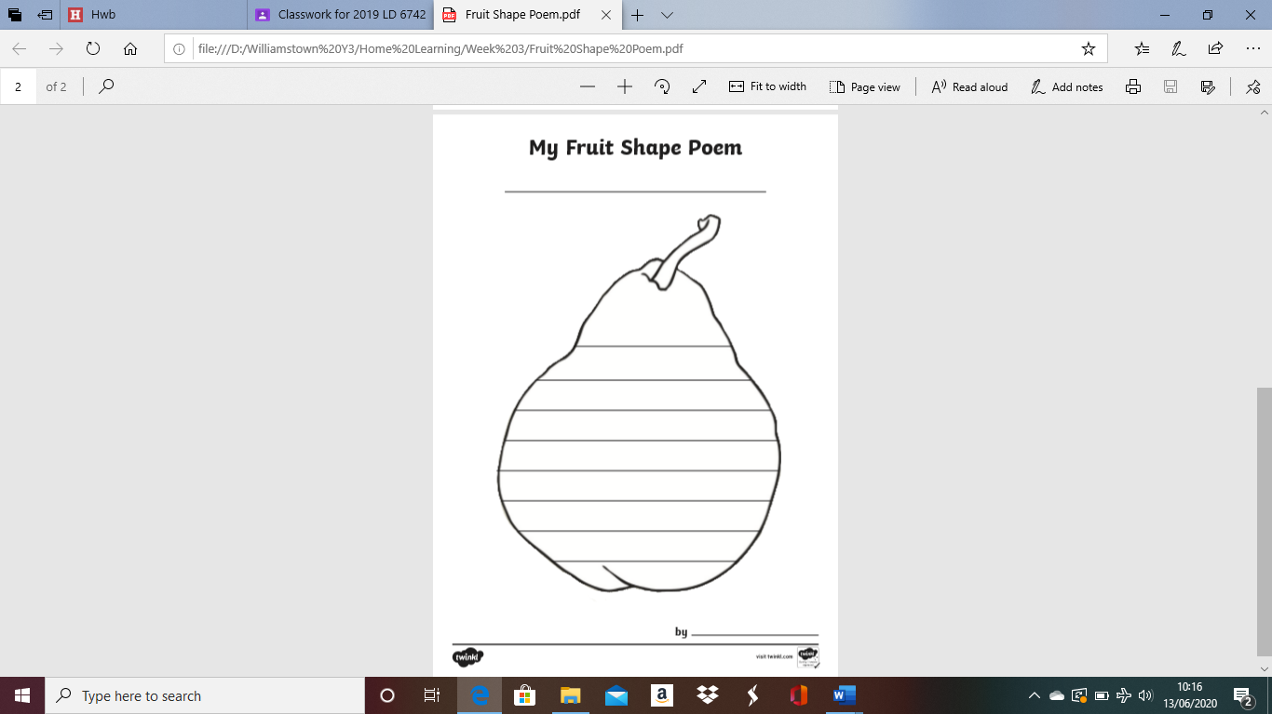
Handwriting
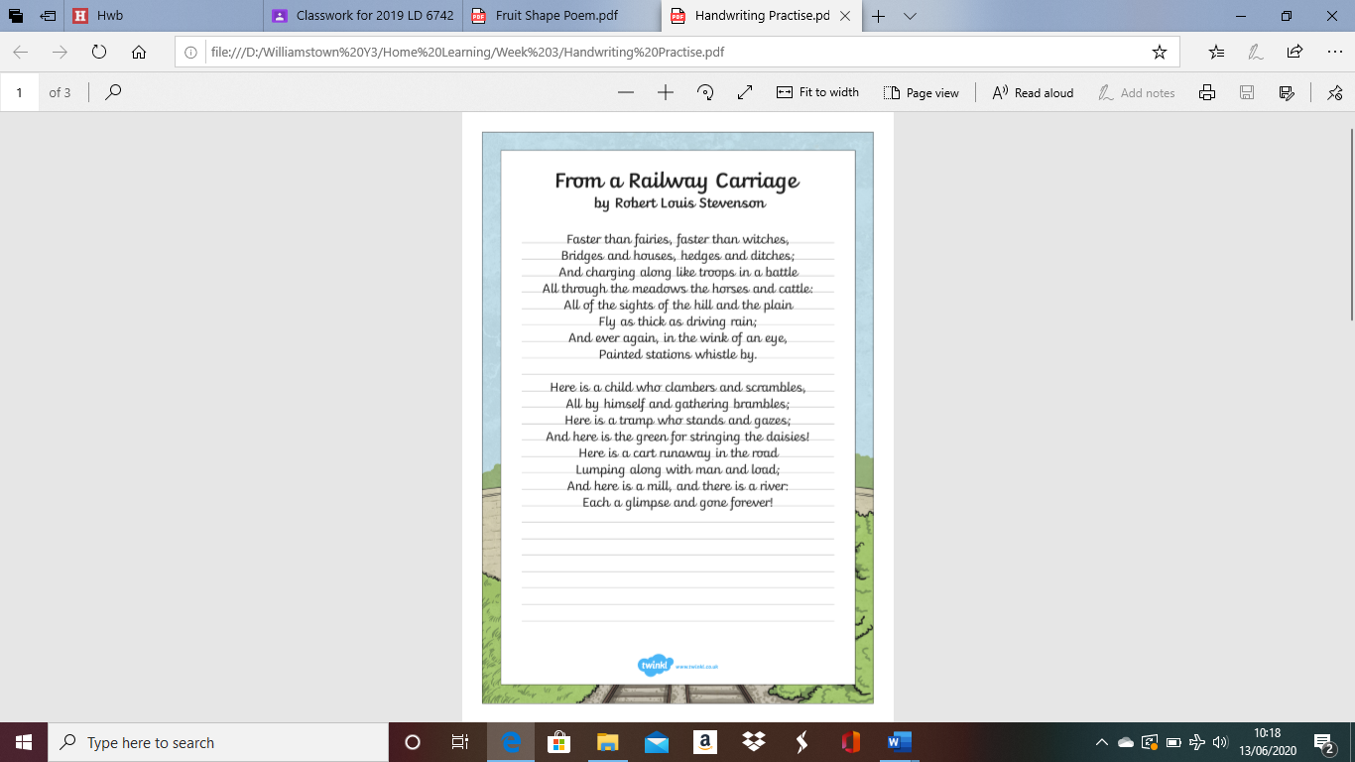
Please practice your handwriting using this poem.

Spellings
Practice your spellings by writing them out 3 times and then using them in a sentence.
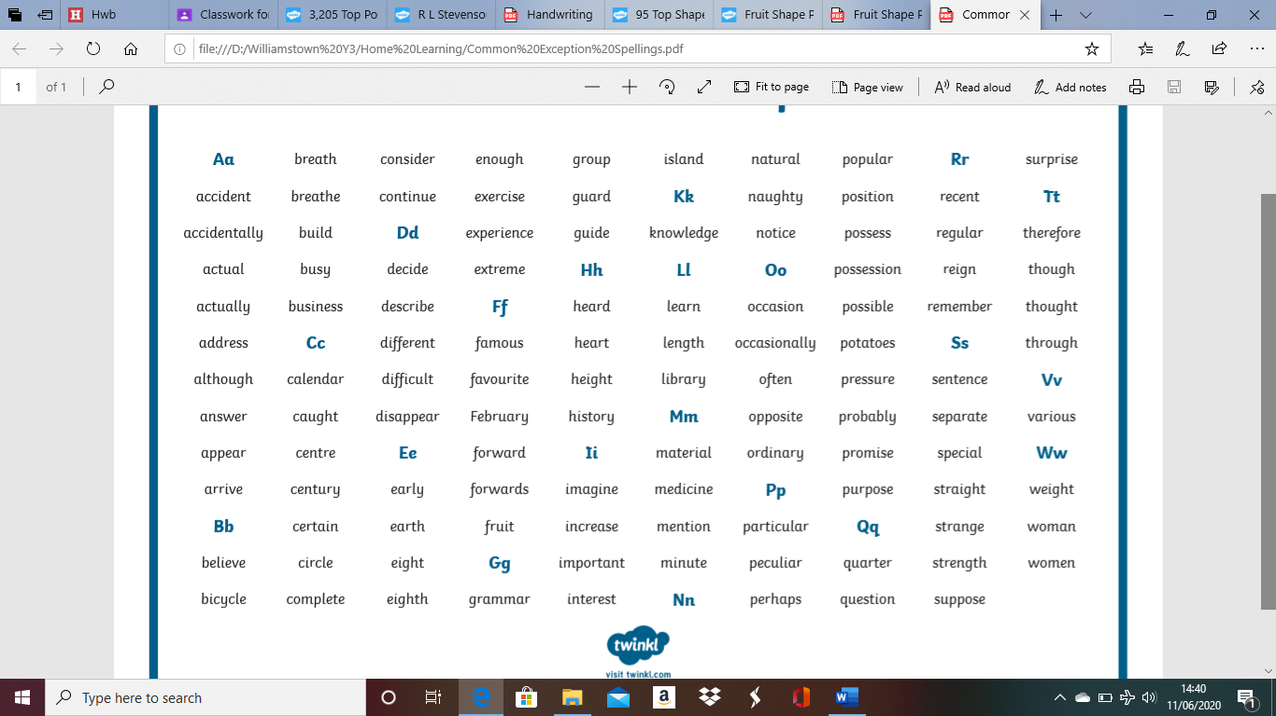

BBC Bitesize English
Practice using commas with this link!
https://www.bbc.co.uk/bitesize/articles/zjm6pg8

Maths
Measuring G and KG
We are learning another new skill this week and are going to be looking measuring weight. You can measure weight in grams (g) or kilograms (kg). Have a look at the poster below to familiarise yourself.

As our topic is keeping healthy, this mathematics skill can be useful as lots of our food is measured in grams.

Please complete the worksheets below which allow you to practise reading scales.

Remember this is a new skill and practise makes perfect :)
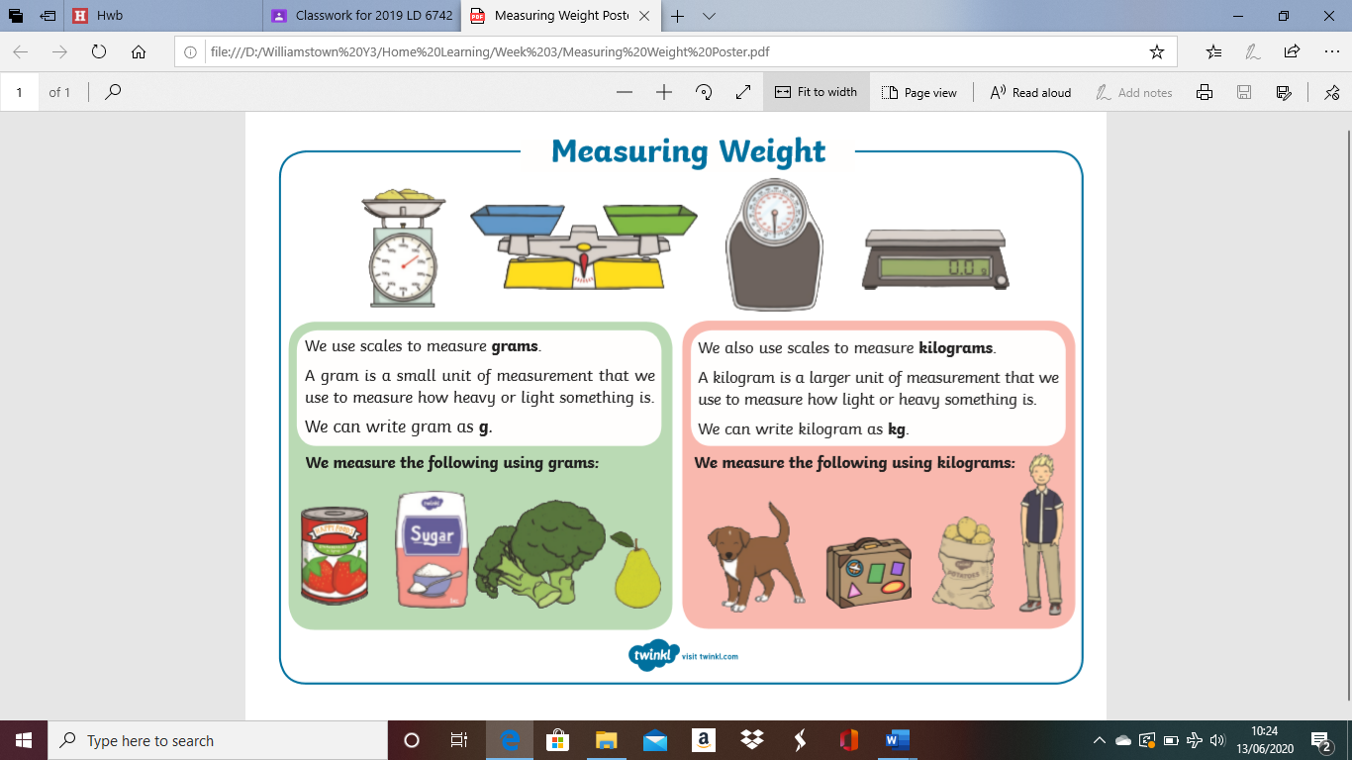
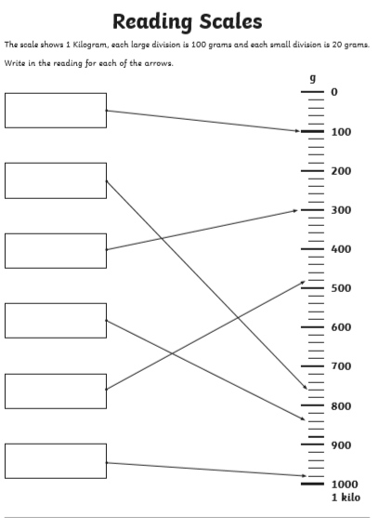
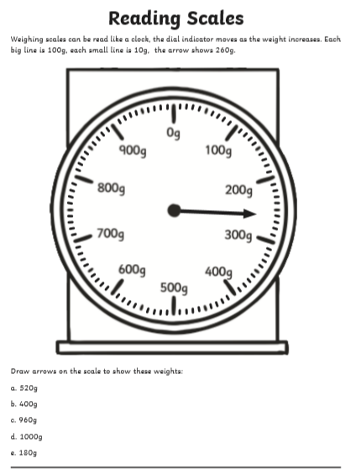
Complete the worksheet below on measuring grams. You will need to read the scales to calculate the weight of each object.

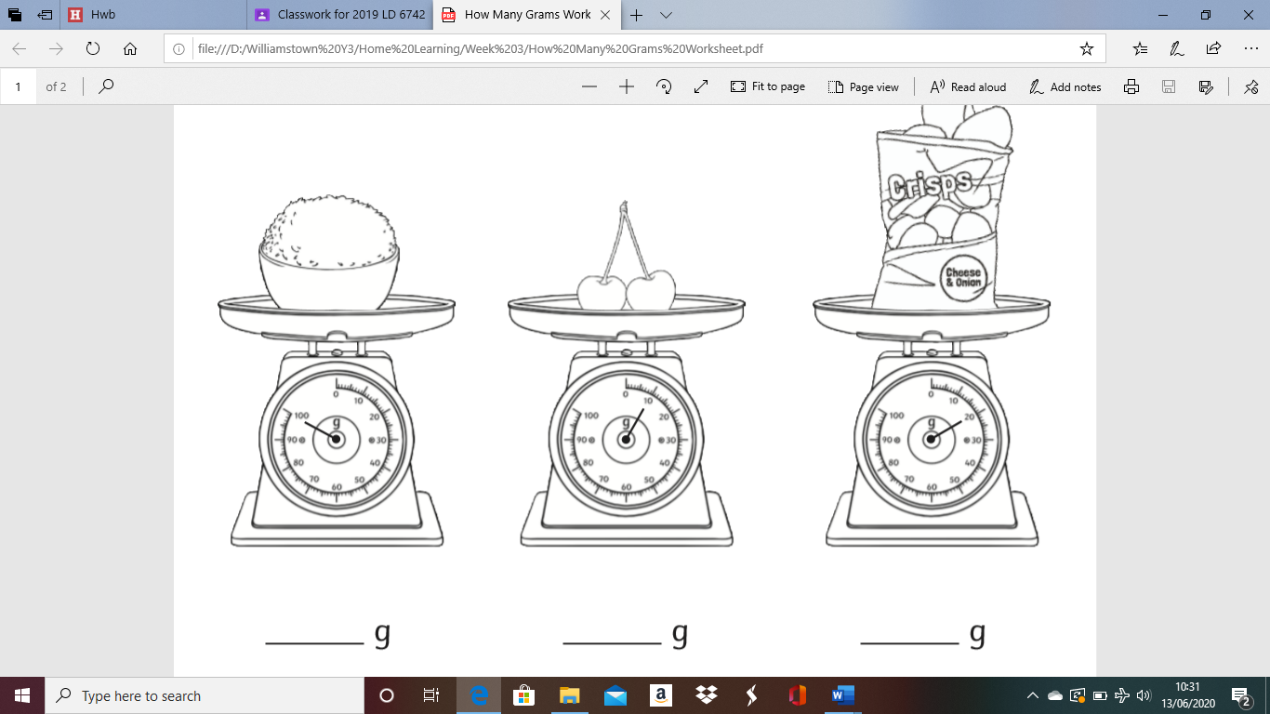
PLEASE COMPLETE THIS ACTIVITY AFTER THE ''MEASURING GRAMS AND KG'' ACTIVITY THAT IS ALSO ASSIGNED'

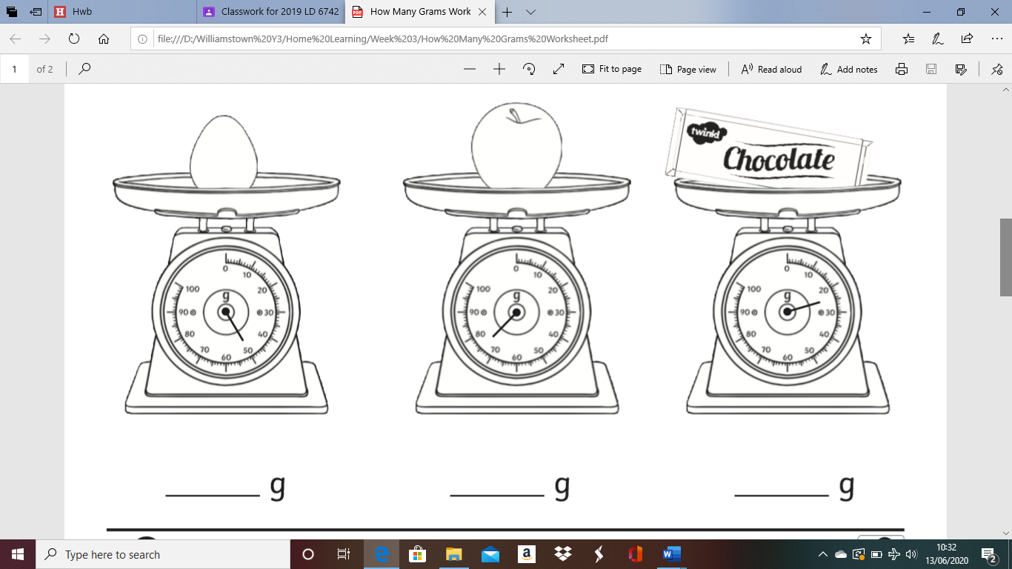

Fairy Cake Recipe
Here is a cake recipe that will test your new weighing skills that you have learned this week. This recipe gives you the opportunity to weigh out all the ingredients needed to make a batch of fairy cakes and complete a practical maths activity!

Please Note: This task is not compulsory and is just an extra fun maths activity for children should you choose to put your skills to the test. :) Make sure you have adult supervision before completing this task.

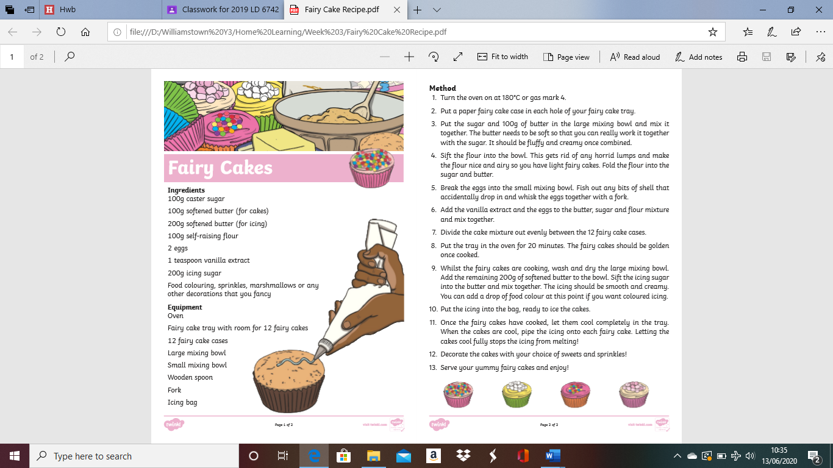

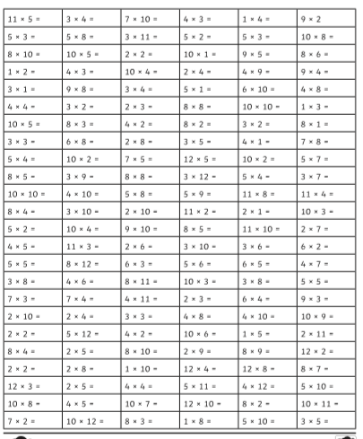
Multiplication and Division Challenges
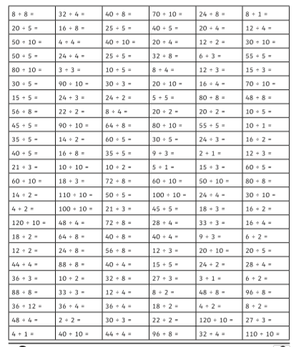
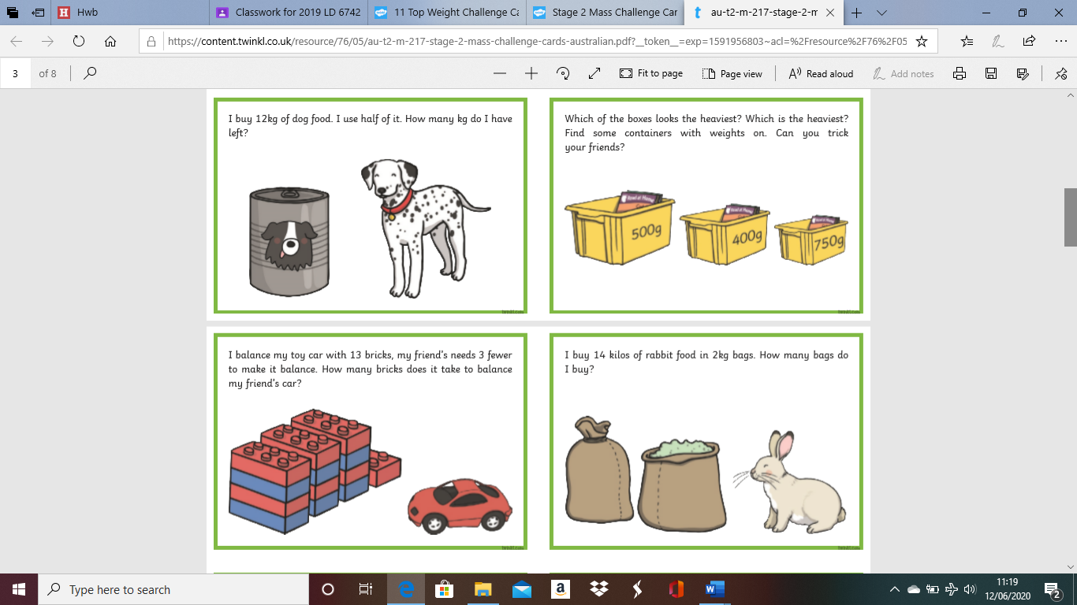
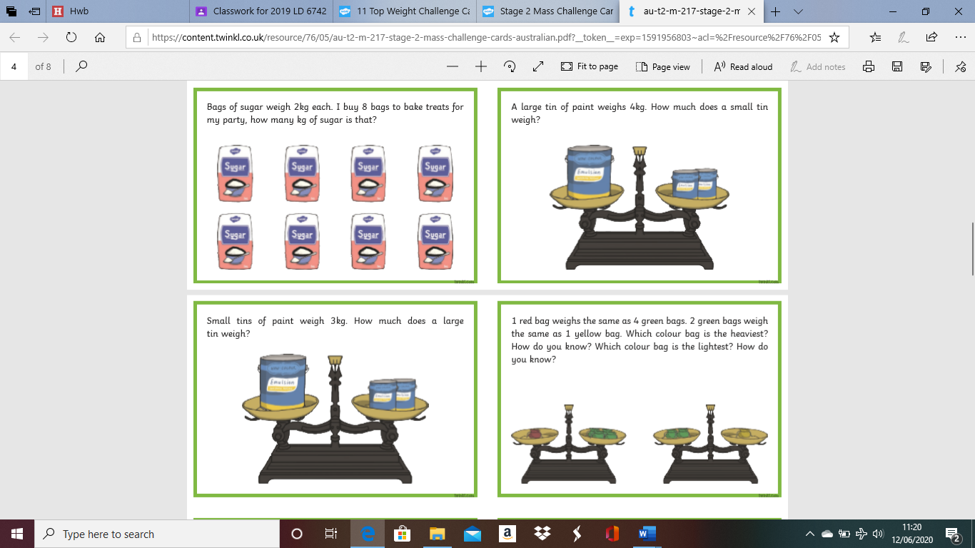
Have a go at the measuring weight challenge cards below. These will test your problem solving skills.

