Home Learning Pack Week 10 Year 6
Miss Kear & Miss Thomas’ class
Hello everybody! Hope you are all well and happy. This will be the last work pack now as everyone should be on Google Classroom. We will try and help anyone still having difficulty signing in as future work now will only appear on Google Classroom.
We know lots of you are intending to come back to school, but the work will still be available on Google Classroom for those of you who will be staying home.
A transition twitter page has been created by Tonyrefail Community School for the students joining them in September. It is called @tcsyr6transit1.
Here is a link to the most recent transition documents on their school website, you will find the introduction letter, information on Uniform, class charts guide for parents and pupils & some transition activities on this page. https://www.tcs.cymru/?page_id=412
They have also uploaded a transition video to YouTube - https://www.youtube.com/watch?feature=youtu.be&v=KZVZs85kHJs&app=desktop
This week:
Maths
Number Sequence – chilli challenge. You have a mild, medium and hot worksheet. We would like you to complete at least two of these. If you’re feeling confident, give them all a go!
Emoji Challenge Cards
Mental Maths – ask someone to test you
Problem Solving – guessing and checking
English.
Grammar: Common Word Endings and Word Games.
Crossword instead of the challenges.
Writing task. Interview: Please interview one of your friends or brothers and sisters to ask them about how they have felt over the last couple of months during lockdown. What have been the advantages/disadvantages of being at home? Have you learned any new skills that you couldn’t have done if we were still in school? Set it out like a playscript. (See Sheet)
Art
Collage Robots

Miss Thomas and Miss Kear

Number Sequence – chilli challenge. You have a mild, medium and hot worksheet. We would like you to complete at least two of these. If you’re feeling confident, give them all a go!
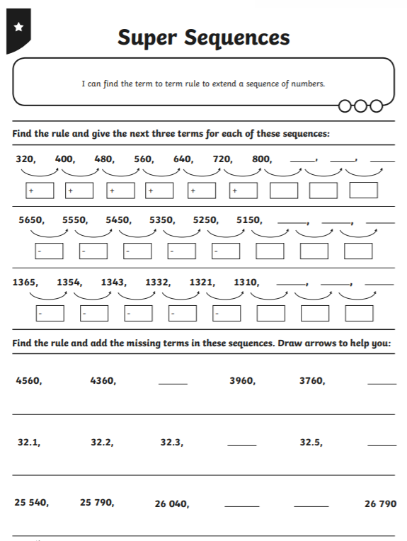
Mild:

Medium:
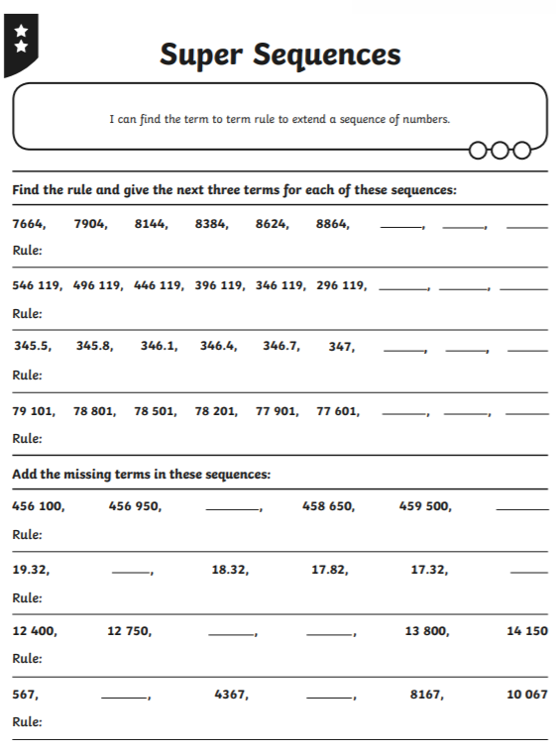

Hot:
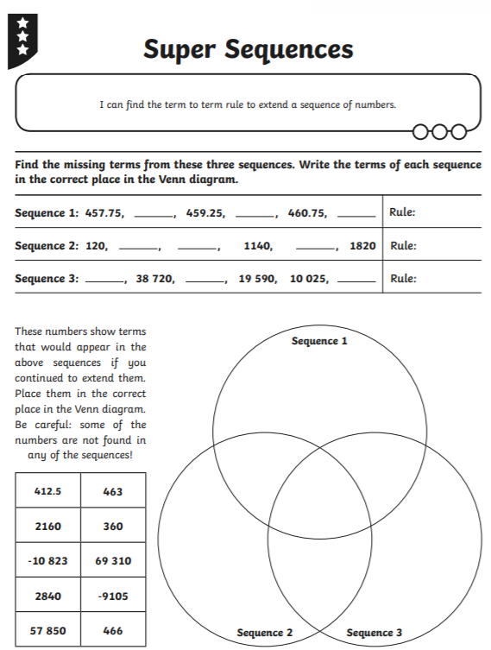

Emoji Challenge cards – be carefull and look at the symobls. Do you need to add, takeaway or multiply?
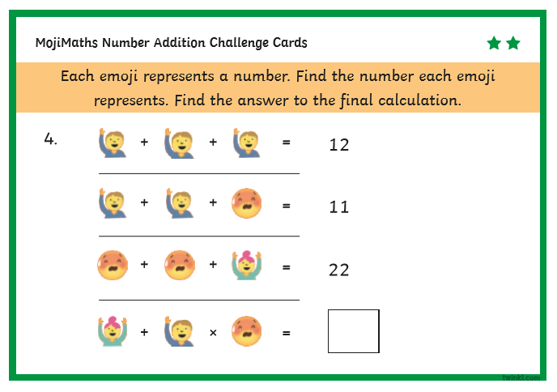
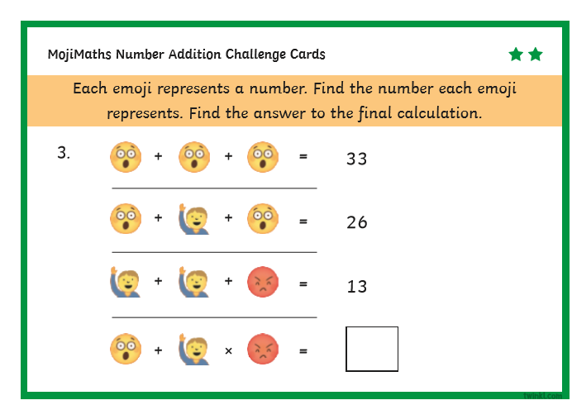
Mental Maths – ask someone to test you
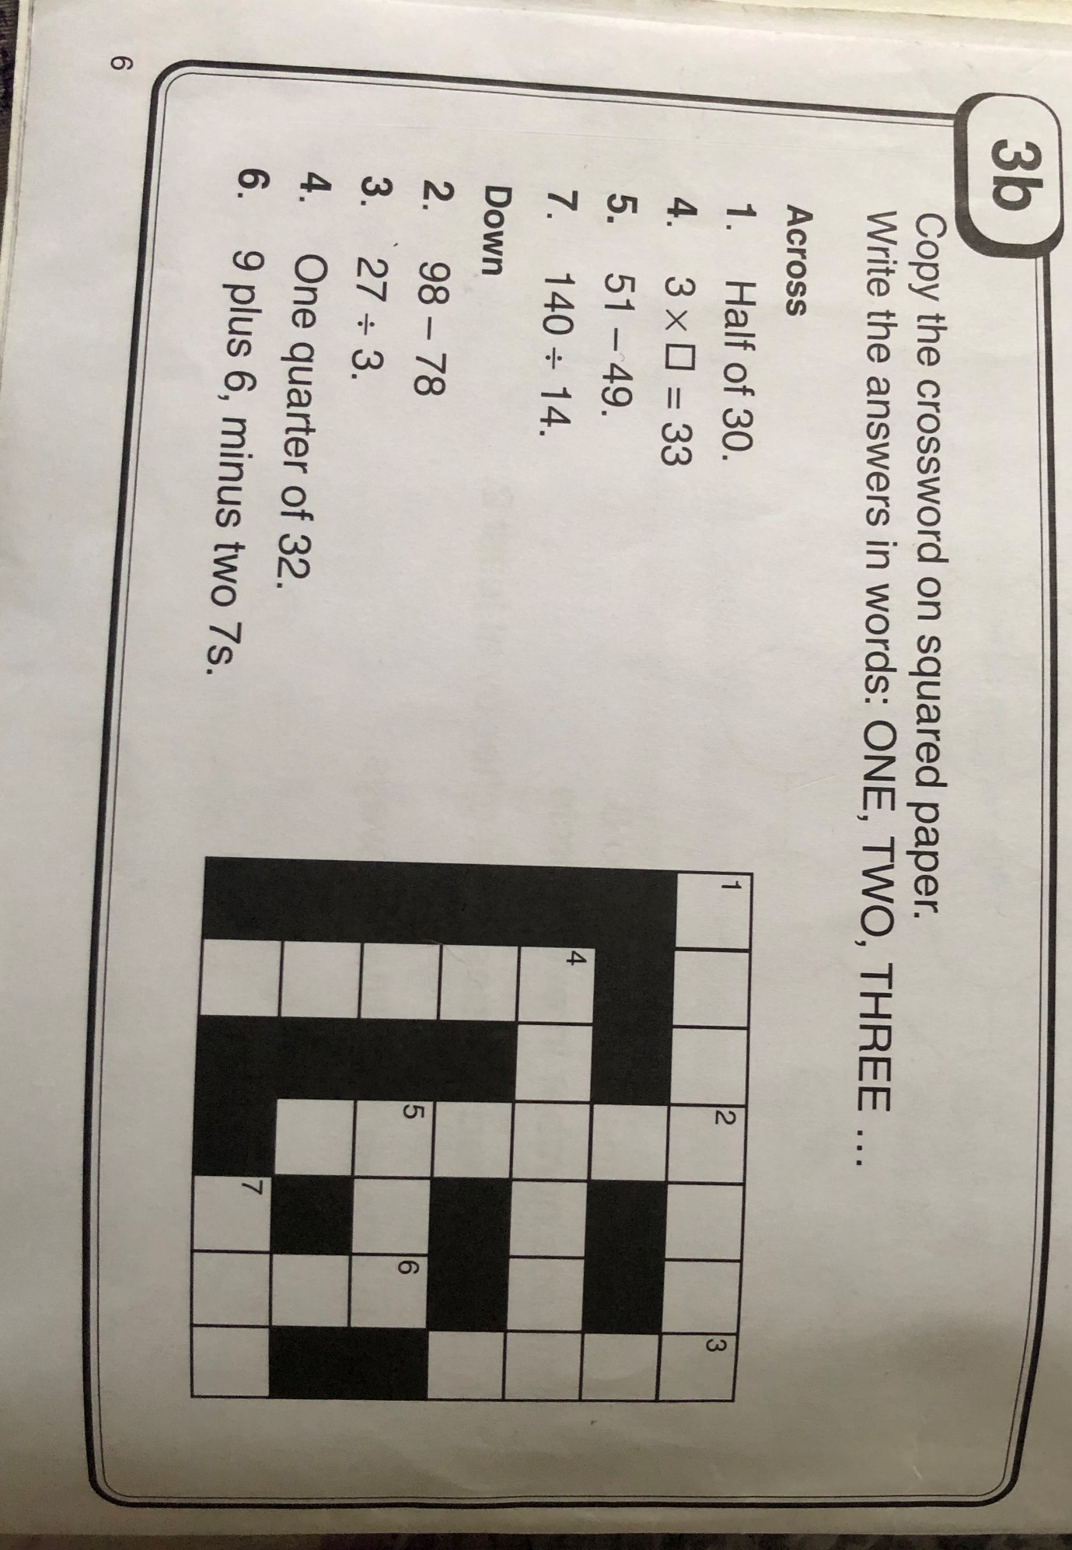
Problem solving – guessing and checking.
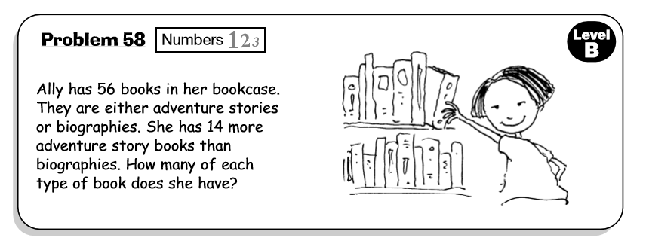
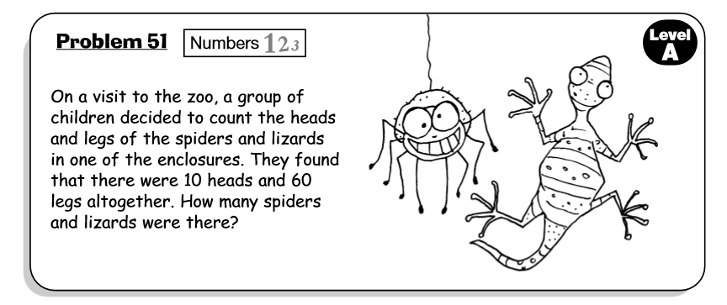
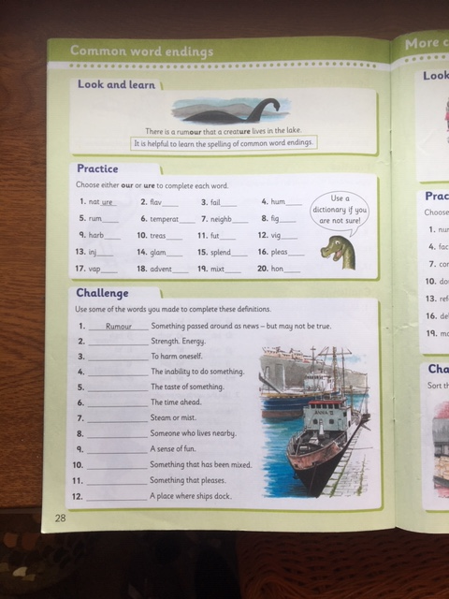
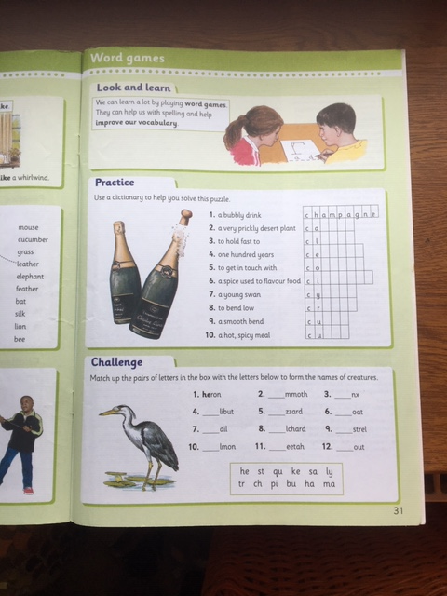
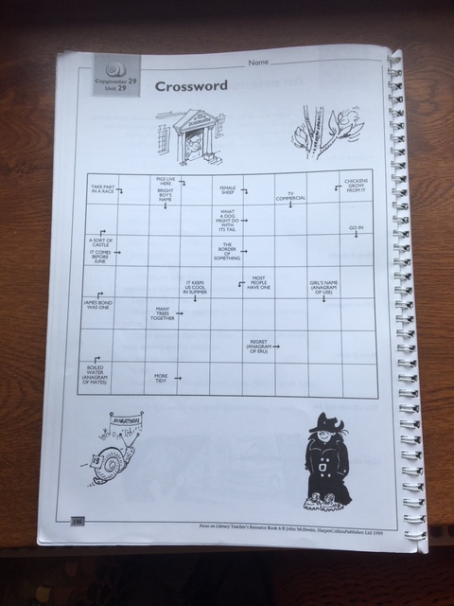

Interviewing a Friend or Family Member.

Think of some questions you could ask your friend or relative about how they have felt about being at home all this time and how they feel about returning to school or staying home. I’ve given you a few questions to get started. Add at least 5 more questions to your interview. Set it out like this:

Spongebob: So Patrick, how have you felt about being in Lockdown?
Patrick: Well, at the beginning I was quite excited about not going to school. I felt like I was on holiday. Then I started to get a bit bored.
Spongebob: What have you done to keep busy?
Patrick: Some weeks I’ve done some of the work packs and my parents have helped me. We’ve also been baking and I’ve kept in touch with my friends online.
Spongebob: What’s been the best /worst thing about having this time at home?

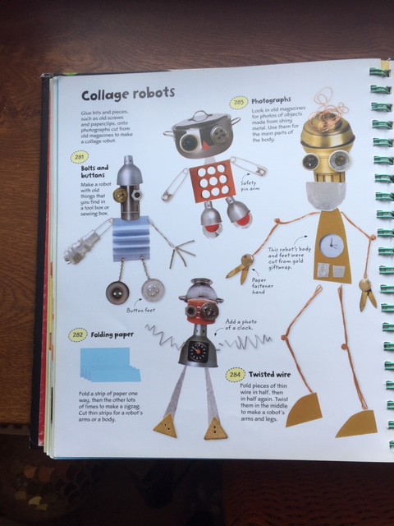
Art



