
Tantalising Teeth
Last week, we looked at teeth, their names and you had to discover their function.
What did your research uncover?

Match the tooth below with its function.
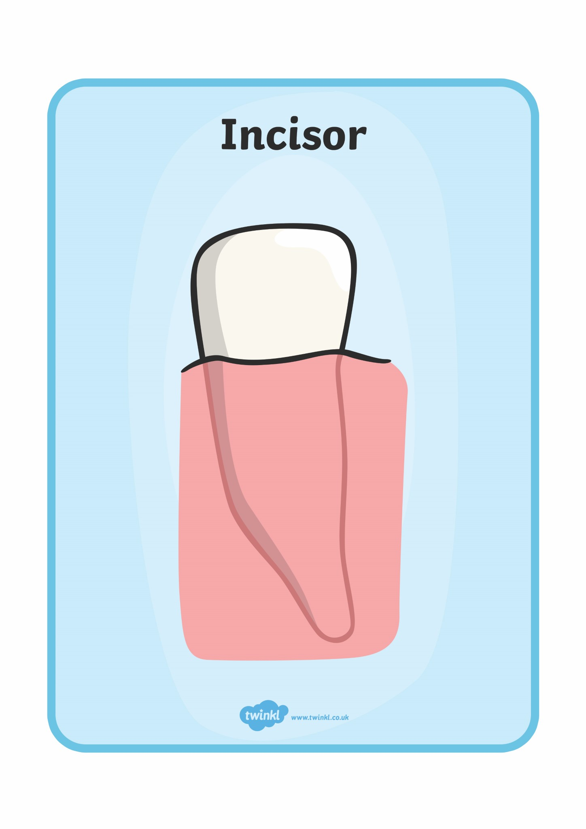
no function
Incisor

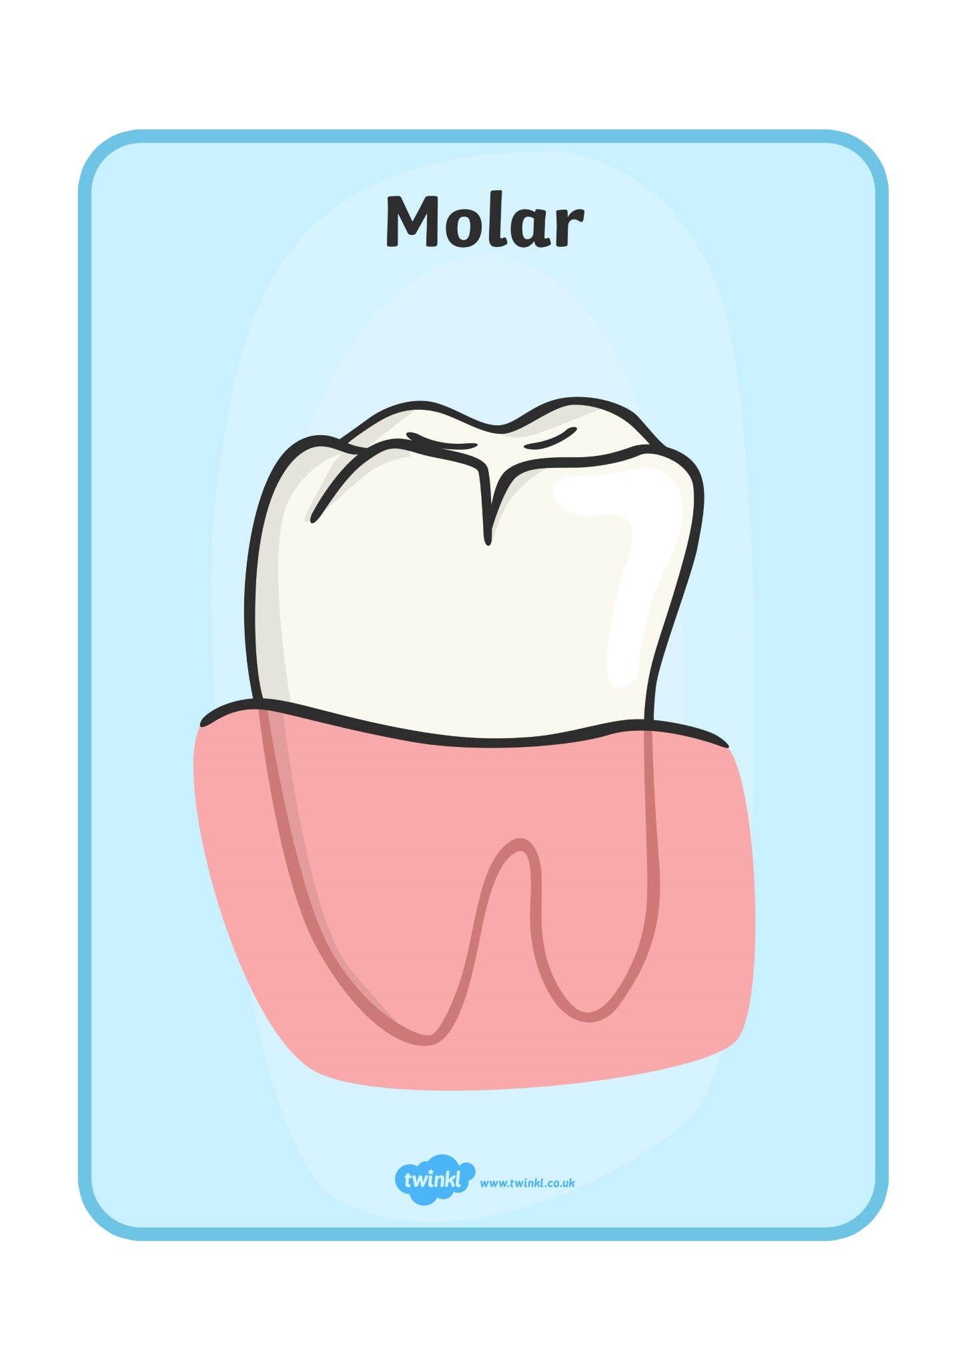
biting and cutting

Molar

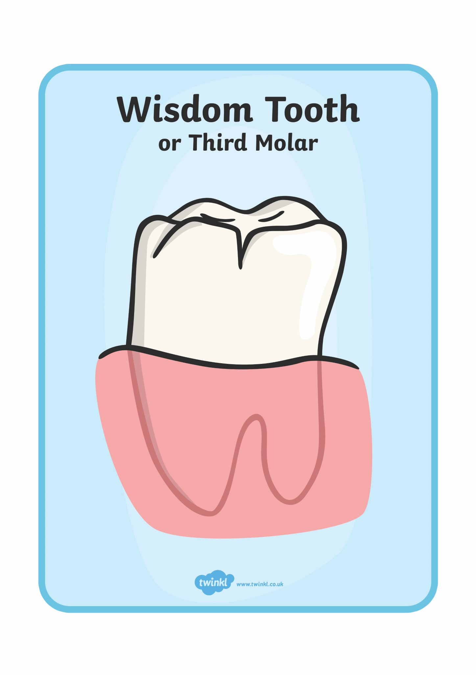
chewing and grinding

Wisdom Tooth
(or Third Molar)

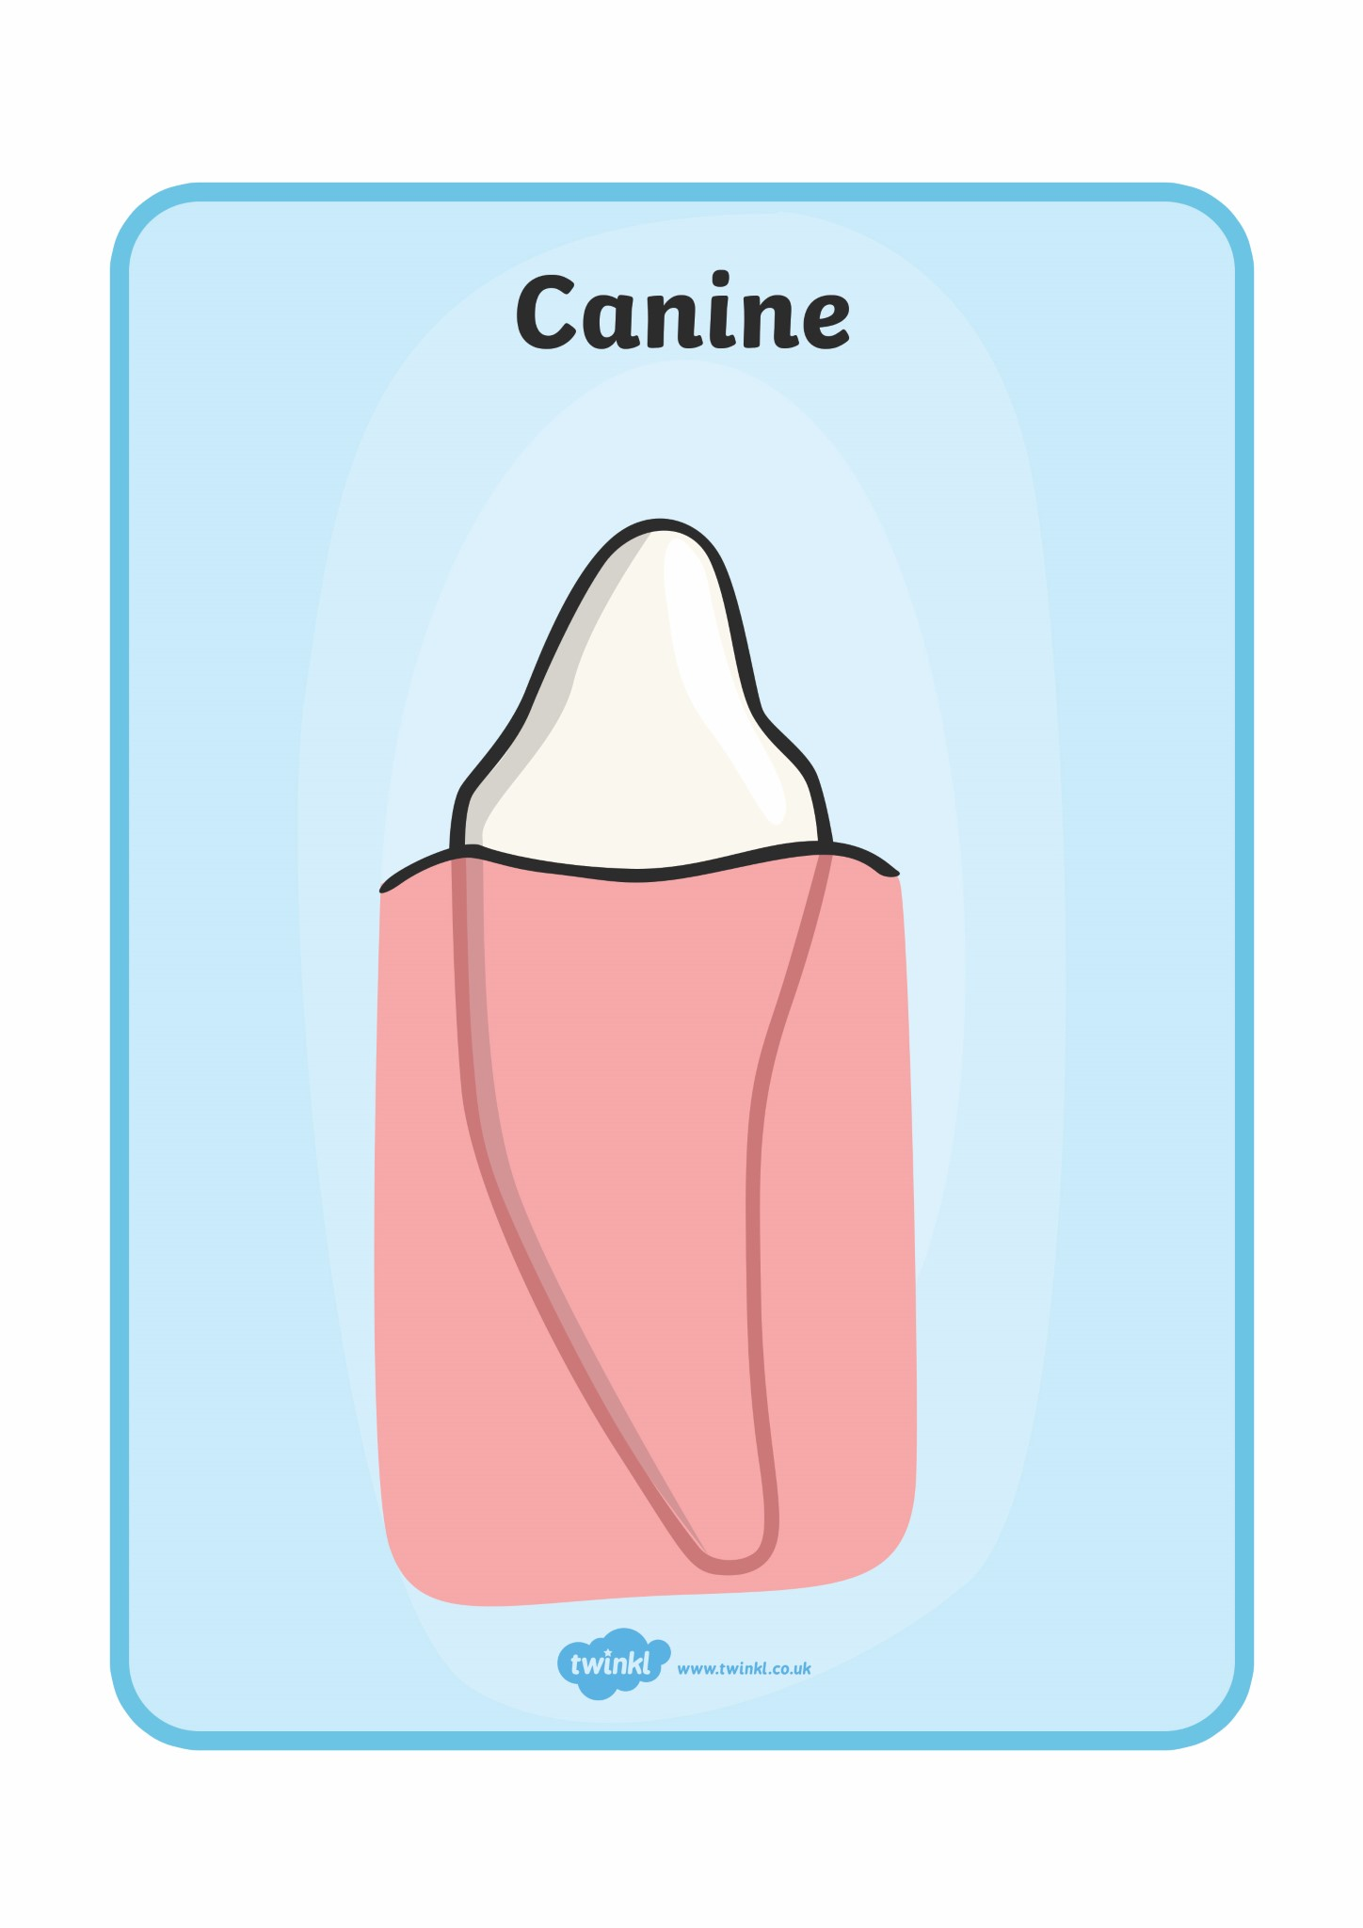
holding and crushing

Canine

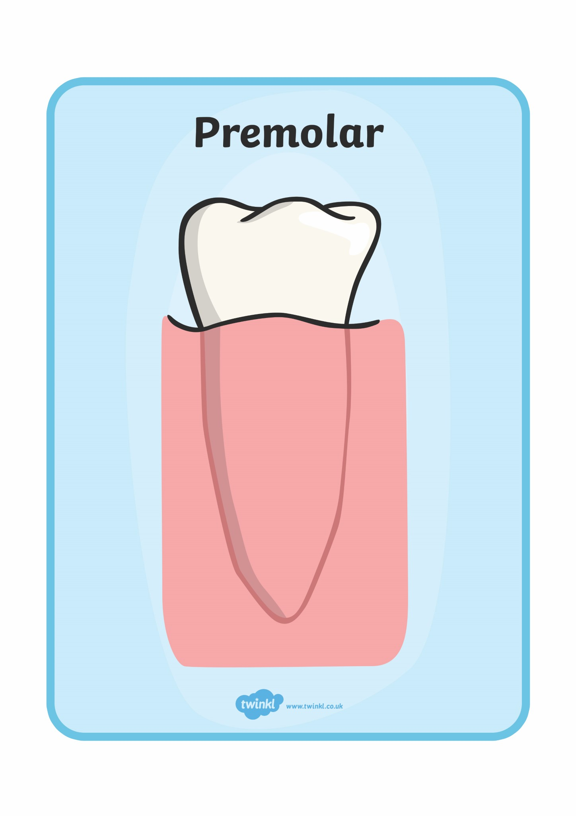
ripping and tearing

Pre-molar

Timer Challenge
In 30 seconds, write down as many ways as you can remember to care for your teeth.
30
seconds

How many could you think of?

Fact Challenge
Can you find 5 interesting facts about teeth?
Number | Interesting Fact
1

2

3

4

5

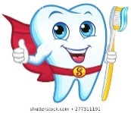
Don’t forget, if you find more facts write them down too!

Inside a tooth
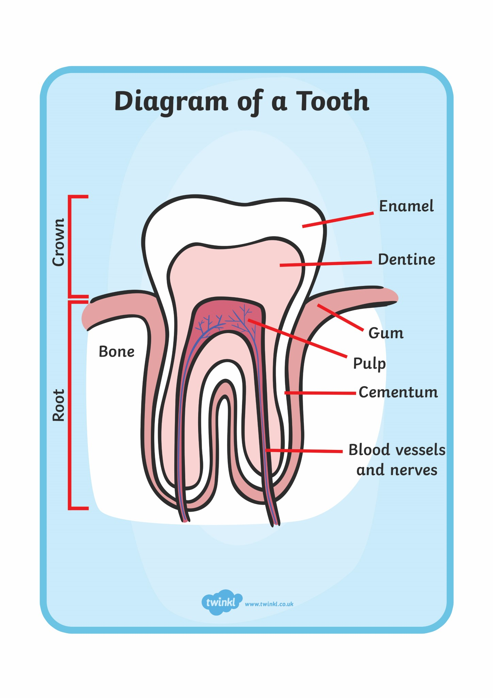
Here is a diagram of the inside of a tooth. Each part has its own importance. You will see that the part of the tooth you can see above the gum is called the crown. The root is the part of the tooth that is hidden under the gum.

What can you tell me about the …
enamel

dentine

gum

pulp

cementum

blood vessels and nerves

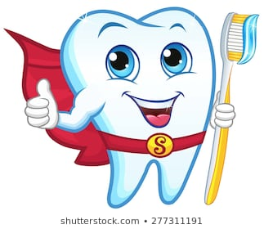
Mrs Davies’ interesting fact
In Elizabethan times, it was fashionable for women to blacken their teeth. Sugar was a new ingredient at the time and was causing teeth to blacken and decay. As it was so expensive, black teeth became a sign of wealth.
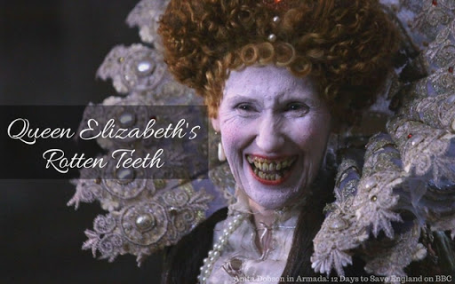

Looking at Elizabeth’s teeth, I wouldn’t forget to brush my teeth if I were you!

Locality Study
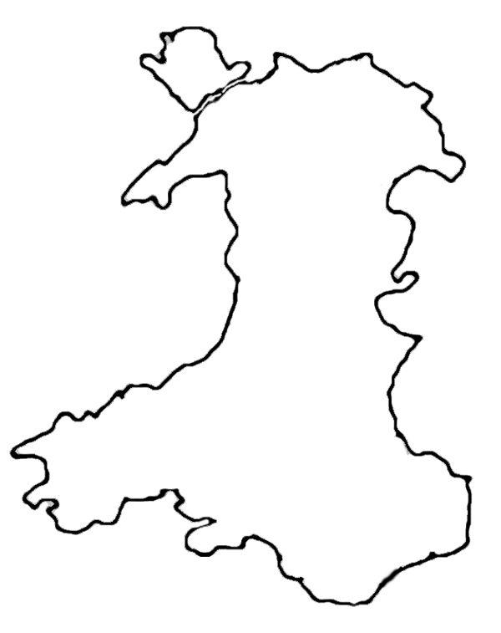
Astudiaeth Ardal
Cymru
Lloegr
England
Môr Iwerddon
Irish Sea
Dyma fap o Gymru.
Here is a map of Wales.
Ble mae Cwm Rhondda ar y map?
Where is the Rhondda Valley on the map? Mark it with a red dot and label it.
What other places do you know in Wales? Mark and label these too.
Cwm Rhondda
The Rhondda Valleys

Let’s research!

The Rhondda Valleys are most famous for their coal mining history.
What three interesting facts can you tell me about their history?

- _____________________________________________________________________________________________________________________________________________

- _____________________________________________________________________________________________________________________________________________

- _____________________________________________________________________________________________________________________________________________

The Rhondda was, and is, also celebrated for its Male Voice Choir.
What can you tell me about its Male Voice Choir?

Rhondda Fawr and Rhondda Fach
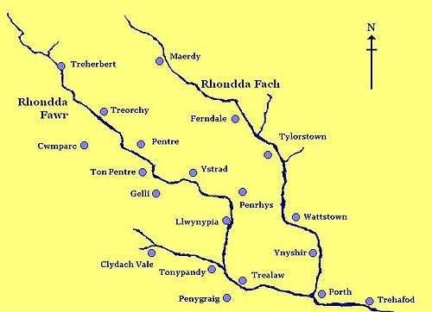

The River Rhondda (Afon Rhondda) has two major tributaries (a tributary is a stream or small river that flows into a larger river). The tributaries are called the Rhondda Fawr and the Rhondda Fach.
The map above shows the tributaries.
Answer these questions.
- Roughly, where is the source (the start) of the Rhondda Fawr?
____________________________________________________________________________________________

- Roughly, where is the source (the start) of the Rhondda Fach?
____________________________________________________________________________________________
- Where do the Rhondda Fawr and the Rhondda Fach join the River Rhondda?
____________________________________________________________________________________________

- Near which village does a small tributary begin?
______________________________________________

- Looking at the map, list the villages of the Rhondda Fawr and the Rhondda Fach...
Rhondda Fach

Rhondda Fawr
- Where do you live?
________________________________________________________________________________________________________________________________________________________________________________________
Next week, we’ll learn a little more about our valley home. If you can, take the opportunity this week, on your daily exercise, to visit the river near you. Take some photos and upload them to share with your friends.

Just because….
This week’s kindness challenge should set your imagination flowing. Again, it involves thinking of others before ourselves.

Draw a picture, create a gift, bake a cake or write a poem for an elderly person in your street.

Many older people are desperately missing those they love the most, especially their grandchildren.
If you create something for them,
it is sure to cheer them up!
Knowing you’ve helped make someone happy,
will cheer you up too!



Take care, enjoy learning
and have a great week!

