Reception – Summer 2- Week 4
Topic – The seaside

Hi, everyone. It has been great to see everyone’s work who has sent something this week, When you have completed a task even if you do not take a picture of it selected handed in so we know you have done the task. there is a lot on google classroom and no pressure to complete it all do what you can do. If you are returning to school, we will go over the work with you and explain to you what is going to be put on here the following week. This week (beg 22nd June) we are continuing to learn through our seaside topic. We will also be doing some PSE things about returning to school to help you feel relaxed about coming back!

Love to all! Mrs Brown x

Literacy – Speaking and Listening

With us going back to school soon, we need to practise our listening skills as we have been out of the classroom for a long time.
I have attached a link which sings songs about the seaside and tells you a story. you have to listen and then can tell someone else all about it after. Sometimes we forget how important our listening skills are.
There are lots of questions in the little video recording to answer, so listening ears at the ready!

https://www.bbc.co.uk/teach/school-radio/eyfs-listen-and-play-at-the-seaside/zvyf6v4

A Seaside Poem

This week we are going to make up and write short seaside poems.

You will need an adult to help you. We are doing a sentence on each of our senses. My example is underneath. Use the seaside word mat to help you with ideas.

Poem seaside

I can see
I can hear
I can smell
I can taste
I can feel

Mrs Browns Seaside poem

I can see the sea
I can hear the waves crashing
I can smell the seaweed
I can taste the ice cream and sauce
I can feel the sand between my toes

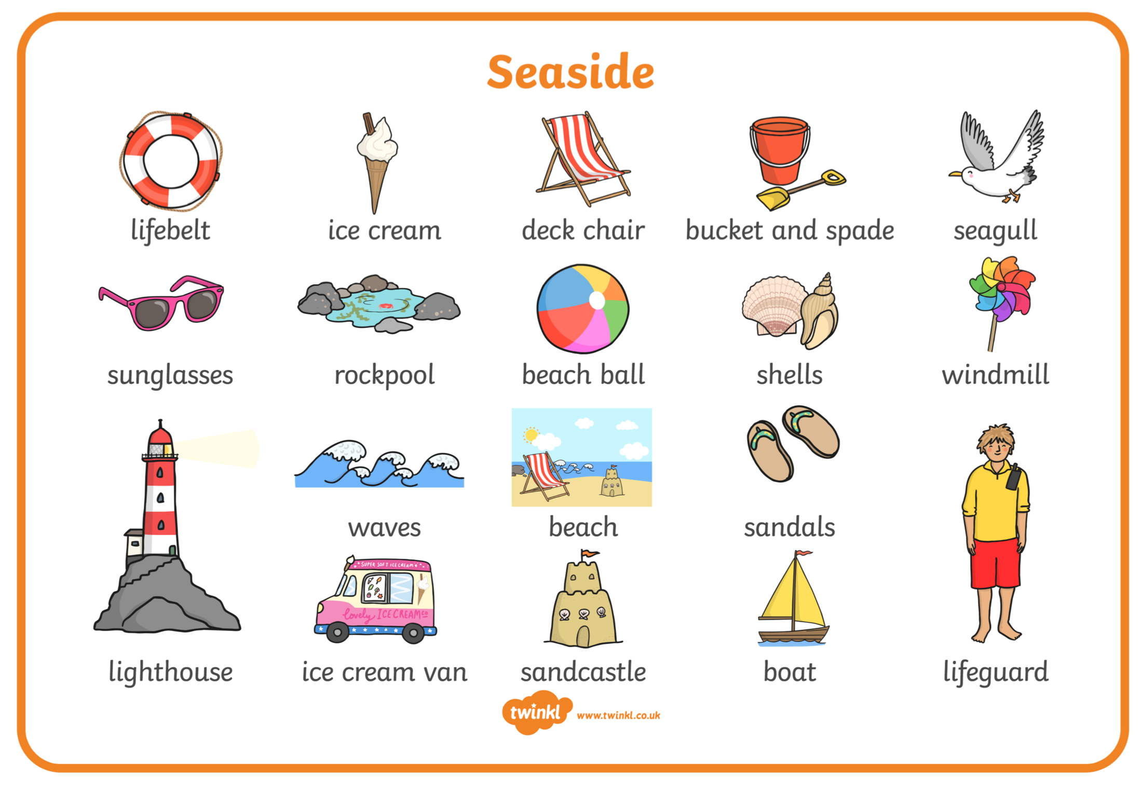

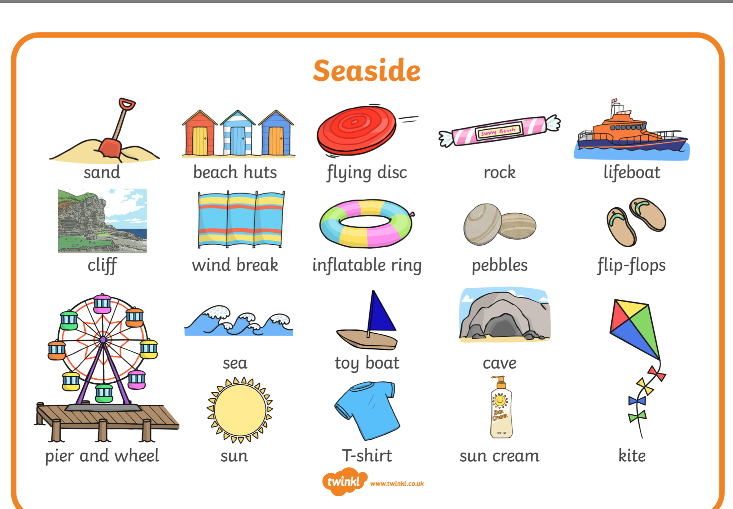
Numeracy/ maths
In September you will be going to Year 1, in year 1 your teacher will want you to be accurate with your counting.
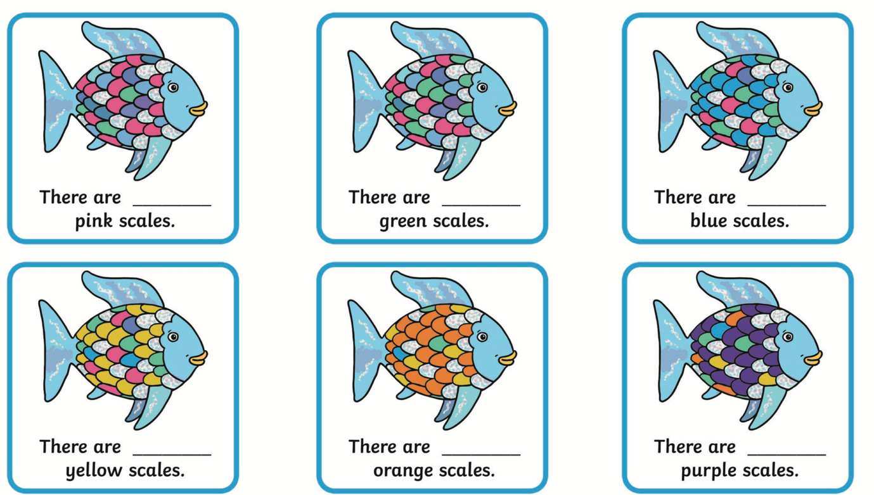
So, we are going to try some really careful counting of these fish scales.

This activity you have to use two numeracy skills. 1. Careful counting of the fish and 2. adding the number to the amount of fish. So, counting and addition. Along with counting and adding you also need to be able to recognise the numbers and record your answers using the correct formations. My, my lots of concentration needed to complete this, good luck!

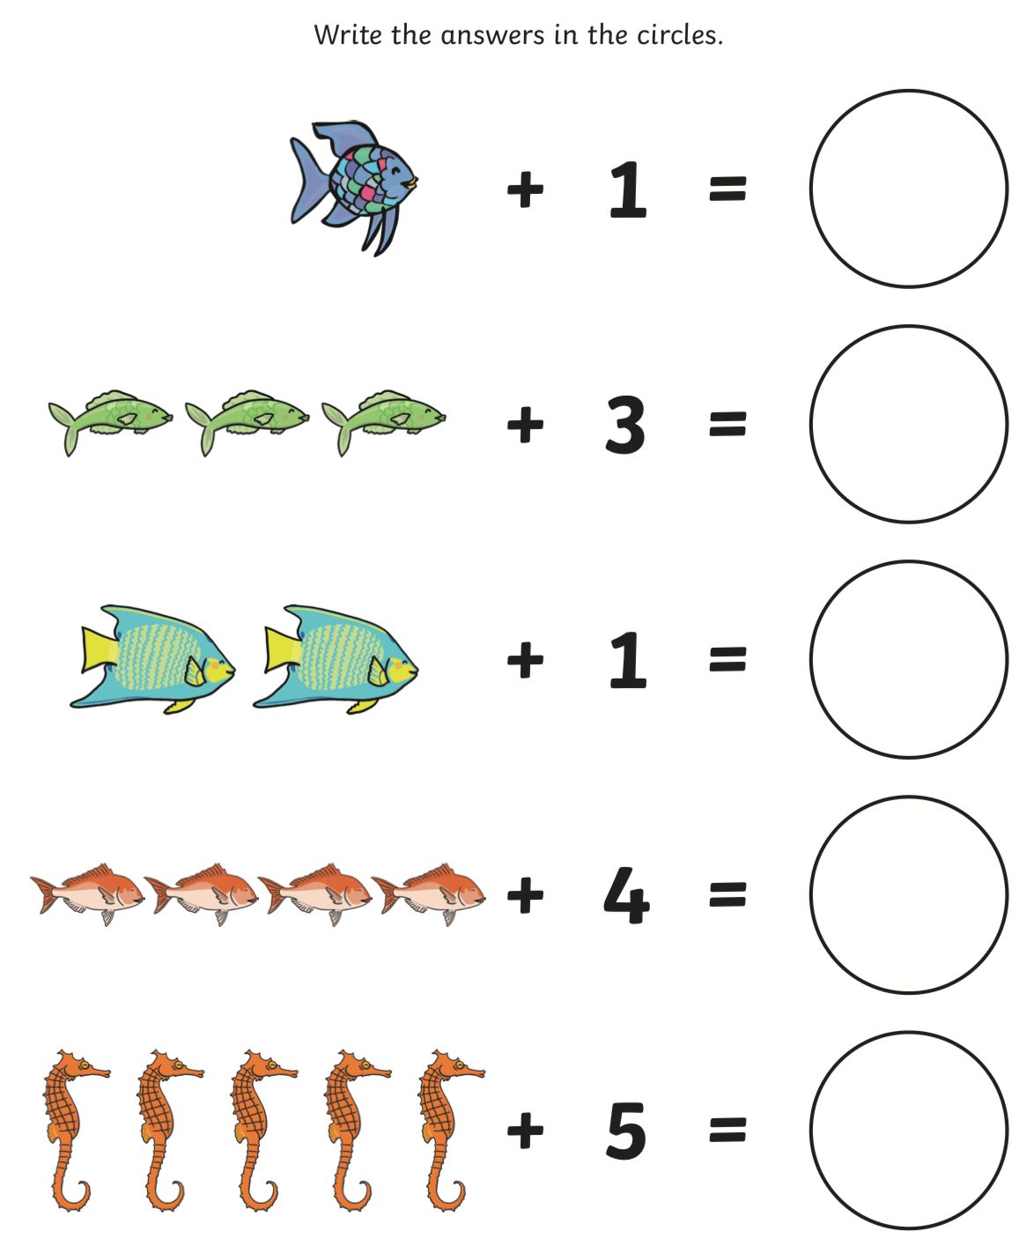
SEASIDE PATTERNS

Can you complete the seaside repeating patterns?
Once you have completed them and had them checked can you design the beginning of a pattern for someone else to finish?

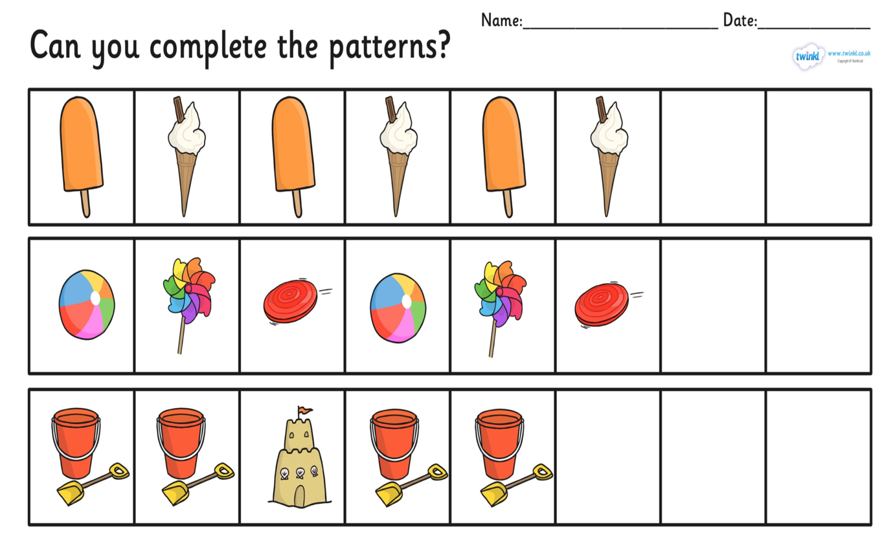

Creative / Topic

Beach huts

We do not see beach huts as much as we used to. At Barry Island there are new beach huts which can be rented out.

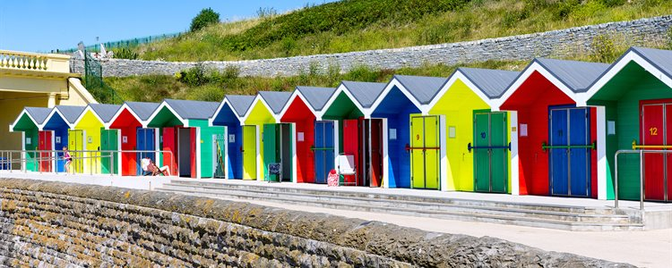
Barry Island Beach Huts

What are they used for:

For people to change into their swimming wear.
To keep food and drinks.
To sit outside on chairs and relax.
To keep all your beach supplies such as sun cream.
To seek shade from the sun.

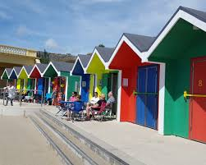

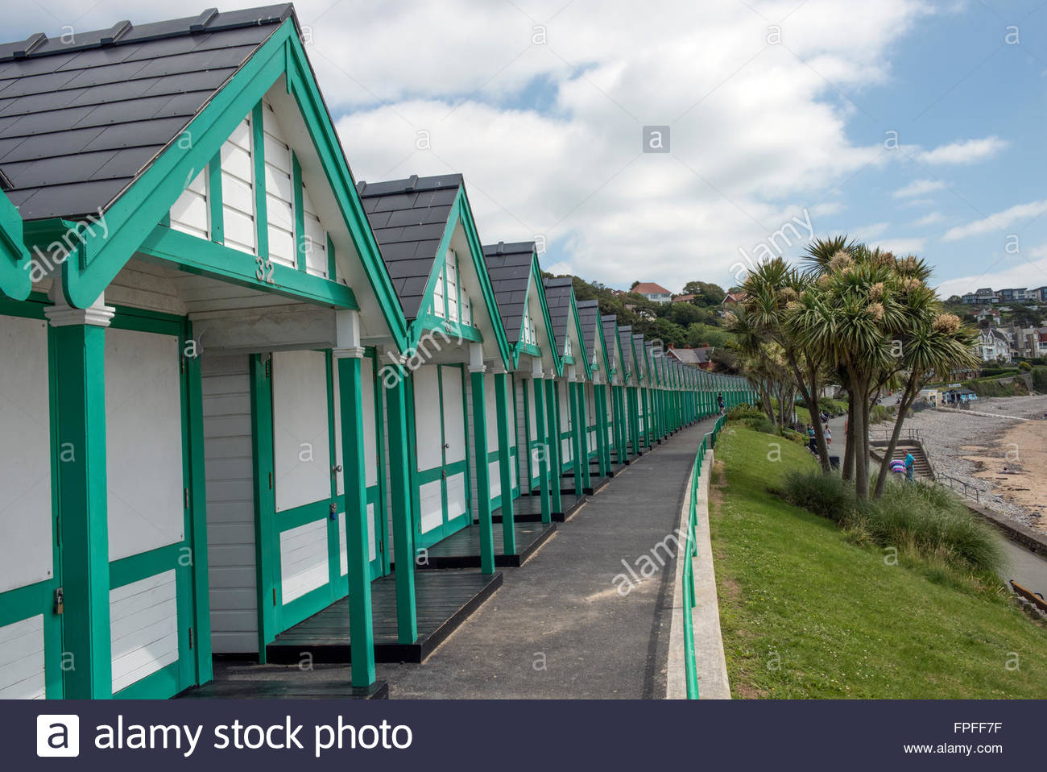

The beach huts in Langland Bay in the Gower.

Some beach huts have electricity so you can have a little fridge and microwave and do some cooking.
What would you have in your beach hut?
This week’s topics task is to design your own beach hut outside and inside.

Think about: The outside and inside design



