Williamstown Primary

Home School Learning Pack Year 3 W-C 22/6/2020

Useful Websites
TWINKL- free code 1 month = PARENTSTWINKLHELPS
BBC BITESIZE TOPMARKS- Hit the button
SCHOLASTIC HWB
Hello Year 3, I hope you are all safe and well, still working hard but also having as much fun as possible
Here is your new pack for this week including English work, spellings, and maths challenges!
Try to use Google Classroom as much as you can if possible to shift away from the website workpacks.
Remember to keep reading, stay safe and keep in touch with your friends when you can
Looking forward to seeing you back at school next week!
Miss Thomas x

Around the World Research
This week I would like you to test your research skills. Please choose a country of your choice from around the world and create fact file on your chosen country. We are going to link this to our new topic and focus on foods and sport that relate to your chosen country.

Within your fact file I would like you to include:

- The name of the country you have chosen.
- WHY you have chosen that country. (Full sentences)
- Research foods that are produced there. How are the foods produced or grown? What foods are produced or grown?
- Are the foods healthy or unhealthy options? Do you like or dislike them?
- What sports are associated with that country? Do they have any famous athletes?
- 5 interesting facts about your chosen country.

Please include as much detail as you can.

Spellings
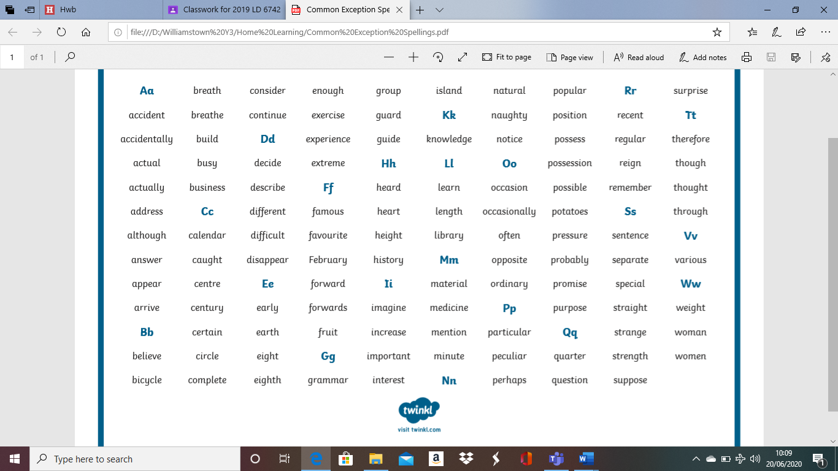
Please write each spelling 3 times and then use in a sentence.

The ‘Tyger Poem’ by William Blake
Please read the attached poem below 'The Tyger' by William Blake.
Then please complete the comprehension activity questions located in the separate file.

These questions are chilli challenged; hot medium and mild. You may choose which one you would like to complete. However, please choose the same challenge level that you would normally complete in class to ensure you are challenging yourself appropriately.

Hot 3 stars
Medium 2 stars
Mild 1 star

Please answer in FULL SENTENCES.

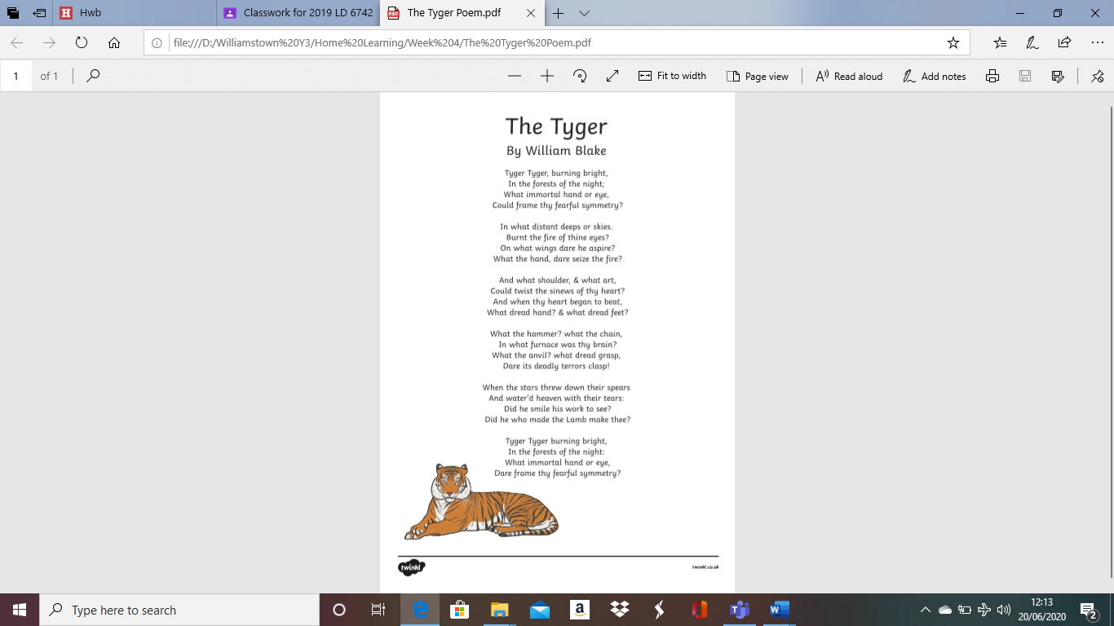
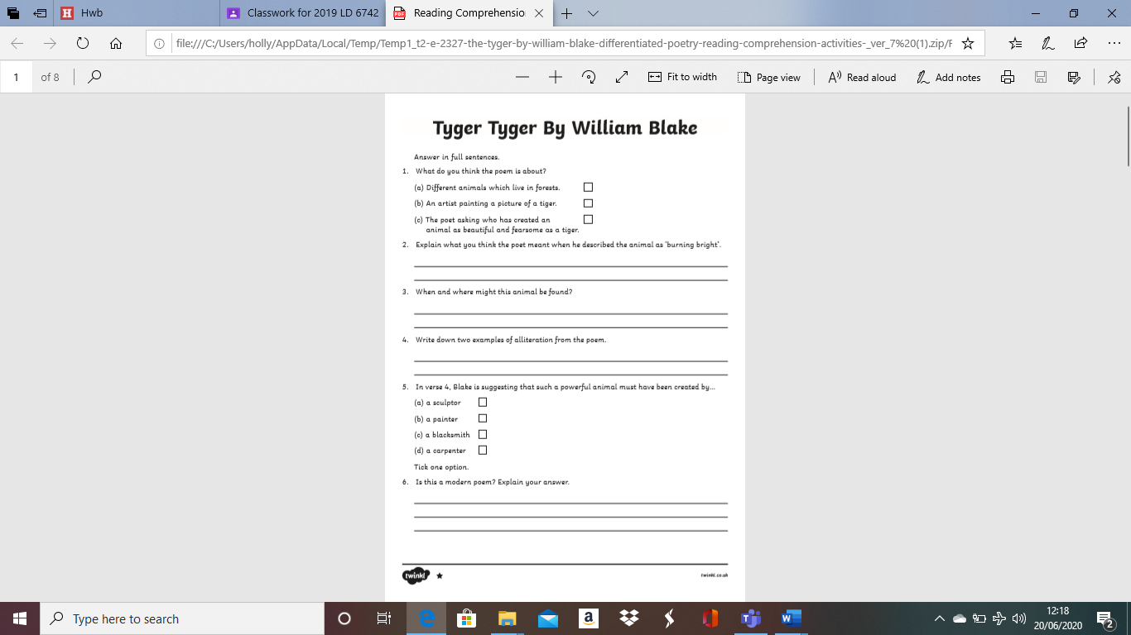
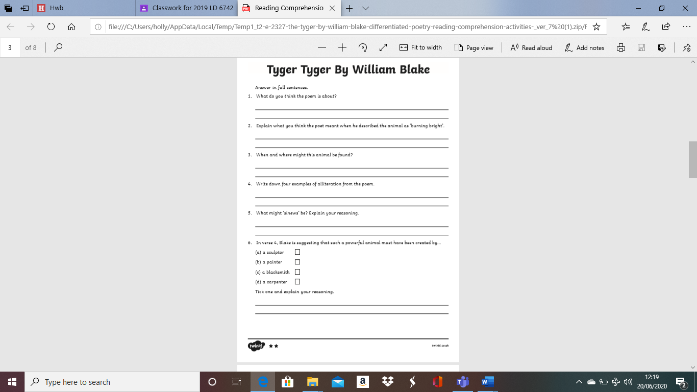
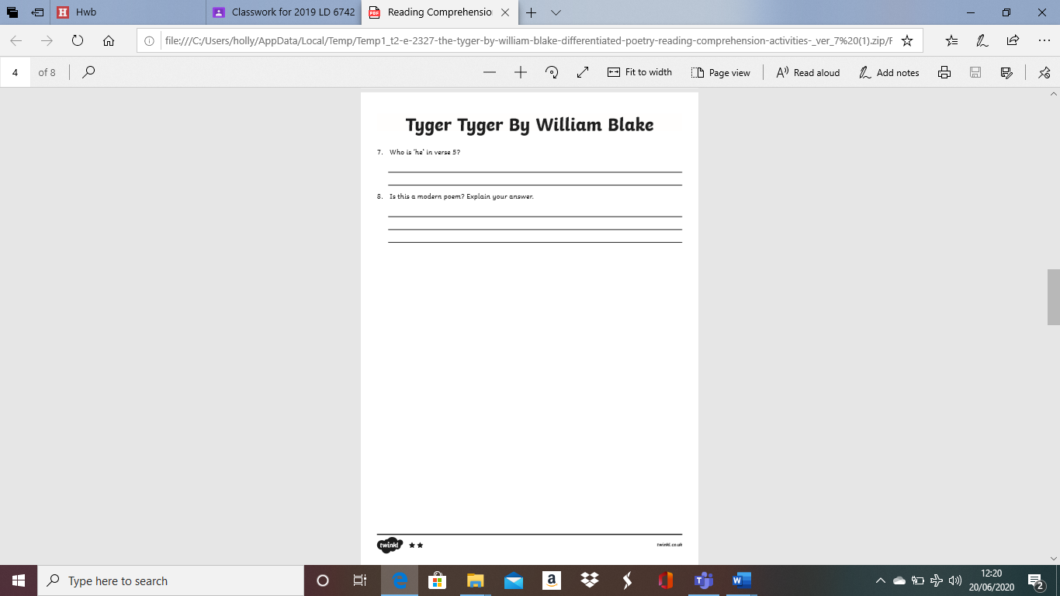
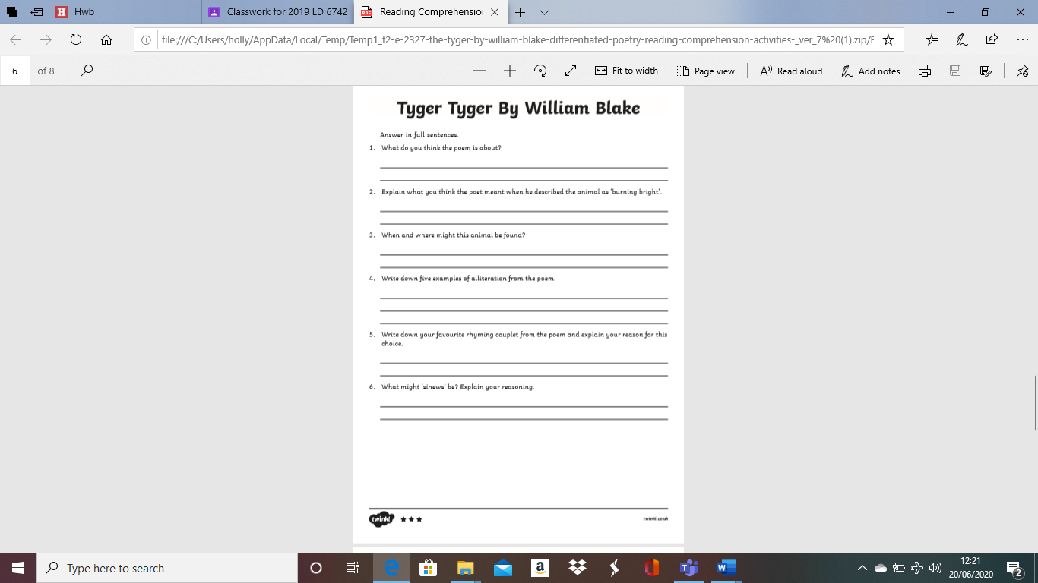
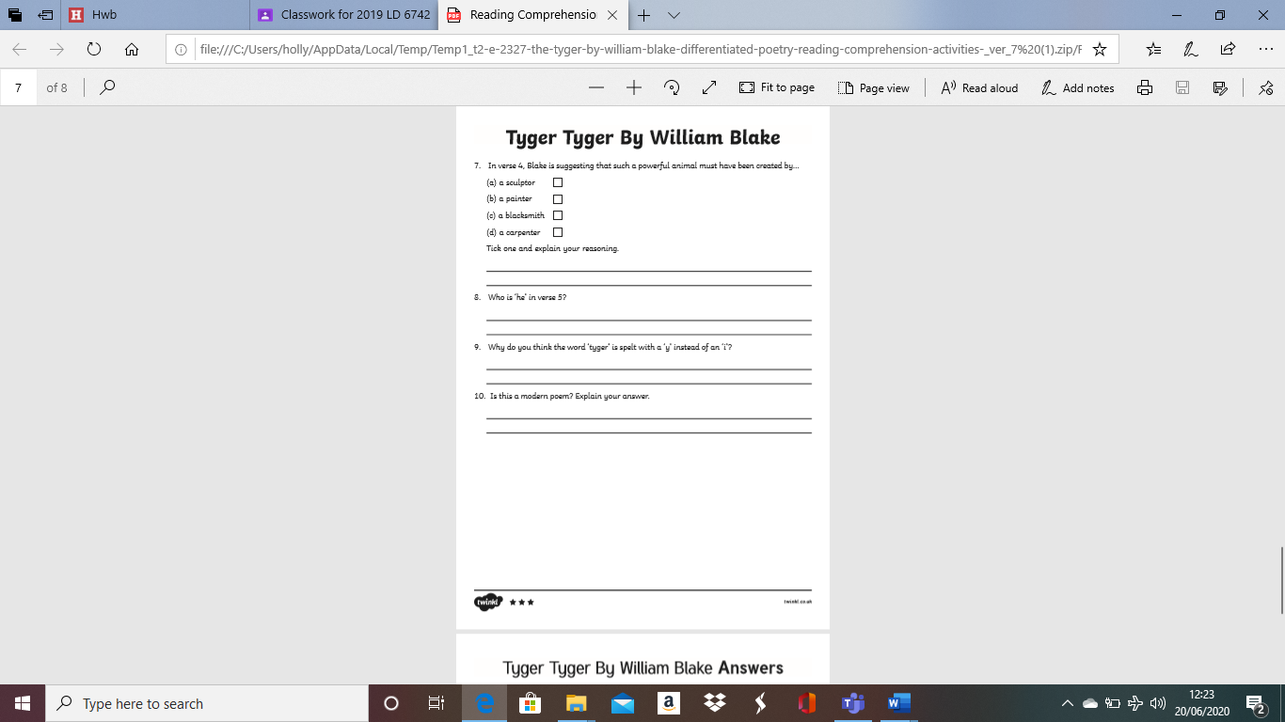
Please complete the worksheet below on similes and metaphors.

Once completed you have an extra chilli challenge:
Mild: Create 3 similes and 3 metaphors of your own.
Medium: Create 5 similes and 5 metaphors of your own.
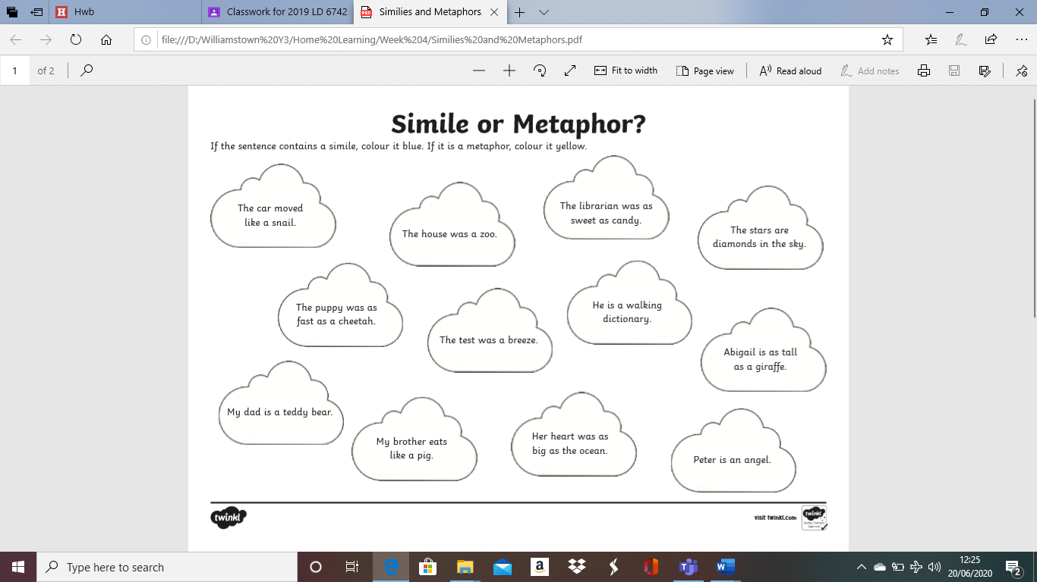
Hot: Create 7 similes and 7 metaphors of your own.
BBC BITESIZE ENGLISH
Please complete the two BBC Bitesize activities below. Both based on poetry.
https://www.bbc.co.uk/bitesize/articles/zm4csk7

https://www.bbc.co.uk/bitesize/articles/zv3v6g8

Maths Magic
This week we are learning another new measuring skill. We are going to be looking at measuring capacity (liquids). You can measure large amounts of liquids in LITRES (l) and smaller amounts of liquids in MILLILITRES (ml).
Just try your best and have a go, practise makes perfect!
Use the capacity poster below to help you complete the reading scales worksheet. This worksheet is chilli challenged (hot medium and mild according to number of stars) you may choose which one you wish to complete.
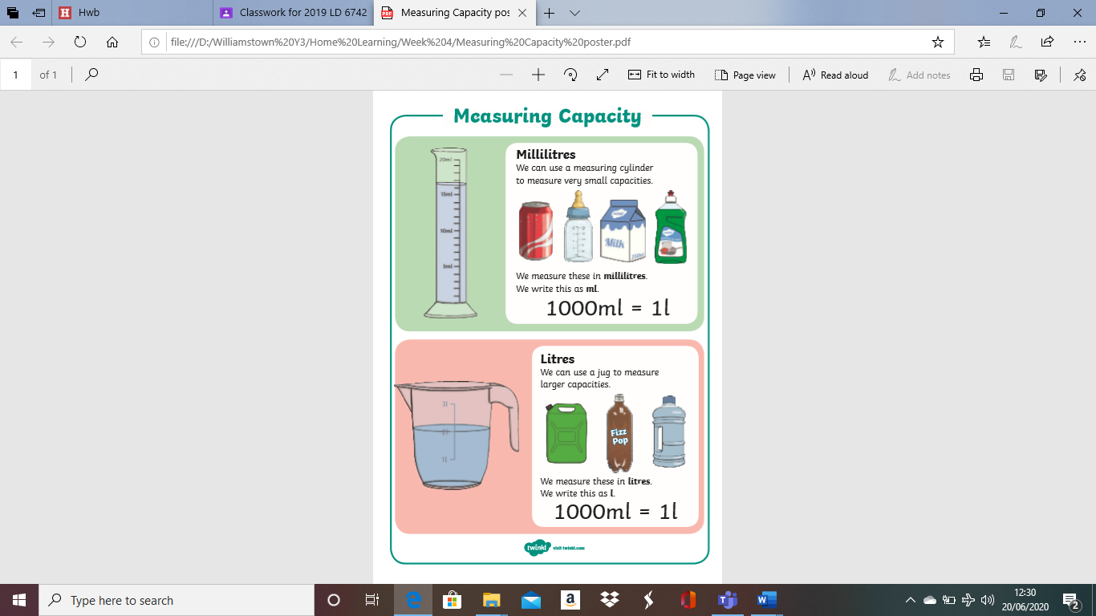
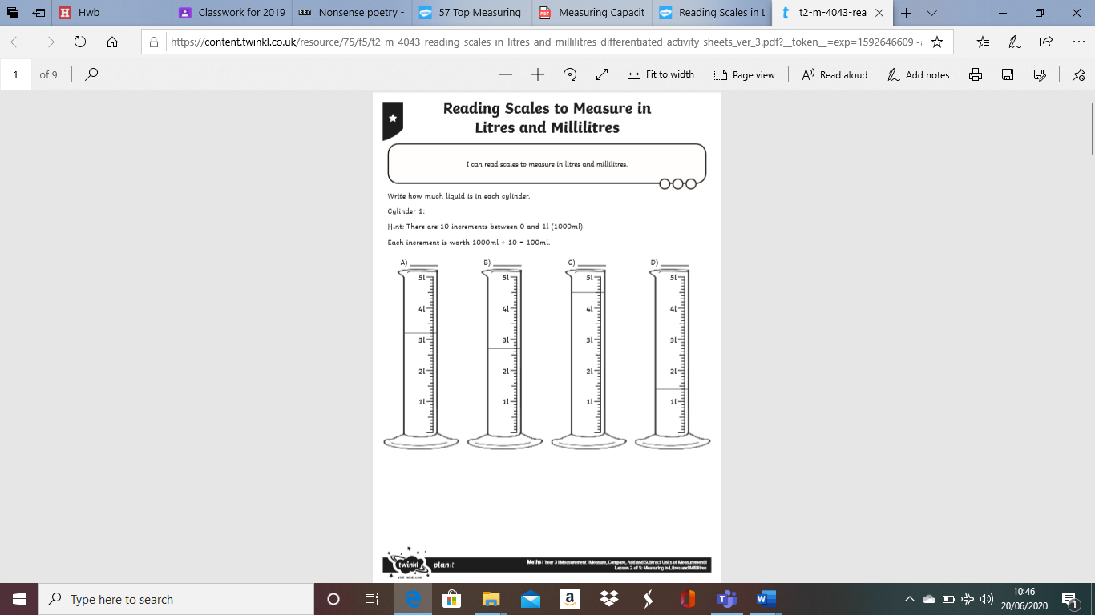
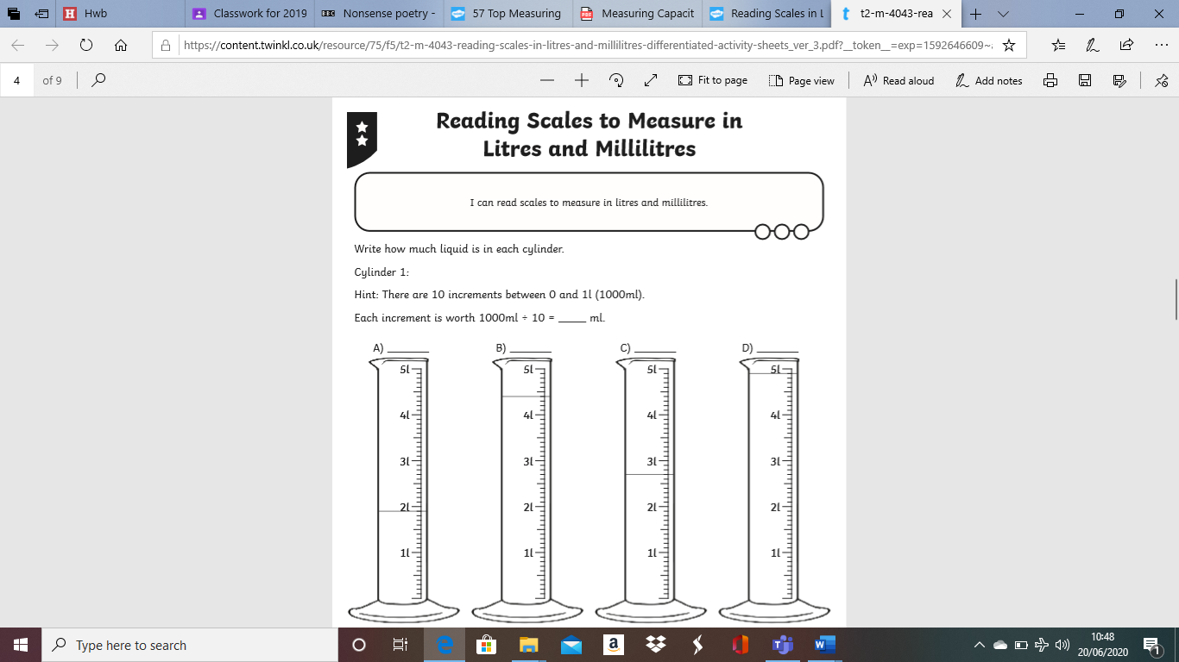
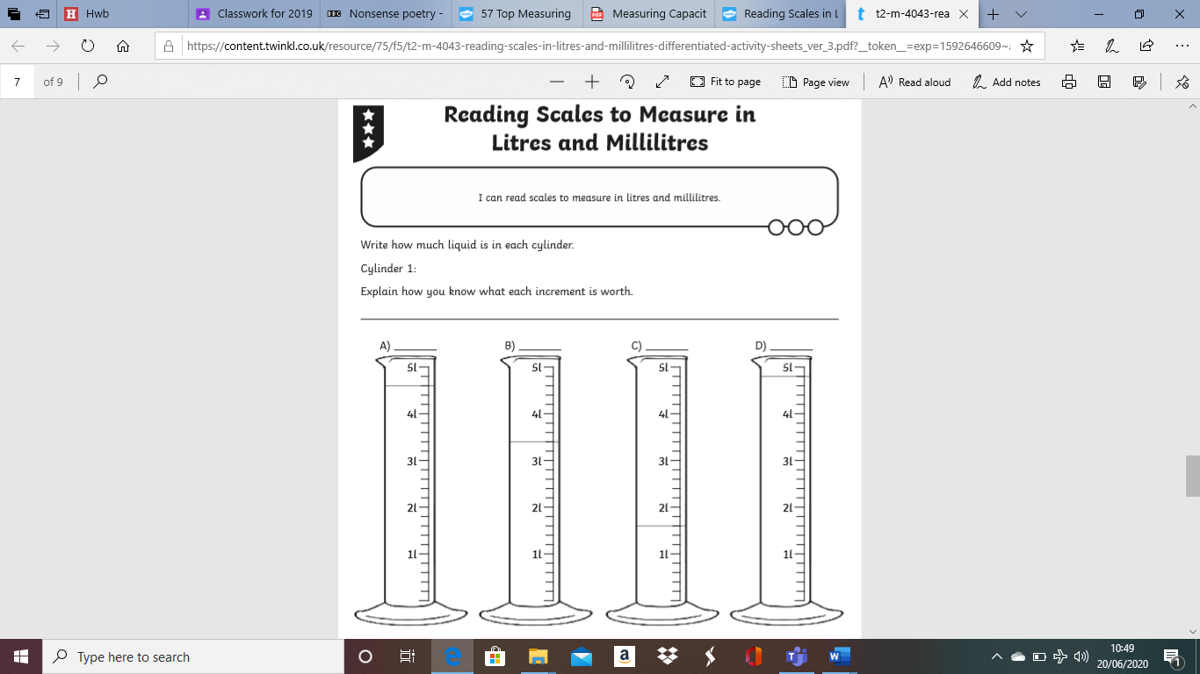
Have a go at this measuring capacity worksheet. You have to read the scales on each jug to measure the correct amount of water in each.
Chilli challenged; hot medium or mild.
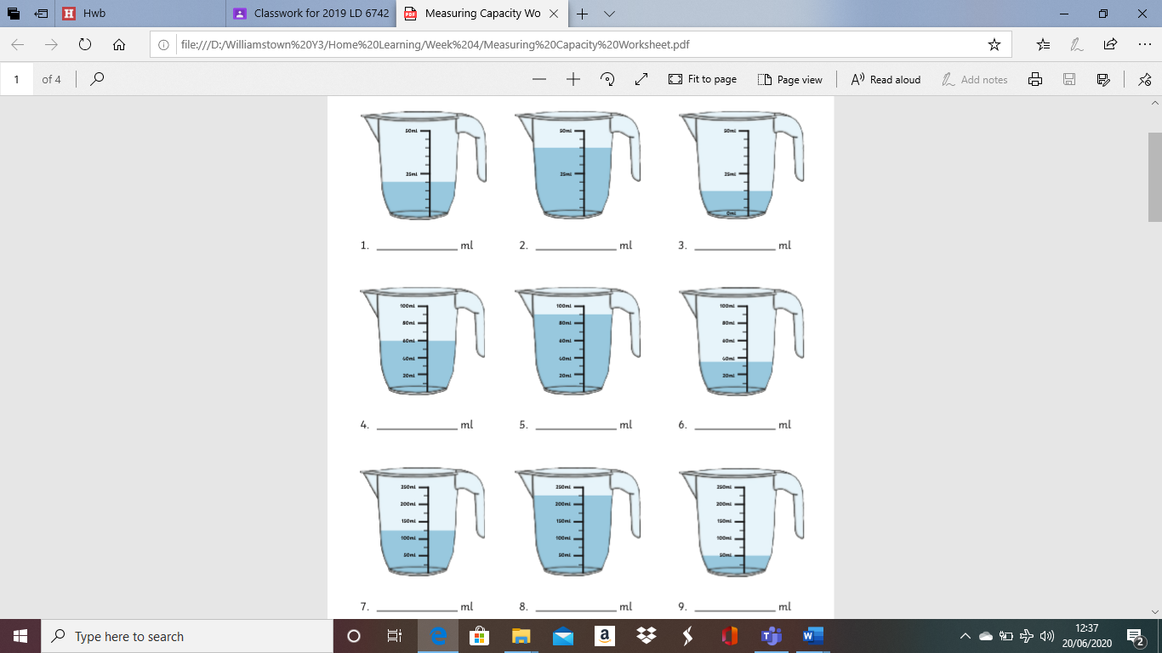
Mild
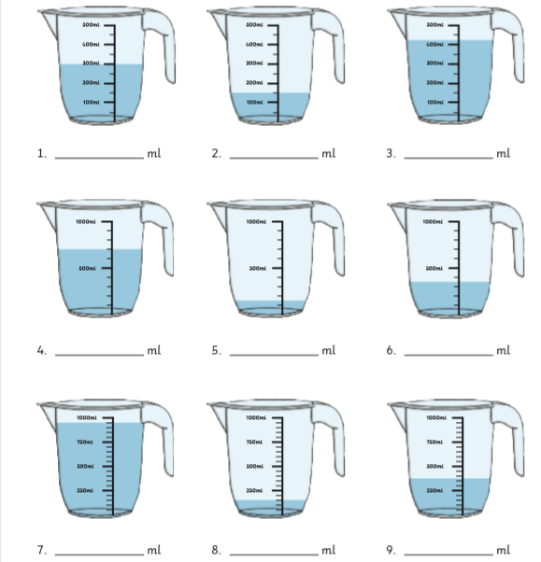
Medium

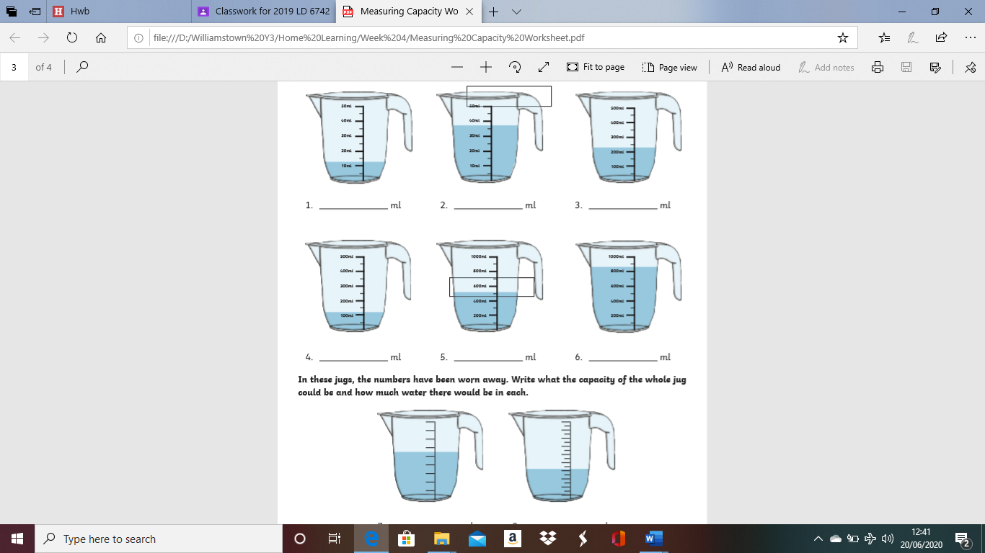
Hot
Please complete the capacity worksheet below.


