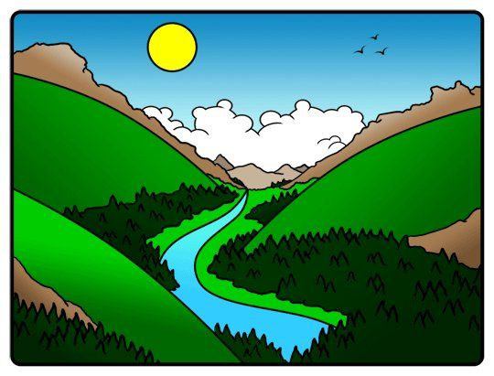
Wondrous Valleys

What is a valley?
A valley is a long depression, or ditch, in Earth’s surface. It usually lies between ranges of hills or mountains.
Geologists (Earth scientists who study our planet’s structure) say there are different types of valleys.

River Valleys
Most valleys are formed by rivers that erode, or wear down, soil and rocks. This process takes thousands of years. River valleys are always changing. Rivers continually wear away the land through which they flow, gradually making the valleys deeper. These are called V-shaped valleys.
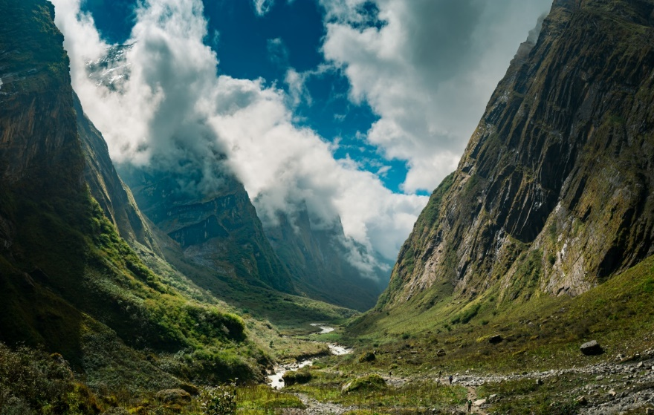

This valley is in the Annapurna Conservation Area, Nepal
Can you see the V shape in this valley? Draw it in.
Glacial Valleys
Not all valleys are formed by rivers. Some valleys are formed by huge, slowly moving bodies of ice called glaciers. Thousands of years ago glaciers covered large parts of Earth’s surface. As the glaciers moved along, they scraped the land and carried away giant boulders and huge amounts of soil. They left valleys behind. These are called U-shaped valleys.
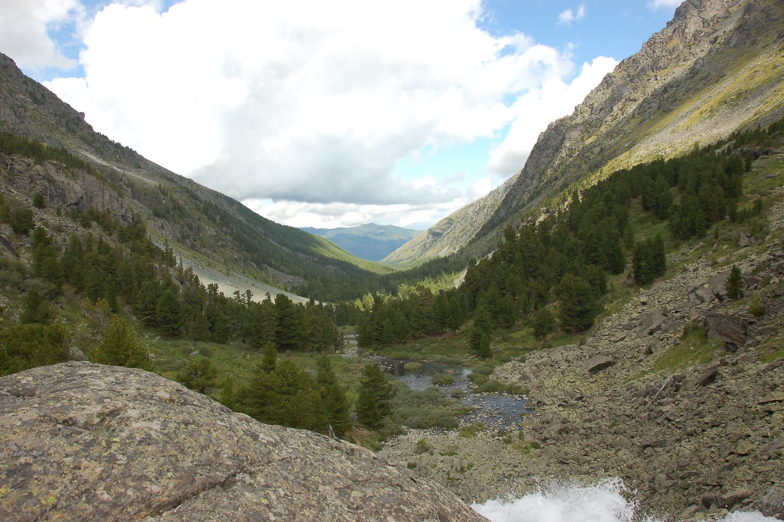

This valley is found in the Altai Mountains of East Asia,
Can you see the U shape in this valley? Draw it in.
The Rhondda Valley
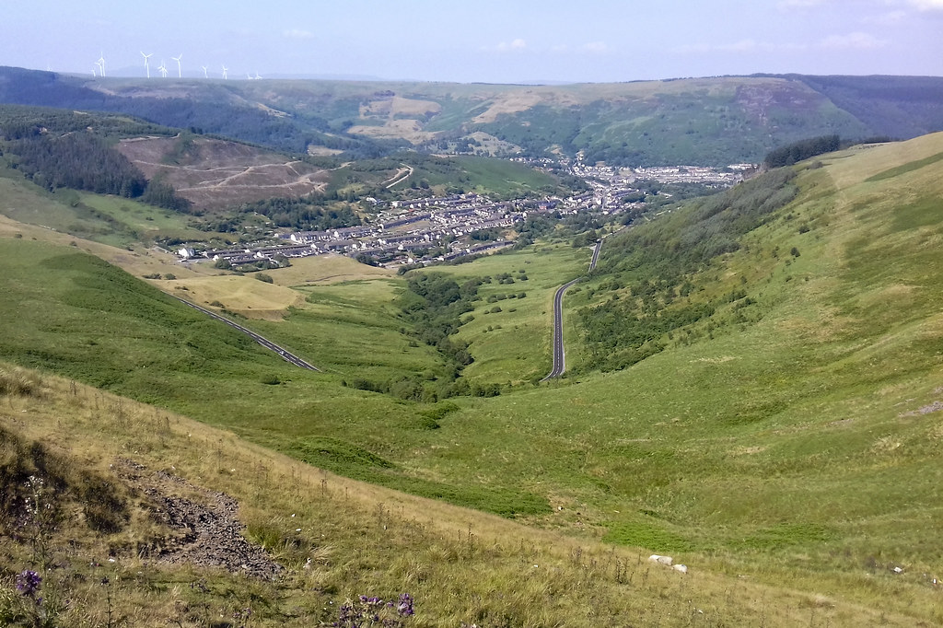
Look out of your window.
What can you see?

Our valley home is something extraordinary. Looking beyond what people have made such as houses and streets, we see the luscious green landscape of mountains, hills and trees all bursting with life. Here, in The Rhondda, we are never far away from wonderful landforms but…
What type of valley is The Rhondda?

Look at the landscape, what do you think. Draw the shape on the photograph, or trace the shape with your finger.
Geologists believe that our valley is the result of something incredible that happened thousands of years ago during the Ice Age - the slow movement of a huge glacier! It is hard to believe that our valley was once covered in ice!
So, is The Rhondda a V-shaped or U-shaped valley?
The Rhondda Valley

U-shaped!
slow moving glacier
U-shape

Look at the diagram below.
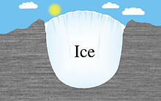

land

Thinking caps on!
Define (what is the meaning of) these words?
Word | Definition
valley

Geologist
erode
glacier
landscape

Answer the questions below as fully as you can using appropriate capital letters and full stops. Watch your handwriting too!

- What is a Geologist?
_____________________________________________________________________________________________________________________________________________________________________
- How would describe a valley?
_____________________________________________________________________________________________________________________________________________________________________
- How are most valleys formed?
_____________________________________________________________________________________________________________________________________________________________________
- What are these valleys called?
_____________________________________________________________________________________________________________________________________________________________________

- The Rhondda is a U-shaped valley. How is a U-shaped valley formed?
_____________________________________________________________________________________________________________________________________________________________________

Let’s Research!
Now it’s time for your own research.
Choose ONE topic form the list below OR one of your choice relating to valleys
- Geology (Earth science)
- U-shaped valleys of the world
- Why were valleys important to ancient civilisations

For Parents
http://www.onegeology.org/extra/kids/what_is.html
https://www.youtube.com/watch?v=f0pkIf2YbS0&t=29s valley formations
https://www.youtube.com/watch?v=loI584OFVpE glaciers
How the Draig Came to Fly for Wales
Press Ctrl and Click on the link below to watch and listen to the story.
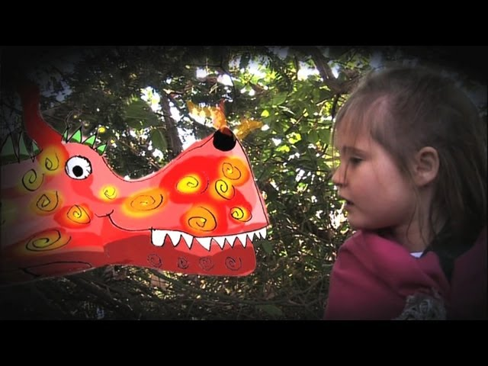
https://www.google.co.uk/url?sa=t&rct=j&q=&esrc=s&source=web&cd=&cad=rja&uact=8&ved=2ahUKEwiLorKA7I3qAhUMXsAKHc_pC-MQwqsBMAB6BAgKEAQ&url=https%3A%2F%2Fwww.youtube.com%2Fwatch%3Fv%3D2CuSNfYTcNE&usg=AOvVaw0i9PXO7Uz2pUyKNvZM6mV3

In the story, the character of Nia is incredibly brave – prickly thistles, slimy toads and hairy spiders are not something I’d enjoy!
However, it is her bravery by walking into the woods that ultimately saved the village. Realising that the Draig was not scary, just misunderstood changed everything.
The one thing the villagers blamed, ran away from and were scared by was the one thing that ultimately helped them and whom they came to love dearly.
Sometimes the unknown is scary, but taking a deep breath and stepping forward is all you need to do. It does not take long to realise how quickly friendships can be made and that they can last a lifetime and beyond.
Can you remember a time when you were particularly brave?
Where were you?
What happened?
Who were you with?
What did you have to do? When did it happen?
Why did it happen?
How did you feel after?


Now, write your story of how you faced your fears.

Just because….

This week’s kindness challenge is a REALLY BIG ASK!
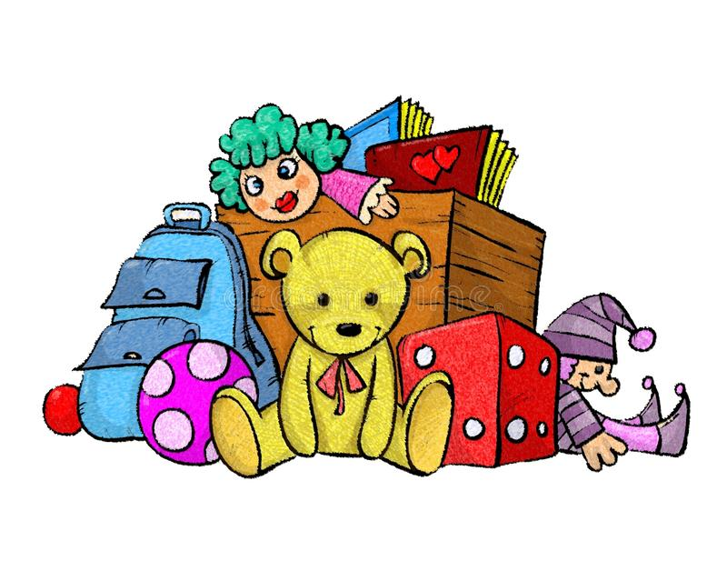

I imagine you have lots of toys. Some you play with all the time, some you play with now and then and some you don’t play with at all.


Think about the toys you don’t play with at all.

Maybe you are too old for them or maybe you’ve just outgrown them, for example you used to like Pokémon but now you don’t.

This week’s challenge is…


Choose at least one toy you don’t want anymore and set it aside to donate to charity. The charity can be one of your choice, there are so many charities to choose from. Choose one that is close to your heart – that means it has a special meaning to you and your family.

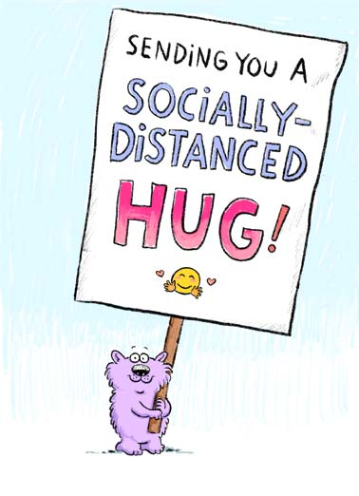


Have a great week!
See you soon!


