
G U I D A N C E

Williamstown Primary School


Managing Traffic Safety on School Premises

September 2025
Contents
Topic No | Description | Page No(s)
1. | Introduction | 1 - 2
2. | Site Access / Layout | 3
3. | Site Speed Limit | 4
4. | Reversing | 4
5. | Pedestrians | 4
6. | Staff | 5
7. | Pupils | 5 – 6
8. | Car Parks | 6
9. | Parents Dropping Off / Collecting Pupils | 7
10. | Visitors | 7
11. | Contractors / Deliveries / Waste & Recycling Collection / School Minibuses | 7 – 8
12. | Home to School Transport | 8
13. | Outside School | 9
14. | Supervision | 9
15. | Monitoring of Compliance Against this Plan | 9 – 10
16. | Reporting of On-site Traffic Incidents / Accidents | 10
Appendix 1 | Morning Drop Off Arrangements | 11 – 12
Appendix 2 | Afternoon Pick Up Arrangements | 13 - 14

1. | Introduction
 | Williamstown Primary School is a single site premises with complex vehicular procedures, peaking at the start and end of the school day. Vehicles present include staff cars, parent (and student) cars, contract buses, minibuses and taxis, delivery vehicles and contractor vehicles including, for example, refuse collection.
 | As with other aspects of health and safety it is important that vehicle movements on site are properly managed. In order to identify hazards associated with traffic management, the starting point for the Senior Leadership Team (SLT) was the undertaking of a risk assessment that identified the significant traffic hazards at the school. After further consideration the SLT, in consultation with Corporate Maintenance, Highways Department and the Council’s Corporate Health and Safety Team, identified control measures to ensure the risks are kept to a minimum. A copy of the risk assessment is available from the Head Teacher.
 | This Traffic Management Plan (TMP) has been prepared to inform and instruct employees, pupils and visitors concerning the site rules that the SLT deem suitable and sufficient to manage traffic movements at the school. The main objective is to keep people safe, principally by segregation of pedestrians and vehicles.
 | The SLT takes the health and safety of all site users very seriously. It is therefore imperative that individuals take care, exercise caution when in the school grounds or within the vicinity of the school grounds, and follow instructions to avoid risk of injury. If there are any concerns about traffic safety on or around the site, these should be reported to the Head Teacher.
 | The instructions contained within this TMP constitute site rules. Pupils and staff in breach of the site rules may be subject to disciplinary action. Staff will be provided with a copy of this TMP at induction, and at regular intervals as required. Pupils will be informed of the relevant parts at the start of the academic year or when they first enrol at the school if that falls outside of the start of the academic year. This is the responsibility of relevant Head of Year.
 | Relevant parts of this TMP will be used to inform parents, contactors, delivery companies, contracted bus services, kitchen staff, cleaning staff and other visitors of the traffic management arrangements at the school.
 | The school has no obligation to staff or parents to provide access to or parking facilities for their vehicles. The safest option for the school would be to close the vehicle gates to parents in order to reduce the amount of vehicle movements on the school grounds. However, the SLT recognises that the impact of closing the vehicle access gates will impact on the local community during busy periods and therefore the SLT has, instead, developed the control measures stated within this TMP. It should be noted that non-compliance with the site rules could involve prohibiting vehicular access to those not following the site rules, or even the closing of the vehicular gates to all.
 | An electronic copy of this TMP is accessible on the school website (insert here clear and specific instructions on how to access it).A hard copy is on display in the reception area. That copy should not be removed from display – additional copies are available at reception

2. | Site Access / Layout (this section should be used to provide a plan showing the traffic management measures at the school including, drop off points, crossings, exits, entrances, one way system etc.)

CVCV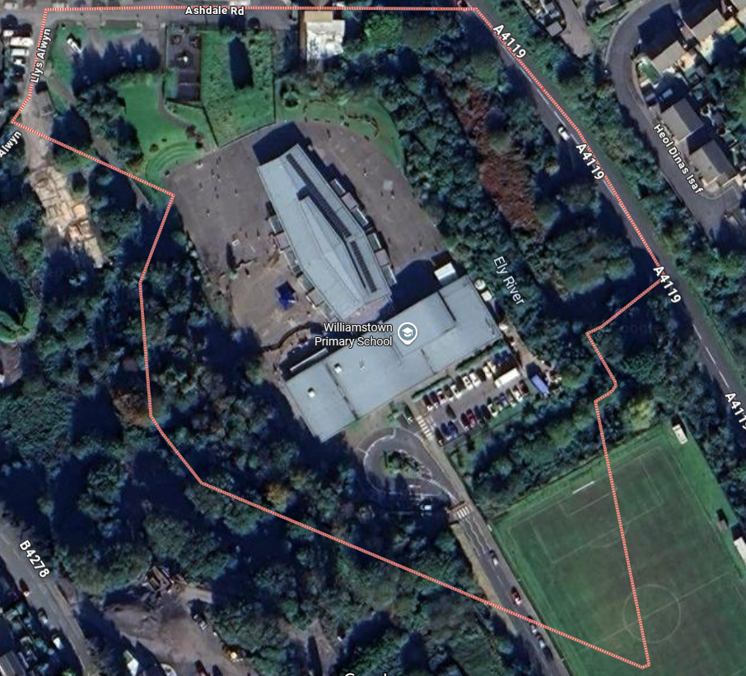
Community Car Park
Pedestrian Access points
Staff Car Park
Compound Access gate
Vehicular access gate A

Bus Bay
Kerb side parking

3. | Site Speed Limit
 | A significant factor in most traffic accidents is the speed at which the vehicle is being driven. This factor also significantly affects the severity of any injuries suffered by pedestrians. Therefore, the school operates a strict maximum speed limit of 5MPH throughout the school. Drivers are expected to adhere to the speed limit (as well as all other site rules) and drive appropriately, taking into account pedestrians as well as local weather conditions and other site traffic.
4. | Reversing
 | Reversing vehicles are a significant factor in many fatal accidents. Reversing on the school site is to be avoided as far as is practicable. In general, this is to be achieved by vehicles entering the site via vehicle gates A, following the one-way system within the site, and exiting the site via the same gate. Where reversing is unavoidable, for example when deliveries are made to the kitchens and there is no drive-through option beyond the kitchen delivery bay, drivers must use all reversing aids at their disposal, such as any alarms, cab-mounted CCTV, reversing assistants, etc., and check that the area is clear of pedestrians before carrying out a reversing manoeuvre. No reversing must be carried out during the morning drop off or afternoon collection periods. Any pedestrians in the vicinity of an area where reversing manoeuvres are being carried out must position themselves in a safe location and away from any crush zones.
5. | Pedestrians
 | Pedestrians must only access the school grounds from the designated entrances, which are clearly marked on the plan. Pedestrians need to recognise that some of these pedestrian gates are adjacent to vehicle access / egress gates that will be in use during peak times and must exercise caution. At no time are pupils to use the vehicle access / egress gates as there is a significant risk of collisions.
 | There are various footpaths around and in the school and all pedestrians must make sure that they use these safely and avoid spilling onto public highways and on-site vehicle routes. Pupils walking in groups must take this into account and allow other users to pass safely. Pedestrians must use the zebra crossings where provided. Dropped kerbs are provided throughout the site to provide suitable access and egress for wheelchair users.
 | During arrivals in the morning, entry into school buildings is only available via the pedestrian entrances. Similarly, the same applies to exiting the buildings at the end of the school day.
6. | Staff
 | All members of staff, as responsible adults, must set a good example, particularly to pupils, but also to others, by complying with all site rules. This includes obeying the site speed limit, only parking in the designated staff car park and not parking haphazardly about the site, and using pedestrian routes after alighting their vehicles. Staff must remember that some pupils, particularly young ones, will have little appreciation of the risks associated with traffic movement and must take this into consideration when driving on or near the school.
 | All staff, irrespective of whether or not they are undertaking any formal supervisory or monitoring duties, must report any incidents of non-compliance with site rules they observe to the relevant person.
7. | Pupils
It is very important that pupils set a good example to others, particularly in the spirit of being a safe school. There are a number of rules that pupils should be aware of:

- Pupils found to be climbing over fences, railings or walls and not following staff instructions in relation to the site, or not adhering to the contents of this plan, will be in breach of the site rules and may be subject to disciplinary action;
- When crossing roads within the school, pupils must use the zebra crossings provided;
- Pupils being dropped off by parents must, wherever practicable, alight the vehicle on the kerbside only;
- Pupils must avoid using earphones as this would disguise the sound of vehicle movements;
- Pupils must ensure that they stop, look and listen before crossing roads, especially when wearing hoodies or similar clothing that restricts vision to either side;
- When using the footpaths – walk, not run. This will avoid accidents and will make you more aware of what is happening around you;
- Pupils must not congregate in car parks, bus bays, near vehicle access / egress gates or vehicle routes or similar.

Pupils must follow the instructions of staff and be aware of the following when accessing the bus bay area:

- The buses must be at a complete stop before embarking / disembarking;
- Pupils must appreciate that bus drivers may not be able to see pedestrians who are out of their direct line of sight and must act responsibly;
- Pupils must only use the designated footpaths around the bus bays;
- Pupils must not walk in the bus bays at any time, unless embarking / disembarking buses;
- Pupils must allow the staff / drivers to carry out their duties without distraction and behave well whilst on board. This ensures that vehicles can move off on time and the journey is comfortable for all.

8. | Car Parks
There is one dedicated car park within the school grounds and this is strictly for use by school staff only or to those with a disabled badge. A one-way system is in operation in this car park and all staff should adhere to the local arrangements.

Community Car Park (Visitors Car Park) is for the use by visitors and the wider community. This is not a controlled car park and lies outside of the school’s jurisdiction

Restrictions apply to the movement of vehicles during the morning drop off (08:30 – 08:50) and afternoon collection times (15:00 – 15:20). No vehicles will be allowed to leave any of the car parks during these times.

Drivers should proceed slowly around the school and within the car parks at all times and within the designated 5MPH speed limit.

Staff are expected to act responsibly on the site when parking and accessing school buildings. If they are aware of unauthorised use of parking bays, this should be reported via the school receptionist or to the school’s Business Manager who will inform / remind the offending driver of the correct use of the site. All staff must supply the school with their vehicle registration number so that they can be contacted if there is a need to do so.

9. | Parents Dropping Off / Collecting Pupils
 | While parents may access the school site to drive around the roundabout, they are not permitted to park on site between 8:30 and 8:50 and between 2:50 and 3:20
10. | Visitors
 | Visitors should park safely at the kerbside parking or in the local community. All visitors must adhere to the 5MPH maximum speed limit on site, as well as all other site traffic rules.
 | Visitors are required to sign in at reception and record their vehicle registration number. On departure, visitors should sign out at reception and leave the building by the main entrance door. Disabled visitors may park in one of the disabled bays which are located in the visitors’ car park.
11. | Contractors / Deliveries / Waste & Recycling Collection / School Minibuses
Contractors and delivery drivers

Drivers of contractor and delivery vehicles must report to the reception desk in the main building to advise of the nature of their visit and to get clarification on where they can park, and to record their vehicle registration details. Initially, they should park in the designated delivery bay outside reception. Drivers must either be issued with a copy of this plan for reference if necessary, or simply be advised of the site rules in relation to the area they are parking at the time, as appropriate to the nature of their visit. All drivers must adhere to the 5MPH maximum speed limit on site, as well as all other site traffic rules. Parking arrangements for contractors who are carrying out long term construction works on site must be agreed to prior to the commencement of the work.

Waste and Recycling Collection

The waste compound is located at the rear of the kitchen, which the caretaker will unlock when the vehicle arrives. The caretaker will position themselves in a safe area if any reversing is required. The refuse / recycling drivers must use reversing assistants during any reversing manoeuvre. All refuse and recycling vehicles must adhere to the 5MPH maximum speed limit on site, as well as all other site traffic rules.

12. | Home to School Transport
The SLT has designated the four bays for the sole use of the Home to School transport. No vehicles apart from the designated buses are allowed to stop or park in these bays at drop-off times.

Home to school transport must be at a complete stop before allowing pupils to get on or off the bus. Engines should be switched off unless there is a valid safety reason to have the engine running. Only when pupils / pedestrians are clear of the vicinity of the bays or are all on board should drivers exit the bus bays, following the agreed departure arrangements and sequence with the designated school supervisor. All transport must adhere to the 5MPH maximum speed limit on site, as well as all other site traffic rules.

Pupils in taxis and minibuses must alight in the designated drop off bay outside the main reception.

13. | Outside School
 | The school accepts that parking near the school is not easy. The residential streets outside the school are busy and can be congested. It is important that the school is a considerate neighbour to local residents. Where parents / carers are unable to access / stop on the school site, they are asked not to park immediately outside the school, but to drop the children off further away, in a location where it is safe to do so, and allow them to walk the remaining distance. Pupils are reminded to walk the perimeter of the site and only enter via the dedicated pedestrian gates
 | There are pelican crossings positioned near the vehicular access point, which pedestrians are encouraged to use. Drivers are asked to keep the road outside each entrance clear to allow vehicles to pass safely. Drivers are asked not to park indiscriminately, such as mounting pavements, double parking, stopping on any yellow lines, obstructing access points and parking near junctions, as this causes danger to pupils and other road users. Accidents can arise if views are obstructed or pedestrians have to negotiate between parked vehicles. In addition, the roads can become congested, which results in frustration to residents and delays to services and ongoing journeys.
14. | Monitoring of Compliance Against this Plan
Key to the ongoing monitoring of the plan is the role of SLT and other staff. All staff have a responsibility to make sure that they are acting in such a way as not to compromise the health and safety of themselves or others. In addition to the supervision arrangements in place, the SLT will carry out monthly site inspections to view practices. The outcomes of this monitoring will be recorded, including details of any instances of non-compliance. Similarly, details of any instances of non-compliance noted at any other times will also be recorded.

Traffic and driving issues arising from the behaviour of parents, contractors, delivery drivers, cleaning and catering staff will be dealt with / escalated by the Headteacher

The Phase leads will be responsible for addressing the conduct of pupils where it is not consistent with the requirements of this TMP.

Home to school transport issues will be reported to the Integrated Transport Unit. Issues involving contractors’ employees, drivers of delivery vehicles or similar will be reported to the relevant employer. All staffing issues will be dealt with by the Head Teacher. The Business Manager will coordinate this function and ensure that both the school traffic management risk assessment and this TMP is updated to reflect any amendments to the actual traffic management arrangements at the school.

16. | Reporting of On-site Traffic Incidents / Accident
 | Incidents and accidents must be reported initially to site management, who will then inform the Council’s Corporate Health and Safety Team using the Incident / Accident Investigation and Injury Record Form HS5(A).
Signed: 
Designation: Headteacher Chair of Governors
Date completed: Sept 2025 Date uploaded onto RAMIS: 09/09/2025
Planned Review date: Sept 2027

