
Williamstown Primary School

Handwriting Policy and Guidelines

Aims

For Teachers
- To know the correct style, letter formations and joins in handwriting to ensure consistency across the school
- To understand the progression in handwriting so that pupils are taught in every lesson and pupils’ handwriting develops and improves
- To ensure high expectations in handwriting lessons and that pupils are expected to apply the same standards in other independent writing

For Pupils
- To know the importance of clear and neat presentation in order to communicate meaning effectively

- To write legibly in both joined and printed styles with increasing fluency and speed by;
  - Having a correct pencil grip
  - Knowing that all letters and digits start from the top, except d and e which start in the middle
  - Forming all letters and digits correctly
  - Knowing the size and orientation of letters of digits

Teaching time
- Nursery and Reception little and often but closely supervised.
- Years 1 and 2 at least 3 weekly sessions lasting no more than 10 minutes.
- Years 3 and 4- three 15 minute sessions a week.
- Year’s 5 and 6- two to three 15 minute sessions a week.

Handwriting in Nursery and Reception
Good handwriting relies on secure motor control and hand-eye coordination. Children should learn handwriting through movement with the actual writing of letters and numbers as the ultimate aim. Children will:
- Engage in activities requiring hand-eye coordination
- Use one-handed tools and equipment
- Draw lines and circles using gross motor movement
- Manipulate objects with increasing control
- Begin to use anticlockwise movement and retrace vertical lines
- Begin to form recognisable letters and numbers
- Use a pencil and hold it effectively to form recognisable letters and numbers, most of which are correctly formed

Throughout Phase 1, children need lots of opportunities to develop:
- Physical control through large-scale movement such as outdoor play. Balancing, climbing, marching and moving to music.
- Manipulative skills such as using tools, cooking utensils and scissors.
- Fine motor control and hand-eye coordination, through activities such as jigsaws, threading, cutting and manipulating ‘small world’ equipment.

The key movements underpinning letter formation should be introduced through largescale movements, from the shoulder.
In the earliest stages, children should make the movements symmetrically using both arms. Once the movement is firmly established in kinaesthetic memory, it can be reduced in scale using activities such as sky writing, using sticks in sand etc. and then reduced further in art activities using felt tip pens, crayons and chubby pencils. Teachers should model letter and number formation using the correct letter patter (See Appendix 1)

Nursery
- Pre-writing stage- patterning
- Physical activities to develop hand muscles and gross/fine motor skills e.g. Dough Disco, sand play, large body movements
- Opportunity to use chunky resources such as paint brushes, chalk etc

Reception
- Pre-writing stage- patterning
- Individual letter and number formation
- Form digits 0-5
- Word formation based on letter groups – linked to letter and sounds, beginning to show joins in diagraphs
- Learn formation through the use of rhymes and songs

Year 1 pupils should be taught to:
- Sit correctly at a table, holding a pencil comfortably and correctly
- Begin to form lower-case letters in the correct direction, starting and finishing in the right place
- Form capital letters
- Form digits 0-9
- Understand which letters belong to which handwriting ‘families’ (i.e. letters that are formed in similar ways) and to practise these
- Make links with phonics and spelling

Year 2 pupils should be taught to:
- Form lower-case letters of the correct size relative to one another
- Start using some of the diagonal and horizontal strokes needed to join letters and understand which letters, when adjacent to one another, are best left not joined
- Write capital letters and digits of the correct size, orientation and relationship to one another and to lower case letters
- Use spacing between words that reflects the size of the letters

Year 3-4 pupils should be taught to:
- Use the diagonal and horizontal strokes that are needed to join letters and understand which letters, when adjacent to one another, are best left not joined
- Increase the legibility, consistency and quality of their handwriting, e.g. by ensuring that the down strokes of letters are parallel and equidistant; that lines of writing are spaced sufficiently so that the ascenders and descenders of letters do not touch.

Year 5-6 pupils should be taught to:
- Write legibly, fluently, with increasing speed and personal style by:
- Choosing which shape of a letter to use when given choices and deciding, as part of their personal style, whether or not to join specific letters
- Choosing the writing implement that is best suited for a task (e.g. quick notes, letters)

It should be noted that these are expectations and teachers will need to be mindful of the point of development for each child and modify their approach as necessary.

Model used
Williamstown Primary School uses the following letter formation:

Lower case letters (Print)

a b c d e f g h i j k l m n o p q r s t u v w x y z

Capitals (Print)

A B C D E F G H I J K L M N O P Q R S T U V W X Y Z

Numbers
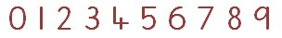

Cursive Script
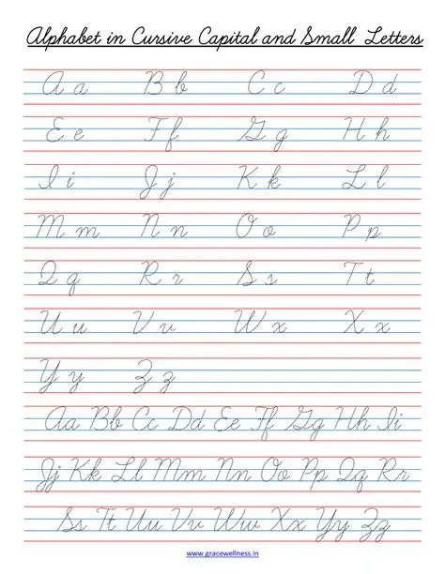

The four joins
- to letters without ascenders
- to letters with ascenders
- horizontal joins
- horizontal joins to letters with ascenders (see Appendix 4)

The break letters (letters that aren’t joined from) are: b g j p q x y z s

Resources
Teachers may use a range of resources for the teaching of handwriting however the model above and letter patterns should not be changed.

Pencils and Pens
Pupils will use HB pencils initially and move onto pens. Children at Nursery and reception should have access to a range of mark making materials and move on to the use of “chunky pencils”. Year one children should use sharp pencils with grips if they require them. Pens must be introduced in hand-writing lessons in Year Four at the latest.

Getting ready to write

Seating and posture
- Chair and table should be at a comfortable height
- The table should support the forearm so that it rests lightly on the surface and is parallel to the floor
- Encourage children to sit up straight and not slouch
- The height of the chair should be such that the thighs are horizontal and feet flat on the floor
- Tables should be free of clutter
- Rooms should be well lit
- Left handed pupils should sit on the left of their partners
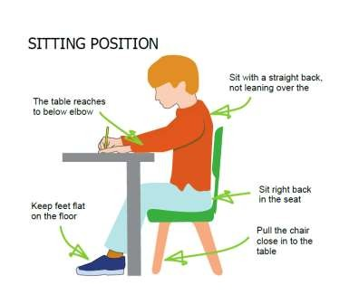
Pencil grip
- A tripod grip is the most efficient way of holding a pencil

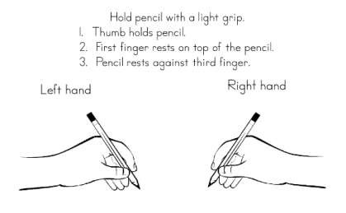

For right handers
- Hold lightly between the thumb and forefinger about 3cm away from the point
- The paper should be placed to the right tilted slightly to the left

- Use the left hand to steady the paper
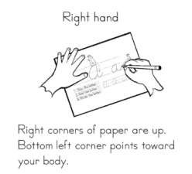

For left handers
- Hold lightly between thumb and forefinger resting on the first knuckle of the middle finger
- Hold about 3cm from the tip but some children may need to grip a little further away from the tip so that the writing is not obscured by the thumb knuckle.
- The hand should be kept below the writing line although some pupils will find a ‘hook’ more comfortable

- The paper should be tilted slightly to the right at about 20 - 30° and pushed about 5cm away from the body to prevent ‘hooking’ of the hand which is caused by the left elbow ‘locking’ into the side of the body.

- Use the right hand to steady the paper
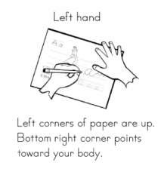

- As a left hander has to push the pencil across the paper, more force can be achieved if the child sits on a slightly higher chair or has a supportive cushion to give extra height.
- Left handers should ideally have light coming over their left shoulders
- Left handed children can be taught to cross t’s and possibly f’s from right to left (pulling instead of pushing)

NB It is very important that a right handed child is NOT seated on the left hand side of a left handed child as their elbows will collide! A left handed child should ideally sit at the left hand end of a table.

Assessment
Children must be assessed on entry into Year Three to see if they are using the correct letter formation for individual letters first. If they are not starting in the correct place they will not be able to join letters accurately. Pupils who need to learn correct letter formation for some letters must be taught this before they begin to join. Some pupils will have begun to learn and use joined handwriting in Year 2 and will need to start from that position in the Progression Ladder (See Appendix 2 for Progression Ladder).

Teachers will assess pupils at the start of the year and decide where teaching should begin in the Progression Ladder. The year group starting points are a guide and teachers will need to use their professional judgement. However, be aware of the expectations at the end of the year.
The SLT in team meetings should monitor children’s writing and presentation in books regularly (as part of the monitoring cycle). The following should be considered:
Is the writing generally legible?
- Are the letters correctly shaped and proportioned?
- Are the joins made correctly?
- Are the spaces between the letters, words and lines appropriate?
- Is the size of the writing appropriate?
- Is the writing properly aligned?

Individual assessment

Children should be observed as they write during handwriting lessons – the teacher must circulate, monitor and intervene. Teachers also need to monitor and mark whole pieces of writing. The following should be considered:
- Is the posture correct?
- Does the child hold the pencil correctly?
- Does the child use the correct movement when forming and or joining letters?
- Are any letters reversed or inverted?
- Does the child write fluently and rhythmically?
- Is the writing easily legible?
- Is the pupil’s handwriting development in line with the National Curriculum?

Teacher modelling
It is essential that teachers model neat and cursive writing in shared writing on the whiteboard, interactive whiteboard and in pupils’ books. Teachers’ writing must be consistent with the Nelson model.

Application
Pupils should be encouraged to apply the hand-writing they are taught in all independent writing. Teachers must have high expectations of all pupils and expect to see examples of what they have been taught in all books.
If pupils are learning joined hand-writing they should be expected to use this in their written work. Pupils should only attempt joins if they have been taught them. Teachers must monitor this and use praise and next steps marking to bring this to pupils’ attention where appropriate.

APPENDIX 1
Letter Patter
a | Around up and down and a flick
b | Down up and around
c | Around and stop
d | Around up and up and down and a flick
e | Out and around
f | A hook and down, pencil off and across
g | A circle around and a hook
h | Down and up and over and a flick
i | A line down, flick pencil off and a dot
j | Down and a hook pencil off and a dot
k | A line down a kick in and a kick out
l | A line down and a flick
m | Down up and over, up and over, flick
n | Down up and over, flick
o | A circle start at the top and around
p | Down up and around
q | Around up, down and down and a kick
r | Down up and hook
s | Around like a snake
t | Down and a hook, pencil off and across
u | Down up, down and a flick
v | Across and out
w | Down and up, down and up
x | Across and across
y | Down and a smile and a monkeys tail
z | Out across out

Number Patter

Straight line down and then we’re done
That’s the way we make a 1
For number 2 go right around
Then make a line across the ground
Around a tree, around a tree
That’s the way we make a 3
Down across, down once more
That’s the way we make a 4
Across and down around the hive
That’s the way we make a 5
Make a curve to do the trick
That’s the way we make a 6
Across the sky and down from heaven
That’s the way we make a 7
Make a ‘s’ and then don’t wait
Go up again and make an 8
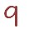 | Make a loop and then a line  That’s the way to make a 9
Make a 1 and then an ‘o’
You’ve made a 10 so of you go!

APPENDIX 2
Progression ladder
Order of teaching

Single letters (YR and Y1)
- c a d g q o
- e s f
- i l t
- u y j k
- r n m
- h b p
- v w x z

Joins Y2 (going into Y3)
Introduction of the four hand-writing joins:
- First join; un um ig id ed eg an or ing ung
- Second join; ch sh th tl ll ill sli slu ckackststi ink unk
- Third join; odpg re veoonoom
- Fourth join; wlvl of ffflflo
- Practise the break letters b p g q y j z
- Practise capital letters

Joins Y3 (going into Y4)
Revision
- Practise the break letters b p g q y j z
- Practise capital letters
Further practise of the four hand-writing joins
- inine
- utute
- ve vi
- ok oh
- sh as es (practising two ways of joining the letter s)
- rirury (practising joining from the letter r)
- oa ad as (practising joining to and from the letter a)
- eeeaed (practising joining from the letter)
- owov ox (practising joining from the letter o)
- kyhyly (practising joining to the letter y)
- ha ta fa (practising joining to the letter a)
- odooog ( practising joining from the letter o)
- erirur (practising joining to the letter r)
- ai al ay
- you oi
- reoefe (practising the horizontal join to the letter e)
- fuwu vu (practising the horizontal join to the letter u)
- otol ok (practising joining to ascenders)
- ai al owol (practising all the joins)

Year 4
- ning ping ting
- oc od oo
- akeome are
- flaflofle
- whowhawhe
- ie in il
- inlykyny
- apar an
- ickuckack
- practise writing with a slope
- he
- we
- re
- fte fir fin
- wrawrikni (silent letters)
- iillttrrnn mm cc ooddssffee
- ewev ex (spacing)
- thhtfl (proportions)
- acagaf
- Capital letters
- Decorated capital letters
- Practising with punctuation ! ? – “ “ , ‘

Years 5 and 6
- Practise and ensure consistency and size of letters
- Practising using a diagonal joining line
- Practising leaving an equal space between letters
- Practising joining to the letter y
- Practising using a horizontal joining line
- Practising the size and height of letters
- Practising joining from the letter i
- Practising joining to and from the letter v
- Practising consistency in forming and joining letters
- Practise speedwriting
- Practising crossing double tt on completing the work
- Practising joining to and from the letter e
- Practising joining to and from the letter w
- Practising printing
- Practising drafting and editing
- Practising joining to the letter t
- Practising with punctuation
- Practising break letters
- Practising joining from the letter m
- Ensuring the ascender on the letter t is the correct height
- Practising spacing within words
- Developing fluency
- Practising printing
- Practising forming and joining the letter f •
- Practising speed writing
- Revision
- Looking at different handwriting styles

APPENDIX 3
Examples of the break letters
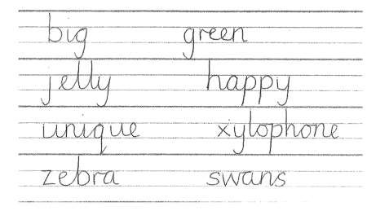
APPENDIX 4
Examples of the joins


