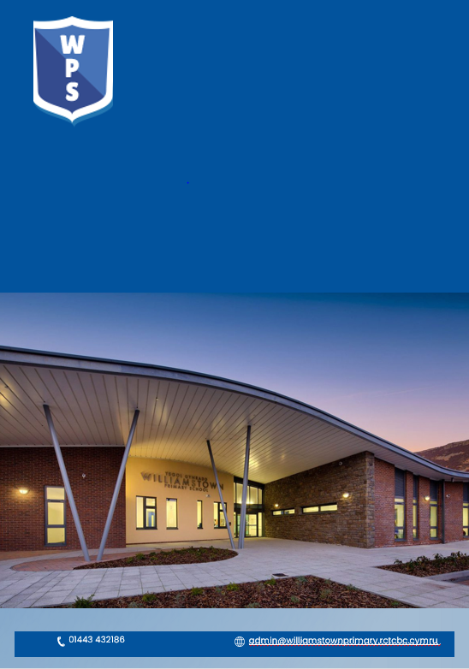

Fire Evacuation Policy

Sept 2025

Chair of Governors:

Date:______________________

Headteacher:

Date:______________________

CONTENTS

1. INTRODUCTION

2. DUTIES AND RESPONSIBILITIES

3. FIRE EVACUATION STRATEGY

4. INSTRUCTIONS ON DISCOVERING A FIRE OR HEARING THE ALARM

5. FALSE ALARMS

6. GENERAL

1. INTRODUCTION

Being a Local Authority School attended by many young children , it is essential that the levels of safety, and particularly that of Fire Safety, are maintained to a high standard at all times.

To ensure that this is the case, under current Fire Safety Legislation, a Fire Risk Assessment Inspection has been completed and it’s findings documented and, as such, it is the duty of the Responsible Person, to ensure that all recommendations made in this report are actioned in a positive manner, with a view to maintaining a safe environment for everyone using the premises.

However, because it is a fact that fires can and do break out on occasions, for whatever the reason, the Emergency Fire Policy and Emergency Plan, which should be communicated to all members of staff, has been developed.

This guidance is intended to act as essential basis for the Staff in the carrying out of their respective responsibilities in relation to the management of fire and in the event of an emergency evacuation of the premises becoming necessary.

2. DUTIES AND RESPONSIBILITIES

The under-mentioned persons have been designated as those with responsibility for the fire safety arrangements at premises, including those duties involving the evacuation of the premises in an emergency:-

- Fire Controller (Responsible Person), Mr David Anstee, Head Teacher
(i.e. the designated Responsible Person with overall responsibility for the
management of the fire arrangements at the home)

- When the Fire Controller (Responsible Person) is not in attendance, the Deputy Head Teacher will be designated to take responsibility.

- In addition to the above-mentioned persons, it should be clearly understood that all members of staff have a responsibility for their actions in relation to fire matters, and anyone who has any queries in relation to their duties should seek clarification from the Responsible Person, without delay.

Daily Responsibilities

The Responsible Person will, as part of his/her responsibilities, ensure that:-

- the Fire Risk Assessment is kept in a readily accessible location and is reviewed periodically
- all doors, giving access and or egress from the premises and doors leading thereto, remain readily available for use.

- fire exit doors, and routes leading thereto, are unobstructed, with security shutters, if provided, open.

- all fire resisting doors, if in use, are in good condition, kept shut, as appropriate, and close fully into their frames.

- the fire alarm system is functioning correctly and tested regularly by competent persons.

- all fire extinguishers are in situ. and in good working order.

- all combustible rubbish is regularly removed from site.

- both gas and electrical installations are regularly checked and maintained at regular intervals.

- the general and emergency lighting is functioning correctly.

- electrical and gas appliances are turned ‘off ’,as appropriate, when not in use.

- Fire Action Notices, FIRE EXIT signs and all other fire signage are displayed in prominent areas throughout the school.

- the ‘No Smoking’ policy is strictly managed.

- the Fire Policy and Procedure Plan is kept up to date

- Regular fire checks of the building are carried out and the Fire Log Book is maintained as an up to date record.

- staff fire training, including induction, fire awareness, refresher and fire drill training is up to date.

- leaders of all visiting groups/clubs, where applicable, are made aware of the action to be taken in the event of fire.

- as applicable, Personal Emergency Evacuation Plans (PEEP’s) for the impaired are up to date.

- strict access control is maintained at all times and a comprehensive lock up program is carried out at the end of the working day.
.

3. FIRE EVACUATION STRATEGY

The fire evacuation strategy at the school is based primarily on a Senior Leadership Team led emergency plan based on the ‘TOTAL EVACUATION’ of the premises of all persons to the designated Fire Assembly Point located in:-

‘THE FOUNDATION PLAYGROUND’

4. INSTRUCTIONS ON DISCOVERING A FIRE OR HEARING THE ALARM

See Appendices 1, 2 and 3 attached - Fire Notices and Staff Responsibilities

N.B. In connection with the above, the following should be noted:-

- Whilst establishing the whereabouts of the fire at the Fire Panel, the alarms may be silenced only on the instructions of the Fire Controller

- When the school has been safely evacuated nominated staff may
attempt to fight any small fire with the fire extinguishers provided,
but only if safe to do so.

- Once the school has been fully evacuated, under no
circumstances should any person re-enter the building until
permission is given by the Responsible person following
agreement with the Senior Fire Officer present.
5. FALSE ALARMS

In the event of the Fire Service being called and the cause of the fire has been found to be a ‘false alarm’, the Fire Control should be contacted and advised accordingly.
This will enable the Fire Controller to decide whether or not to turn back the fire appliances responding.

6. GENERAL

It is essential that all Staff have a detailed understanding of the evacuation policy, fire extinguishers, lighting switches, exits from the building, and the whereabouts of any visitors to the premises.

In addition, key members of staff should know the location of water, gas and electric isolation controls.

To support this, a suitable Essential Building Information File containing details of information which might be required in the event of any emergency situation arising e.g. emergency telephone contact numbers, plan of building, service isolation valves/switches etc., is kept in a prominent accessible location in the building.

Williamstown Primary is a nurturing school. Our ethos is underpinned by the six principles of nurture which are:
- Children’s learning is understood developmentally
- The classroom offers a safe base.
- The importance of nurture for the development of wellbeing.
- Language is a vital means of communication.
- All behaviour is communication.
- The importance of transition in children’s lives.

Following any fire drills or alarms, support will be provided to any learners showing signs of anxiety and who need support with their wellbeing.

Specific Staff Responsibilities in the event of a Fire Evacuation

All staff and pupils on site should be aware of fire drill procedures.
On hearing the alarm /

Teachers:
- Instruct children to leave quietly and calmly through the nearest clear exit.
- Take copies of registers
- Line up class at collection point
- Call register

Designated staff:

Cook:
- Check kitchen is clear
- Switch off appliances where possible
- Vacate premises

Secretary:
- Check office and Reprographics, HT office and toilets closest to office where applicable
- Check ELSA room and Sensory room
- Take visitors’ iPad
- Vacate building
- Check presence of visitors at collection point

Pre-School Staff:
- Check classroom, toilets and designated play areas
- Take register
- Vacate building

ASC 1 Staff:
- Check classroom and designated play area
- Check Adjoining classroom, Toilet and Sensory room
- Vacate building

ASC 2 Staff:
- Check classroom and designated play area
- Check Classroom 1 and both toilets
- Vacate building

Foundation Phase Additional Practitioners in the Nursery and Reception class:
- Check Nursery toilets
- Check all areas, including kitchen and changing room
- Vacate the building

Additional Practitioners in N - Y3:
- Check class toilets and cloakrooms
- Vacate the building

Additional Practitioners in Year 4:
- Check Heart space,class toilets and cloakrooms
- Vacate the building

Additional Practitioners in Year 5:
- Check IT hub if unlocked
- Check Staff room
- Vacate the building

Additional Practitioners in Year 6:
- Check class toilets and cloakrooms
- Check disabled toilets
- Check Music room and adjoining toilets
- Check ALN office
- Vacate the building

Headteacher:
- Check Caretakers Room
- Check Hall
- Check Foyer
- Check Office,
- Vacate the building

Williamstown Primary School

CLASSROOM FIRE NOTICE

ON DISCOVERING A FIRE OR HEARING THE FIRE ALARM:

If you discover a fire, operate the nearest fire alarm point.

- Commence evacuating all the children to the Designated Fire Assembly Point which is:-

‘THE FOUNDATION YARD’

- Take the attendance Register

- As you leave close all doors and windows if safe to do so

- Line up class at collection point

- A roll call should be carried out at the earliest opportunity following evacuation.

- Notify the Responsible Person as to the last known whereabouts of any missing children/persons.

- Pending the arrival of the Fire Service and after all children have been accounted for, staff may carry out such firefighting as can be done without personal risk in line with the School’s Policy.

On no account must staff re-enter the building following a full evacuation, until the school has been declared safe by the Fire Officer in Charge.
Williamstown Primary School

FIRE NOTICE - (Senior Leadership Team Members)

ON DISCOVERING A FIRE OR HEARING THE FIRE ALARM:

- Operate the nearest fire alarm point / shout ‘Fire! Fire!’
- Close all doors immediately surrounding the fire.
- Commence evacuating the Service Users by the nearest exit
- Ensure that the Fire Service is called immediately by dialling
999

ON HEARING THE FIRE ALARM:

- Establish the affected area as indicated on the fire alarm panel
- Ensure that the Fire Service is called immediately by dialling 999.
- Carry out an immediate investigation into the cause of the alarm
- If safe to do so, carry out a ‘sweep’ of common areas (toilets, assembly hall, canteen etc.
- Ensure that all persons are accounted for at the earliest opportunity following evacuation.
- Notify the Officer in charge of the first appliance to arrive the last known whereabouts of any missing persons.
- Pending arrival of the Fire Service and after all persons have been accounted for, staff may carry out such firefighting in accordance with School Policy.

On no account must staff re-enter the building following full evacuation, until the building has been declared safe by the Fire Office in Charge.

