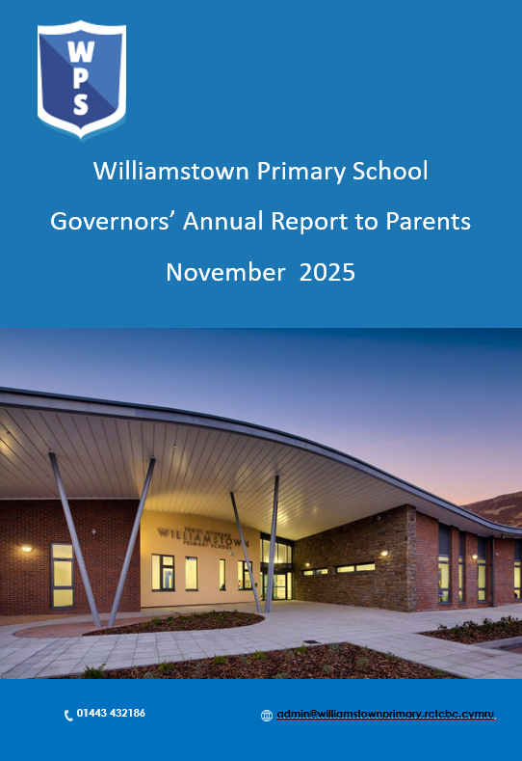

Governors Annual Report to Parents
2024/2025

Suggested - a foreword from chair setting out their thoughts about how the past year has gone, how the governing body, school leadership team and local authority have worked together, and what their key challenges might be for the year to come.

Details of meetings with parents and carers over the past year

There have been no meetings this year

Governors’ details

The Clerk to the Governing Body is Mrs Gaynor Davies, Director of Education and Inclusion, Valleys Innovation Centre, Navigation Park, Abercynon, CF45 4SN.

The Chairperson of the Governing Body is Mrs Claire Bridge c/o Williamstown, Primary School, Dinas Isaf West, Williamstown, Tonypandy, RCT, CF40 1AG

The following people are currently members of the Governing Body.

Name | Category of Governor | Appointed By | Retirement Date
Samantha Morgan  Sarah Rogers  Vacancy | LEA | Council Members | 28/02/2026  10/03/2028
Gemma Price-Davie  James Watts-Rees  Helen Tuck  Ellen Davies | Parent | Parents | 30/06/2028  13/05/2029  15/02/2026  07/06/2029
Claire Bridge  Darren Young  Vacancy | Community Governor | Governing Body | 02/04/2029  07/10/2028
Vacancy | Minor Authority  (If applicable) | Community Council
Mr D Stagg | Teacher | Teaching Staff | 06/10/2027
Mrs E Millwater | Staff | Non-Teaching Staff | 23/04/2028
Mr D Anstee | Headteacher |  | n/a

When fully constituted this governing body is made up as follows

LEA Representatives | 3 |  | Community Governors | 3
Parent Governors | 4 |  | Teacher Governor(s) | 1
Staff Representative | 1 |  | Minor Authority (if applicable ) | 1
Headteacher | 1 |  | Total

The next election of parent governors is due to take place on 15/02/2026

However, if there are any parent governor resignations before this date, arrangements will be made for an election to take place to fill the vacancy.

Performance and target information

- Attendance for 2024-25 was 89.82%.
- Unauthorised attendance was 2.95% or 1318 days
- Authorised attendance was 7.22% or 3229.5 days
- Children leaving year 6 have gone on to attend Ysgol Nantgwyn, Tonyrefail Community School, Treorchy Comprehensive School, Porth Community School and Ysgol Hen Felin

A financial statement
Carry Forward from 2023/2024
Carry Forward from 2023/24 | £-106,522.75
Expenditure
Teaching | £890,250
Non-Teaching | £445,426
Relief Staff | £196,908
Recruitment | £243
Total Staffing | £1,561,987
Total Premises | £149,020
Total Supplies and Services | £122,013
Total Expenditure | £1,833,020
Income
Formulae Allocation (LA) | £1,456,628
Grant Income | £272,886
Additional Income | £119,340
Carry Forward from 2023/2024
Carry Forward 2024/25 | -£90688.75

Action taken by the governing body or school

A range of policies have been ratified by the Governing Body. In addition, the Governing Body have appointed a new headteacher who began his role in April 2025 and a new Acting Deputy headteacher, who began his role in September 2025.

School Prospectus

The School Prospectus is updated annually to include any changes required by the Welsh Assembly Government or other related bodies. A copy of the prospectus is issued to parents whose children are starting school for the first time or to the parents of those children transferring to us from other schools. A simplified version can be seen on the school’s web site. The prospectus has been redesigned for the 2025/26 academic year and is available on our school website.

Organisation, plans and policies

Governors are responsible for drawing up (in conjunction with staff) the School Development Plan. The plan identifies the direction the school will take over a three-year period, in delivering the curriculum. The plan is regularly monitored and revised to take account of progress made and any changes to curriculum requirements.
The School Development Plan for the 2024-2025 academic year was approved by Governors. The targets set included short, medium, and long-term aims, and were regularly reviewed by the Governing Body,
The SDP priorities for 2024/25 were:
- Target 1 - To raise the standards of reading across the school. To refine our school curriculum, using our cluster designed curriculum maps.
- Target 2 - To continue to embed the new Additional Learning Needs (ALNET) bill into the everyday workings of the school
- Target 3 - To continue to develop a range of well-being strategies to support pupils and staff. To further develop links with the community to strengthen relationships.

Term | From | To
Autumn 2025 | Monday, September 1 2025 | Friday, October 24 2025
Half Term | Monday, October 27 2025 | Friday, October 31 2025
Autumn 2025 | Monday, November 3 2025 | Friday, December 19 2025
Christmas Holidays | Monday, December 22 2025 | Friday, January 2 2026
Spring 2026 | Monday, January 5 2026 | Friday, February 13 2026
Half Term | Monday, February 16 2026 | Friday, February 20 2026
Spring 2026 | Monday, February 23 2026 | Friday, March 27 2026
Easter Holidays | Monday, March 30 2026 | Friday, April 10 2026
Summer 2026 | Monday, April 13 2026 | Friday, May 22 2026
Half Term | Monday, May 25 2026 | Friday, May 29 2026
Summer 2026 | Monday, June 1 2026 | Monday, July 20 2026

- Mon 1 Sept 2025 and *Monday 20 July 2026 will be designated INSET days for all LEA Maintained Schools. The remaining three INSET days to be taken will be at the discretion of each individual school following appropriate consultation with staff. *It is intended that this INSET Day will either be taken on Mon 20 July 2026 or at an alternative time for example in the form of twilight sessions.

All schools will be closed on Monday 4 May 2026 for the May Day Bank Holiday.

Significant dates:
Christmas Thursday 25 December 2025
Easter Good Friday 3 April 2026
Easter Monday 6 April 2026
May Bank Holidays Monday 4 May 2026
Monday 25 May 2026

Additional Learning Needs

The school’s policy for the Assessment of and Provision for Pupils with Additional Learning Needs is summarised as follows:

The school’s policy for the identification, assessment and provision for pupils with additional learning needs is consistent with the requirements of the Additional Learning Needs Code for Wales (approved by the Senedd on 23rd March 2021) under section 4 of the Additional Learning Needs and Education Tribunal (Wales) Act 2018.

The school’s Additional Learning Needs Co-ordinator (ALNCo) works closely with all other members of staff to ensure that individual educational plans are developed and implemented to meet the needs of pupils, appropriate to those who require them.

The ALNCo also liaises with all members of staff, to ensure that the progress of all pupils is regularly monitored and assessed and to ensure that each pupil reaches his or her potential.

During the academic year 2024/2025, 20 pupils were in receipt of an Individual Development Plan (IDP)

RCTCBC is the Admissions Authority for all schools (other than Church schools where the schools governing body is the admissions authority) within the Authority’s boundary. The school’s admission arrangements are therefore operated in line with the Authority’s policy on school admissions which is contained in the publication Starting School Book. The book is made available to parents at the point of their application for their child’s admission to school. The contents of this book can also be accessed online on the Authority’s website.

Pupils will usually remain in the school until they complete year six and then transfer to secondary school. This school is a feeder school for Ysgol Nantgwyn however pupils may apply to attend any secondary school they choose, subject to compliance with the Authority’s admissions policy.

It is the Authority’s policy that all children, as far as is possible within the terms of the Education Act 1996 (amended by the Special Educational Needs and Disability Act 2001 and the Additional Learning Needs and Educational Tribunal Act 2018) should be educated in mainstream Welsh, English and dual language schools within their local communities. The Additional Learning Needs Code 2021 provides statutory advice to professionals regarding their roles and responsibilities and further guidance is provided within the Equality Act 2010.

The Additional Learning Needs and Education Tribunal Act 2018 clearly states that most pupils with additional learning needs should receive appropriate and inclusive additional learning provision within their local mainstream Welsh, English or dual language school. However, children with significant and very complex learning difficulties may be offered placement in a Learning Support Class within a mainstream school or in a special school. Children with significant and highly complex social, emotional and behavioural difficulties may receive their education via RCT’s EOTAS (Education Other Than At School) Provision. Decisions regarding specialist placements are made by the Access and Inclusion Service following consultation with parents, schools, health professionals and other relevant support services.

The Governing Body is mindful of the requirements of the Equality Act 2010 and the Special Needs and Disability Act (SENDA) 2001 in drawing up the School Development Plan/Post Inspection Action Plan, and the day-to-day operation of the whole site.

The school is committed to ensuring that all pupils are able to participate in the school curriculum and (where they desire) in activities such as after school clubs, leisure/sporting events and educational visits. All aspects of accessibility, including access to written information are included in the planning process.

The Authority has in place an Accessibility Strategy Plan and in line with this strategy has had an audit of the school site undertaken, as part of an Authority wide brief, to identify any potential barriers and to improve the access to the school.

Healthy eating and drinking

As in previous years, we continue to support and promote our pupils’ health and wellbeing. The development of healthy lifestyles is of high priority in our school.

Children take part in a range of activities to ensure that they feel safe and staff receive biannual safeguarding training. We have a good PSHE curriculum addressed through class sessions, assemblies and circle time. In regular class check-ins, children highlight very positive attitudes to school life and report that they feel safe and happy at Williamstown Primary School. The school continues to have a robust safeguarding and child protection procedure in place, including safer recruitment.

School lunches are always nutritionally balanced by our catering team and we actively encourage parents to supply pupils with a healthy packed lunch, where school dinners are not taken. Pupils are encouraged to bring with them a piece of fruit for break time and all pupils have regular access to water in their classes. Foundation pupils will also receive milk during their morning break. Fizzy drinks, chocolate, sweets or foods high in fat and salt are not encouraged by the school

Curriculum and organisation of education and teaching methods

At Williamstown Primary School, we support the concept of lifelong learning, recognising that both adults at school and children learn new things every day. We maintain that learning should be a rewarding and enjoyable experience for everyone. Through our teaching we seek to equip children with the skills, knowledge and understanding necessary to be able to make informed choices about the important things in their lives.
• Ambitious, capable learners
• Enterprising, creative contributors
• Ethical, informed citizens
• Healthy confident individuals.

We recognise that people learn best in different ways: most lessons incorporate aspects to support pupils who learn best through visual, audio and kinaesthetic approaches. However, we do not usually label children as specific types of learners. Rather we aim to provide a rich and varied learning environment that supports children in developing their skills and abilities in a range of ways, in order to achieve their full potential. Through our teaching we aim to develop pupils who have additional needs.

Children with Additional Learning Needs are catered for through high-quality universal provision and additional academic and social, emotional interventions.

In addition, Williamstown Primary School is proud to host two Local Authority classes catering for children with Autistic Spectrum Condition (ASC). These classes are an important part of our school and integrate well with mainstream classes.

Welsh language

Williamstown Primary School is an English medium school. Lessons and other school activities are communicated through the medium of English. Welsh is taught as a second language and the school is currently involved in the Siarter Iaith Cymraeg, obtaining Gold award in 2024. The charter consists of three awards - bronze, silver and gold. Each award comprises of ten targets and these targets become more challenging as pupils progress through the awards. In Foundation learning Bilingualism incorporates the teaching of Welsh.

Through the Language, Literacy and Communication (LLC) Area of Learning and Experience (AoLE) we aim to provide children with a basic vocabulary, enabling them to converse in Welsh. Initially the lessons are entirely of an oral nature and will also involve learning simple songs and rhymes to reinforce the vocabulary. As the children mature and their understanding of the language grows, they are introduced to Welsh in its written form, where they will be encouraged to read and write Welsh as well as improving their oral proficiency. From Year 3, formal teaching of Welsh as a 2nd Language takes place, however bilingualism and incidental Welsh is common practice during all lessons. Pupils for whom English is a second language are catered for according to their needs.

Provision of school toilet facilities

The school provides sufficient toilets for the number of pupils on roll. These toilets are cleaned on a daily basis, with extra checks carried out at lunchtime. Toilets are designated to each class however individual toilets are available should these be requested/required. A sufficient amount of sanitary bins are provided and these toilets are clearly marked.

