
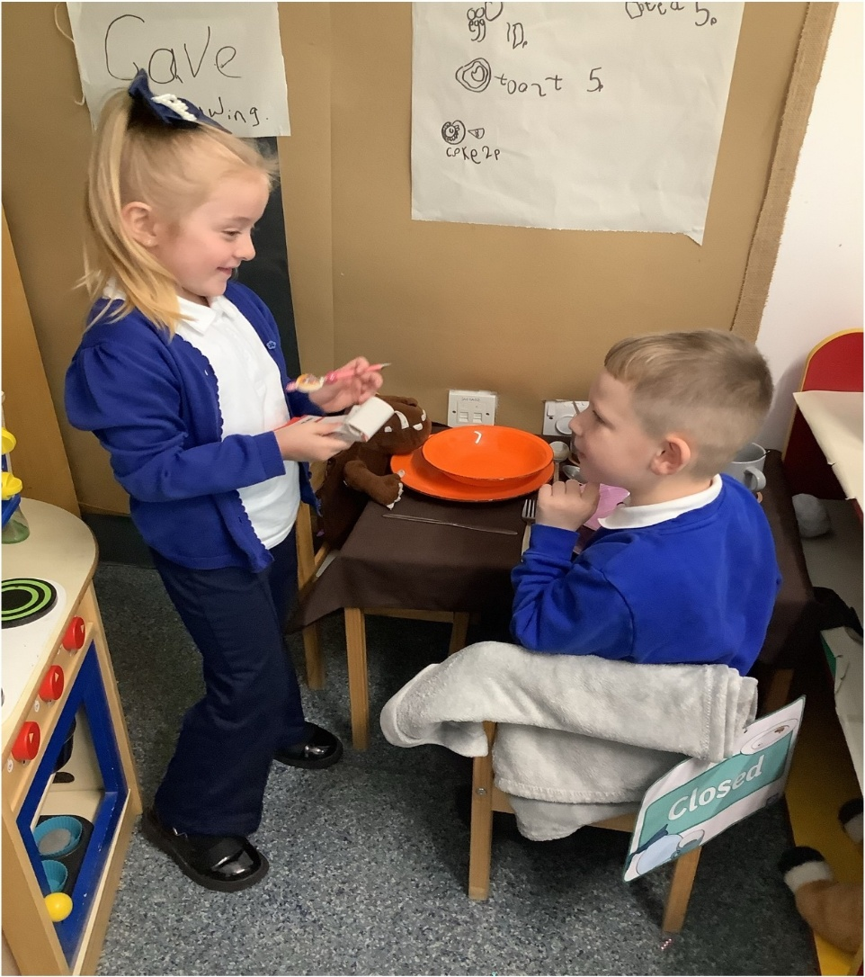
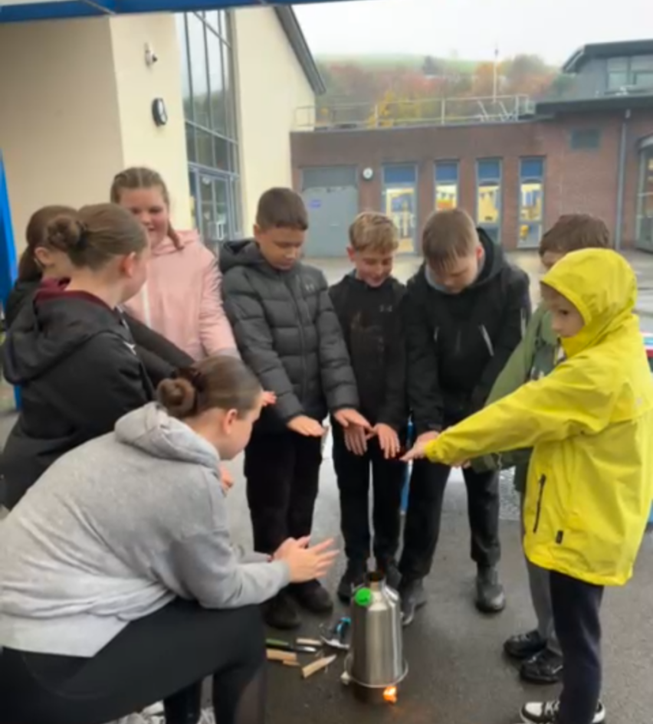
Williamstown Primary School
Prospectus 2025-26

Draft Vision Statement

Williamstown Primary School recognises its place in the heart of its community. We value the rich interactions created by our relentless pursuit for excellence as each member of the community strives for success. This ambition creates challenge, and we work together, using our core values to support each other to achieve. We have high expectations of each other and value the process of building our community into a safe, inclusive, fair environment which focuses on developing the unique qualities of every individual. We all believe in our community’s purpose in providing an innovative, engaging environment where our young people grow into independent, resilient, thoughtful contributors.

UN Convention on the rights of children

At Williamstown Primary School we put the United Nations Convention on the Rights of the Child (UNCRC) at the heart of our school’s planning, policies, practice and ethos. We follow the Nurture Schools ethos where we teach about children’s rights and also model rights and respect in all its relationships: between teachers, adults and learners.

The UNCRC underpins our school vision and aims. In designing, adopting and implementing our curriculum, we incorporate opportunities for learners to:
- learn about human rights: the acquisition of knowledge and skills about human rights, and the sources of those rights
- learn through human rights: the development of values, attitudes and behaviours that reflect human rights values
- learn for human rights: the motivation of social action and empowerment of active citizenship to advance respect for the rights of all.

Inclusion

Williamstown Primary School is an inclusive school that aims to meet the needs of all its learners. The Additional Learning Needs and Education Tribunal (Wales) Act 2018 is a legislative framework for improving the planning and delivery of additional learning provision through a person-centred approach. Identifying needs early, putting in place effective support and monitoring, and adapting interventions is key to ensuring that we deliver desired outcomes.

At Williamstown Primary School we use this framework to allow for a broadening of learning, ensuring that all learners with additional learning needs (ALN) are supported to overcome barriers to learning and achieve their full potential

A welcome from the Headteacher

Dear Parent/Carer
Welcome to our school – a place where we believe in Making a Difference Together.
At the heart of our vision is a commitment to excellence in both learning and behaviour. We set high expectations for every child, encouraging them to be curious, resilient, and ambitious in all they do. Our dedicated staff work tirelessly to create a nurturing and stimulating environment where children feel safe, valued, and inspired to achieve their very best.
We are proud to be a school rooted in community. We believe that education is most powerful when it is a shared journey – one that brings together children, families, staff, and the wider community. Through strong partnerships and open communication, we build a culture of trust, respect, and collaboration.
Inclusion is not just a principle here – it is a lived experience. Every child is welcomed, celebrated, and supported to thrive, regardless of background or ability. We embrace diversity and ensure that all voices are heard, all needs are met, and every child feels a true sense of belonging.
Together, we are shaping confident, compassionate learners who are ready to make a positive difference in the world.
We look forward to welcoming you into our school community.
Warm regards,
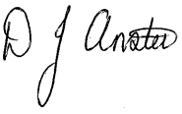
Mr D Anstee
Headteacher

Contact Details

Williamstown Primary School
Dinas Isaf West
Williamstown
Tonypandy
RCT
CF40 1AG

01443 432186
admin@williamstownprimary.rctcbc.cymru

Headteacher – Mr D. Anstee
Deputy Headteacher – Mr D. Stagg
Chair of Governors – Mrs C. Bridge
School Clerk – Mrs L. Francis
Caretaker – Mr R. Davis

Timings of the School Day
Nursery – Reception
Morning Session: 9:00 am - 11:30 am
Afternoon Session: 12:30pm - 3:15 pm
Morning Break: 10:45 - 11:00 am
Lunch: 11:30 am – 12:30 pm

Year 1 – Year 2
Morning Session: 9:00 am - 11:45 am
Afternoon Session: 1:00pm - 3:15 pm
Morning Break: 10:45 - 11:00 am
Lunch: 11:45 am - 1: 00pm

Year 3 - Year 6
Morning Session: 8:50 am – 12:15 am
Afternoon Session: 1:15pm - 3:15 pm
Morning Break: 10:30 – 10:45 am
Lunch: 12:15 am - 1:15pm
We ask that you support us by ensuring your child arrives at school on time.
Staff welcome pupils into the classrooms from 8.50am.

Class | Teacher
Nursery | Mrs Buchanan / Mrs Jenkins
Reception/Year1 | Mrs Ellis-Bees
Year 1/2 | Mrs S Thomas
Year 1/2 | Mr J Lewis
Year 3 | Miss F Evas
Year 3/4 | Mrs G John / Mrs L Davies
Year 4/5 | Miss H Thomas
Year 5/6 | Mrs D Jones
Year 5/6 | Mr D Stagg/  Miss N Densley
ASC 1 | Mrs R Williams
ASC 2 | Mrs J Maunder
Class Structure

Leadership structure

Mr D Anstee – Headteacher
Mr D Stagg –Deputy Headteacher

Additional Learning Needs Co-ordination
Miss N Densley - ALNCo

Teaching and Learning
Mr J Lewis – Responsible for Teaching and Learning Nursery – Year 2
Mr D Stagg – Responsible for Teaching and Learning Year 4 – Year 6

Wellbeing - whole school
Mr J Lewis and Mrs L Davies

Our Chair of Governors is Mrs C Bridge who can be contacted via the school office.

Other SLT responsibilities are:
Mr D Stagg – Assessment, Miss N Densley – Intervention, Mr J Lewis – Curriculum

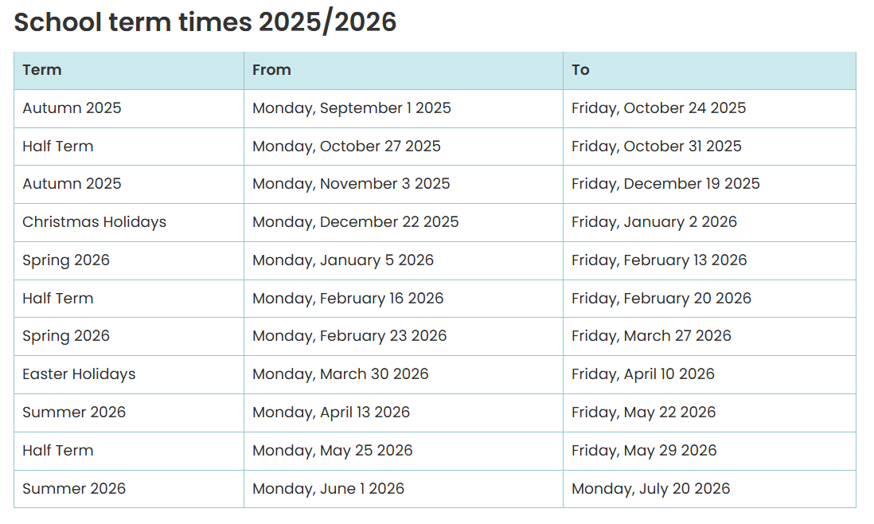
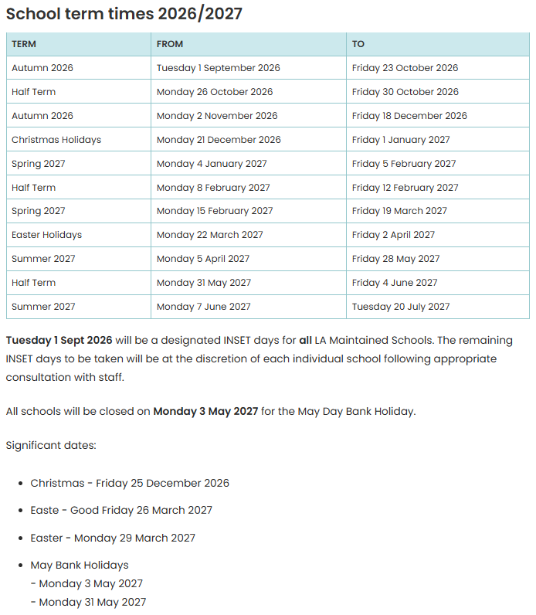
Admissions
Williamstown Primary School admits most of its pupils from the local catchment area, as defined by Rhondda Cynon Taff County Borough Council. Details regarding the admission policy, as defined by RCTCB, can be found here:
https://www.rctcbc.gov.uk/EN/Resident/SchoolsandLearning/SchoolAdmissions/Applyingforaschoolplace.aspx
All parents/carers must complete an application form before a child is admitted into school. These must be submitted to the Local Authority. Birth certificates must be produced for a child to be admitted to nursery class.
Parents of nursery children are asked to liaise closely with staff to ensure a smooth transition from home to school - our nursery team will conduct a home visit the term before your child's admittance. in order to introduce themselves to you and your child.
Parents of Reception children also need to apply to the Local Authority for admission into Reception. Parents will be invited into school before their child starts for a tour of the school and a meeting with a member of our leadership team

Home/School Partnership

We believe that an effective partnership between home and school is essential if children are to achieve their full potential. When your child starts school we ask you to sign a Home-School Agreement. This has been drawn up by the Parent Council and is a commitment towards working together for the good of your child. A copy can be found in the consent form pack that we will provide for you. We will keep you well informed about your child's progress and we value your interest and support.

Newsletters and other information are regularly sent home with pupils to keep parents informed about school activities and dates of any forthcoming events. This information is always available on the “My Child At School” app.
Wherever possible, we will also offer workshops for parents, offering information about how we teach specific aspects of the curriculum and how you can support your child at home.
Attendance
Pupils need to attend school regularly if they are to take full advantage of the educational opportunities available to them. The progress of pupils is affected by non-attendance at school. Children are expected to attend school every day, punctually, unless there is a valid reason for not doing so.

Authorised Absences
It is inevitable that there will be times when your child will need to be absent from school. It may be because of a visit to the hospital for example. Whilst we would ask that, where possible, appointments are made outside school hours, we acknowledge that in certain circumstances it is not possible. At these times, we ask you to notify the school in advance, either through the “My Child at School” app or by emailing the school office. Should your child be absent through illness, we ask that you contact the school on the morning of the first day of absence so that we know that your child/children are safe at home. If you are unable to contact the school, we request that you send in a brief note on your child’s return to school stating the reason/s for absence. We operate a first day calling system where, if the school is not contacted, the school will contact you by text.
Holidays within Term Time
We ask parents to try their best to arrange holidays in official school breaks. Any requests for holidays during term will be subject to the school’s attendance policy. The school has an application form which will require information regarding the length and purpose of the holiday, with exact dates and any family circumstances. In some cases, holidays in term time can result in FPNs being issued. More information can be found on our school website regarding Holidays in Term time.
Care of our Pupils
Ensuring your child is cared for and looked after, whilst at school, is of great importance to us. If you have any queries at any time then you are very welcome to come and speak to your child's teacher. However, please remember that after school is the best time, as the teacher has his/her class to prepare for, and to look after, at the beginning of school. You should always go to the main office to ask if the teacher is available – in the interests of school security, please, do not enter the school to look for them. If your child’s teacher is unavailable, short messages can be passed on via the school office. If necessary an appointment can be made for the earliest possible opportunity. Regular opportunities will be provided for all parents to meet with teachers during our allocated Parent Evening meetings to discuss your child’s progress and any potential concerns that staff may have.

The people responsible for attendance matters at Williamstown Primary School are:
Mr D Anstee, Head teacher
Mr D Stagg, Deputy Headteacher
Mrs L Davies / Mr J Lewis – Wellbeing lead (SLT)
Mrs M Martin – Family and Attendance Lead
Mrs Claire Bridge, Governor with responsibility for attendance

Safeguarding
The school has a Safeguarding policy which lays out the procedures all school staff and volunteers must follow. The Headteacher is responsible for reporting to Children’s Services any concerns that are deemed to be of a child protection nature. All staff have appropriate training in Child Protection and Safeguarding on a rolling programme. In cases where a child or children are considered to be in need of support then the consent of the parent/carer will always be sought. In cases of child protection concerns, it is not always in the interest of the child to inform the parents/carer and a report may be made directly to Social Services. Please be assured that the primary concern will always be in the interest of the child. The Child Safeguarding Policy can be viewed upon request.
Our Safegaurding team are:
Mr D Anstee (Designated Safeguarding Officer), Mr J Lewis (Deputy Safeguarding Officer)
Miss H Thomas, Mrs G John, Mrs S Thomas

Operation Encompass
The school is part of a police safeguarding project called ‘Operation Encompass.’ If police attend a domestic violence incident where children have been present, the school will be informed by 9am the following morning in order that we can provide timely support. If you are concerned about or the victim of Domestic abuse then please seek help. Our safeguarding team are available for you when needed.

Uniform
Although, at the Primary school stage, the wearing of a school uniform is not compulsory, we do have a distinctive school uniform at Williamstown Primary School that we encourage pupils to wear, in response to the wishes of the vast majority of parents.

School Uniform Requirements
Our uniform consists of the following items, which are designed to be practical and affordable:
- Grey trousers, skirt, or shorts: Any plain grey item that is suitable for school.
- White t-shirt: Plain or with the school logo, available at multiple retailers to ensure affordability.
- Blue jumper or cardigan: Plain blue or with the school badge (badging is optional to reduce costs).
- Footwear: Sensible black shoes or trainers that are practical for school activities, including outdoor play.

We encourage all pupils to wear the above uniform daily, but we recognise that circumstances may occasionally prevent this, and we will work with families to ensure that every pupil feels comfortable and included.

PE Kit
For PE days, the following is required:
• Plain white t-shirt.
• Black or navy shorts or tracksuit bottoms.
• Trainers for physical activity.
All items can be sourced from a variety of suppliers, including local shops and supermarkets, to ensure they are easily accessible and affordable for all families.. The school also operates a recycled uniform scheme which can be accessed by parents. Please contact the school office if you would like more information.

Cloakrooms and Storage
All pupils have access to coat pegs and storage within our cloakroom areas to store their belongings during the school day. Likewise, storage is available in class for other personal items. We do ask that Pupils only bring in drawstring style bags with them to school and not backpacks.

Lost Property
Please ensure that all items of your child’s belongings are labelled clearly with his or her full name. We actively encourage the children at School to be responsible and independent and to look after their own belongings. However, if they do mislay any items, we have a Lost Property box.

Collecting pupils from school
All foundation pupils must be brought to and from school by a responsible adult (over 16). Pupils in Years 3-6 should be brought to and from school by a responsible person of at least 16 years or over. It is for the parent/carer to decide if pupils over the age of 8 are responsible and safe enough to walk to and from school alone.
The school must also be informed if someone different comes to collect your child. If the school hasn’t had prior information shared, the pupil will be kept with school staff until parents can be contacted to confirm who is collecting their child.

Our Curriculum
At Williamstown Primary School, we support the concept of lifelong learning, recognising that both adults at school and children learn new things every day. We maintain that learning should be a rewarding and enjoyable experience for everyone. Through our teaching we seek to equip children with the skills, knowledge and understanding necessary to be able to make informed choices about the important things in their lives.
- Ambitious, capable learners
- Enterprising, creative contributors
- Ethical, informed citizens
- Healthy confident individuals.

Our curriculum policy details the extent of our curriculum and this can be found on our school website www.williamstownprimary.com. The curriculum is based on a clear vision of excellence for all.
Homework
Homework is an ideal way for us to keep parents up to date with what is being taught in school and for parents to be involved in supporting their child’s progress. The school is currently working with parents to undertake a review of homework. Whilst this review is ongoing, parents can expect to receive a range of homework tasks including weekly spellings, daily reading and numeracy work.
RSE
Williamstown Primary School is committed to adopting a Whole School Approach to high-quality provision of Relationships and Sexuality Education (RSE) for all learners. Therefore, it is important that this policy has been developed in consultation with a range of stakeholders including staff, parents the Governing Body and the active engagement of learners.
RSE allows for all learners to grow and develop in a safe environment to understand how to become healthy adults who are critical thinkers, whilst developing positive and healthy relationships with others. It is important that learners are able to explore, develop and nurture positive attitudes towards equality, gender diversity and respectful relationships. This RSE Policy supports wider approaches to preventing violence against women, domestic abuse, and sexual violence (VAWDASV), harmful sexual behaviours, and peer-on-peer harassment and abuse.

Cymraeg
All children learn Welsh as part of their curriculum. The school actively promotes the Welsh language through the use of incidental Welsh throughout the school day and look to integrate into the wider curriculum where possible the school has an active Criw Cymraeg and working towards the reaccreditation of the Gold Siarter Iaith award

Curricwlwm Cymraeg
We are very fortunate that here in Wales we have a rich history and culture which we believe should be celebrated. All of our learning seeks to reflect the diversity of Wales, its heritage and culture and how everyone can be part of creating the Wales of the future. Our annual Eisteddfod is an example of one of the ways in which we promote Cwricwlwm Cymraeg, where pupils take part in a number of competitions through the medium of both Welsh and English.

Careers and Work Related Education
Williamstown Primary School is keen to promote links with local businesses and other organisations within our community and benefits greatly from their support.
We have strong links with Ysgol Nantgwyn, which is our cluster secondary school, and we work together to ensure all pupils in year 6 have a smooth and purposeful transition. Visits are planned each year giving opportunities to attend a range of lessons. Liaison meetings take place between teachers at all cluster schools in a number of areas each year including pupil leadership, literacy, numeracy, curriculum and assessment. Pupils in year five and six visit Ysgol Nantgwyn and meet other children who will be attending the school. Transition activities include a mix of social and educational tasks.
Children have many opportunities to listen to a wide range of speakers from various agencies. These include our Members of the Senedd, Member of Parliament, local clergy, the fire brigade, school dentist, school nurse and other visitors who bring with them specialist skills and knowledge.
Charities that we regularly support include Children in Need, Comic Relief, Save the Children and Macmillan Cancer support and each year.

Additional Learning Needs (ALN)
Children with additional learning needs or ALN are well supported across the school through universal provision, differentiated practice, scaffolding, excellent resourcing and well-trained teaching and support staff. The school’s Strategic lead for Additional Learning Needs is Mrs Nesta Clement who can be easily contacted via the school office or by email: admin@williamstownprimary.rctcbc.cymru
Miss Densley is the school’s ALNCo
The processes, policies and practices of Williamstown Primary School are fully compliant with the Additional learning needs and tribunal act, which also directs us in providing enhanced support, including referrals to outside agencies.
Where children join the school who have English as an additional language, additional support is provided by the local authority, where appropriate. The school’s policy for the identification, assessment and provision for pupils with Additional Learning Needs is consistent with the requirements of the Additional learning needs and tribunal act 2021
The School’s Additional Learning Needs co-ordinators (ALNCO) works closely with all other members of staff to ensure that Individual Development Plans (IDPs) are developed and implemented to meet the needs of pupils.
If you have any concerns regarding your child’s progress or additional need or require some more information (or just a chat) then please get in touch. The process of ALN identification can be lonely and we are here to support you. In addition to this, the school runs regular ALN coffee mornings for parents to come and chat together over a cup of tea! Remember; you are not alone, and we all want is best for your child!

Equal Opportunities
The school has adopted the Local Authority Schools Equalities Policy which is reviewed annually by the Governing Body. We believe that all individuals deserve equal opportunities. We aim therefore to structure the curriculum, the organisation and the management of the school so that all at school are offered equal opportunities for participation and for inclusion, for advancement and for growth, regardless of gender or social class, race or religion, age or disability. We strive to foster an understanding and appreciation of the diverse cultures within our society.

Pupils with Disabilities
Pupils with disabilities do not necessarily have additional learning needs and many such pupils will learn together with their peers in mainstream. They will not need any provision that is additional to or different from that usually provided by schools apart from equipment such as wheelchairs, hearing aids or low vision aids. Teachers must identify potential areas of difficulty at the outset and make 'reasonable adjustments' to ensure that pupils are not placed at a substantial disadvantage or treated less favourably than pupils without a disability. This is a requirement of the SEN and Disability Act 2001 which came into effect in September 2002. For example, teachers may need to plan for additional time for certain activities or may need to provide additional equipment or alternative activities to ensure access to particular parts of the programmes of study, e.g. music and art for pupils with sensory needs, PE for pupils with physical disabilities.
We are very fortunate to be housed in a 21st Century school building. As such we have modern facilities that ensure every child and adult, regardless of their physical disabilities can have equitable access to the school site. Some of the ways in which the school has been built with disability in mind are:,
- Wider doorways
- Ramped access to all outdoor areas
- Universal toilets with alarm

Children who are looked after (CLA)
Children who are in the care of the Local Authority may have particular needs. Mrs Nesta Clement is the senior leader at school responsible for co-ordinating the education of Looked After Children. Appropriate plans will be put in place to support the specific needs of these pupils.

Local Authority ASC classes
At Williamstown Primary School, we are proud to host two Local Authority (LA) resource base classes for pupils with additional learning needs—one in Foundation Phase and one in Key Stage 2. These ASC classes provide specialist support within a nurturing environment, tailored to meet the individual needs of each learner. While they are LA provisions, they are a valued and integral part of our school community. Pupils in our ASC classes participate in whole-school activities and events, and their presence enriches the inclusive ethos that underpins everything we do. We celebrate diversity and work collaboratively to ensure every child feels a sense of belonging and is supported to thrive. Then ASC class teachers are Mrs R Williams (ASC1) and Mrs J Maunder (ASC2)

Building Positive Relationships
Teachers work in partnership with parents to assist children to grow into caring and responsible people enjoying positive attitudes and good relationships with others.
We involve our pupils in the creation of rules and link these to our class and school charters and we expect children to conform to the high expectations we have of them. Positive behaviour is promoted and where necessary, appropriate sanctions are put in place in the interest of all pupils. We expect our pupils to work and play together harmoniously in a happy school environment and to treat all members of the school community with courtesy and respect. Our school rules are designed to ensure the safety and wellbeing of the children, to promote effective learning and to encourage care for the environment. If parents are concerned about their child’s behaviour or emotional well-being they are urged to contact the class teacher, ALNCo, Wellbeing leads or Headteacher to discuss any difficulties. Equally, if the school is concerned about any aspect of a child’s behaviour, we usually invite parents to school to discuss any issues which have arisen.
Any instances of bullying are taken very seriously, and bullying will not be tolerated at Williamstown Primary School.
Our Behaviour and Anti-Bullying policy outlines our aims and objectives and are available upon request.

Health and Wellbeing

At Williamstown Primary School we believe that we are not only here to educate pupils on academic topics, but that it is also important to teach children about the need to be healthy and active. We aim to establish this within the school through a number of different ways including weekly PE & fitness sessions, providing after school clubs for pupils, establishing links with local sports clubs, providing regular swimming lessons, improving our outdoor provision to encourage fitness and establishing links with healthy eating groups.

Williamstown Primary School is working as part of the Healthy Schools Network in Wales. You can be sure that during your child’s time with us, they will develop their own understanding and awareness of how to be happy and healthy members of the community. Within the school, Foundation Phase pupils receive free school milk to aid healthy growth and development of bones, our lower foundation classes and there are regular visits from the School Nurse to teach children about a range of topics including keeping clean, sun safety and dangers of smoking. In line with our continued drive towards the promotion of healthy lifestyles for all our pupils, we actively encourage our pupils to increase their daily consumption of drinking water. To assist with this goal, we ask parents to provide a reusable school water bottle to be used in school on a daily basis.

Breakfast Club

The school operates a free Breakfast Club for all pupils every morning from 8:00 a.m. – 8:50 a.m. Pupils must be in school by 8:15am at the latest to be given access to Breakfast club. Pupils who arrive after this time will not be given access to breakfast club. In addition to being offered a healthy choice of cereal, toast, milk etc., the children are provided with the opportunity to socialise and enjoy a variety of fun activities. Your child is welcome to attend on some or all days. Registration forms are available from the main school office and must be received by the school before your child can attend breakfast club.

School Meals
RCT Catering provides universal free school meals at lunchtime for all full-time pupils. There is a hot lunch and jacket potato option daily. Packed lunches Provision is made for those children who bring their own food for lunch. However, for reasons of Health & Safety pupils are not permitted to bring drinks in cans or glass bottles as part of packed lunches. We ask that parents limit the amount of “treat” type snacks to one per day in line with our school Healthy Eating policy. No energy drinks should be brought to school. Please note- there are no facilities for warming of food for packed lunch children.

Toilets

The school provides sufficient toilets for the number of pupils on roll. These toilets are cleaned on a daily basis, with extra checks carried out at lunchtime. Toilets are designated to each class. There are a sufficient number of sanitary bins are provided, and these toilets are clearly marked.

For further information regarding toilets and toileting, please refer to our website, where our policies can be located.

Charging Policy

For some school trips and enrichment events we rely on the support of parents to pay towards such activities. Advance notice will be given of such trips and costs. Our aim is to ensure that no pupils are disadvantaged and therefore ask parents to speak to the Headteacher if there are any financial implications that the school may be able to assist with to ensure that all pupils have the opportunity to participate in such activities.

Management of the school – security of pupils and premises

The school is conscious of the need to have good security procedures.
There are entry buzzers at the main entrance, community door and ASC1 entrance. Entry will only be allowed once it is clear who it is seeking entry. Under no circumstances should children open the door to visitors. Side gates to classrooms are locked at 9.00am and can only be opened by school staff or automatically in the event of a fire.

Visitors and contractors should always report to the main office to be signed in and are requested to wear a visitor’s badge at all times
The following additional measures are in place:
- The external and internal buildings are monitored by CCTV. (Policy available on the school website)
- For safety reasons, parents are not permitted to park or drop off their children in the staff car park unless they have the express permission of the headteacher.

In addition, for health and safety the gates will be closed during inclement weather and in the evenings. Any persons driving onto the school site should adhere to the Traffic Management Policy which is available upon request.
We make every attempt to ensure the safety of pupils throughout the school day, including playtimes and lunchtimes. Teachers regularly emphasise the need for pupils to remain on the footpath, and that they should never respond to approaches from strangers.
In addition, parents are reminded of their responsibilities when dropping children off and collecting them at the end of the day; namely that all vehicles should park in the designated parking areas only, except where express consent has been given by the school for parents to park on site.
The school undertakes termly fire drills and have clear lock down procedures in place.
For the safety of all pupils and parents, dogs, other than assistance dogs, must not be brought onto school premises
The school’s policies concerning health and safety are available on the school web site or from the school office

Collective Worship
Every school must by law provide daily collective worship for all its pupils, with the exception of those pupils who are withdrawn from these activities by their parents. The school complies with the statutory regulations by holding a daily act of Collective Worship. The head teacher is responsible for collective worship provision, in consultation with the governors. The majority of acts of collective worship in the school are "wholly or mainly of a broadly Christian character". A "broadly Christian" act of worship must contain some elements which relate to the traditions of Christian belief and which accord a special status to Jesus Christ.
If you wish for your child to be absented from Collective Worship it must be for valid religious reasons.

Our Governing Body
The Governing Body and the Headteacher share responsibility for the strategic management of the school, acting within the framework set by national legislation and by policies of the Local Authority (LA). While the LA is the employer of staff, the Governing Body and Headteacher have separate and particular responsibilities for the selection and management of staff. The internal management of the school is the responsibility of the Headteacher. The full Governing Body meets at least once a term, usually more frequently.
In addition, sub-committees meet regularly to discuss specific issues. The minutes of Governing Body meetings are available from the Governor Support Officer, Mr G Tranter at RCTCBC Governor Support

The Governing Body for our school is:
GOVERNOR | NAME | TERM OF OFFICE ENDS
Chair of Governors/Community | Claire Bridge | 02/04/2029
Teacher Governor | Mr D Stagg | 06/10/2027
Staff Governor | Mrs E Millwater | 23/04/2028
Headteacher | Mr D Anstee | n/a
Parent Governor | Helen Tuck | 15/02/2026
LEA Governor | Samantha Morgan | 28/02/2026
LEA Governor | Sarah Rogers | 10/03/2028
Parent Governor | Gemma Price-Davies | 30/06/2028
Parent Governor | James Watts-Rees | 13/05/2029
Community Governor | Darren Young | 07/10/2028
Parent Governor | Ellen Davies | 07/06/2029
Community | Marc Morgans
Lesser Authority | Vacancy
Local Authority | Vacancy

G.D.P.R.
As a public body, there are certain tasks that will require us to process your child’s information under the basis of ‘Public Task’. During your child’s time at school, we will process a large amount of information about them, in order to provide them with the best possible care and support within their education. At Williamstown Primary School data protection is given a high priority, and we do all we can to ensure that your information is held securely.
As part of this prospectus pack you will find a guidance booklet entitled ‘Your Child’s Data’ which gives a simple explanation to how our school processes your child’s data. This is also available on our website. Please find below a brief overview of how we establish Data Protection procedures within Williamstown Primary School.
Processing Data
At Williamstown Primary School there are 6 core objectives that we adhere to when processing information about our pupils. As a school, we will ensure that all information held about your child will be:
1. Processed lawfully, fairly, and in a transparent manner.
2. Collected for specific, explicit and legitimate purposes.
3. Adequate, relevant and limited to what is necessary.
4. Accurate and, where necessary, kept up to date.
5. Kept in a form no longer than is necessary.
6. Processed in a manner that ensures appropriate security of the personal data.
The collection of Personal Information
The school collects information about pupils and their parents or legal guardians when they enrol at school. The school also collects information at other key times during the school year. Information is also received from other schools when pupils transfer. The school processes the information it collects to administer the education it provides to pupils.
For example:
- Providing effective educational services to individuals; ◻ Monitoring and reporting on pupils’ educational progress.
- The provision of Welfare, pastoral care and health services.
- The giving of support and guidance to pupils, their parents and legal guardians.
Personal Information Held
The sort of personal information that will be held includes:
- Personal details such as name, address, date of birth.
- Pupil identifiers and contact details for Parents and Guardians
- Information on Performance in internal and National assessments
- Information on the ethnic origin and National Identity of pupils
- Medical information needed to keep pupils safe while in the care of the school
- Information on attendance and any disciplinary action (e.g. exclusions)
- Information about the involvement of Social Services within individual children.
Organisations who may share Personal Information
Information held by the school, LEA and the Welsh Government on pupils, their parents or legal guardians may also be shared with other organisations when the law allows, for example:
- Other education and training bodies, including schools, when pupils are applying for courses, training, school transfer or seeking guidance on opportunities.
- Bodies doing research for the Welsh Government, LEA and schools, so long as steps are taken to keep the information secure.
- Central and local Government for the planning and provision of educational services.
- Social services and other health and welfare organisations where there is a need to share information to protect and support individual pupils.
- Various regulatory bodies, such as inspection authorities, where the law requires that information to be passed on so that they can do their work.
Your Rights
You have certain rights under Data Protection Act, including a general right to be given access to personal data held about your child. The presumption is that by the age of 12 a child has sufficient maturity to understand their rights and to make an access request themselves if they so wish. A parent would normally be expected to make a request on a child’s behalf if the child is younger. If you wish to access personal data regarding your child, then please complete a ‘Subject Access Request’ form, available on the school website.
Please note that in some instances, particularly where Child Protection cases are involved, you may not be entitled to view all information held on your child for legal purposes.
Keep us up to date
It is very important that you keep the school informed of any changes to personal information, such as address, mobile number etc. This will allow us to maintain our records in line with Data Protection guidelines. We will share with you the information we hold during Parents Evening (annual), for you to check that the information we hold about your child is accurate. Information can be updated via the “My Child at School” app or by contacting the school office

Complaints Procedure
The Governing Body of Williamstown Primary School take all complaints very seriously as we are committed to providing high-quality education. We aim to make the school’s complaints procedure easy to follow with three easy steps:

- Step 1 – Informal Stage You must contact the Headteacher of the school first as the vast majority of complaints are resolved at this stage.
- Step 2 – Formal Stage All complaints will need to be in writing and addressed to the Chair of the Governing Body. They will be thoroughly investigated, and a response will be made in writing.
- Step 3 – School Complaints Committee If you are unhappy with the investigation you must write to the school and request the Clerk to the Governing Body, who convenes the Complaints Committee of the Governing Body to review your complaint.

The information which appears in this booklet, is correct at the time of printing but may be subject to change before the start or during the school year or subsequent years

