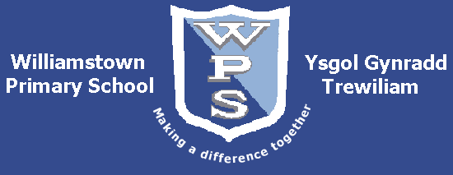

Home School Agreement

At Williamstown Primary School we believe the success of your children depends upon a partnership between the school, children and parents. We ask you to read and sign the following agreement reflecting this partnership.

The School will:

- Care for your child’s safety and happiness.
- Encourage your child to achieve their full potential.
- Provide a balanced curriculum at an appropriate level for your child.
- Achieve high standards of work and behaviour through building good relationships and developing a sense of responsibility.
- Keep you informed about your child’s progress and about general school matters.
- Be open and welcoming and offer opportunities for you to become involved in the general life of the school.

As a family we will try to:

- Make sure our child arrives on time properly equipped for school.
- Make sure our child attends school regularly and provide notification promptly of any absence.
- Support the school’s policies and guidelines for learning and behaviour.
- Support my child in any work sent home and other home learning opportunities.
- Attend Parents Evenings and discussions about my child’s progress.
- Get to know about my child’s life at school.

Together we will try to:

- Share any concerns or problems, by telephone, note or in person, that might affect the child’s work or behaviour.
- Support the child’s educational and social development.
- Prepare the child to be a confident and happy member of society.

As the child – I will try to:

- Bring all the equipment I need every day.
- Be tidy in my appearance.
- Do all my work at school and at home as well as I can.
- Be polite, kind and helpful to others.
- Be well behaved and sensible.
- Take care of school equipment, our building and the school surroundings.

Signed: ___________________________________________________________ (School)

____________________________________________________________ (Family)

