School Closure Home School Pack
Miss Densley’s Class
Week beginning 27.4.20
I’ve added some more ideas for another week of home learning. I’ve left the ongoing spelling/reading/times tables on there.
Literacy
- Practice the reading/spelling of high frequency words – you can do this in creative ways using different materials (e.g. paint, magnetic letters) and try timing yourself
- Carry on with your reading books – make sure someone asks you lots of questions about them and if you are reading Dockside practice those cover words
- I have included a sheet of general literacy activities and some paper to complete them on
- Here is a link for Oxford Owl’s free ebook library (you will have to create a login but it should all be free): https://www.oxfordowl.co.uk/for-home/find-a-book/library-page/?view=image&query=&type=book&age_group=Age+9-11&level=&level_select=&book_type=&series=#

- Over the next few weeks I would like you to work through a booklet on creative writing written by Jo Pearce for “Talk for Writing”. I don’t want to bombard you with all of it so will include a few pages from it each week. Eventually you will have written your own story inspired by a tale called “King of the Fishes”. Please see below – I hope you enjoy reading it!

Maths
- Practice your times tables (in class we have practised the 2, 5, 10, 3, 4, 6, 8 and 9). A great tool for this is J2Blast on Hwb (I can see some of you have already had a go at this!)
- Practice telling the time on analogue (clock faces) and digital clocks
- Topmarks is a fantastic website to help with both of these

- This week’s topic is to extract and interpret information from an increasing range of diagrams, timetables and graphs. I have included some questions on pie charts below for you to have a go at with an extension to create your own (sorry it’s a bit blurry). Here is a link to a video to help explain how to do it: https://www.youtube.com/watch?v=Ruc9n6ho3l4

Good websites to help with any of the above include Letters and Sounds for phonic practice, Topmarks, Crickweb for problem solving practice, Twinkl, Espresso, Hwb, BBC Bitesize and Primary Resources.

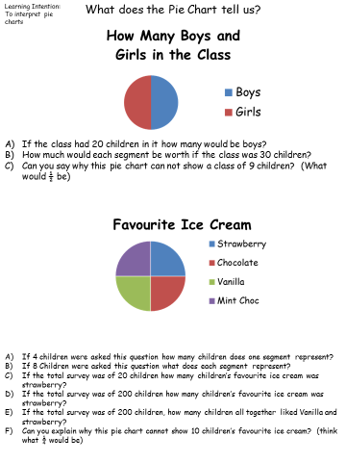
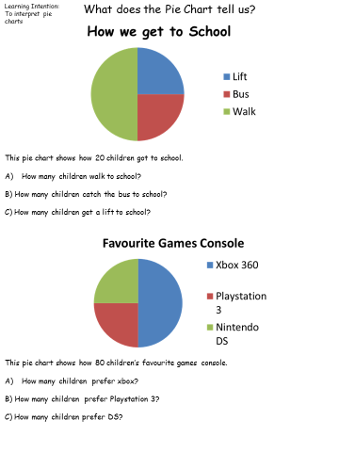
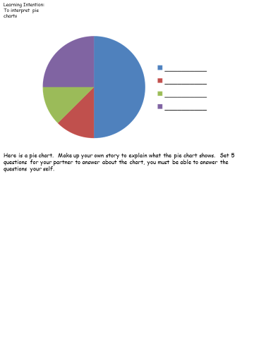
History
I have uploaded another Powerpoint from Twinkl about democracy in Ancient Greece. Have a look through it and see if you can explain what democracy means. Have a go at sorting the picture cards below into two piles; those who are included in the democracy and those who are not (see slide 12 on the presentation). Discuss whether you think this system is fair. Finally, have a think about our modern democracy system (who is able to vote?) and have a go at the sheet below on the main differences between democracy then and now. Which do you think is the fairer system?

Welsh
I have attached some slides from a Powerpoint below for you to practice some questions and answers. See if you can have a go at writing your own dialogue. Don’t forget all the vocabulary you need for “Y Dref” (The Town) was on last week’s work pack and I have included all the translations below the slides in case you need them.
Also here’s the link for the Cyw website where there are lots of activities for you to explore: https://cyw.cymru/en/

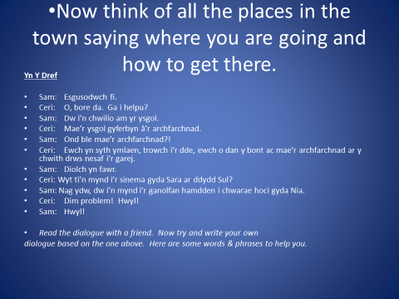
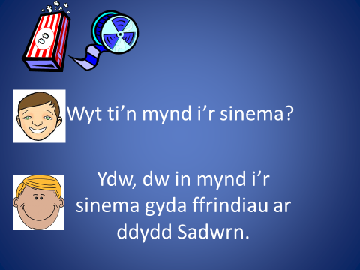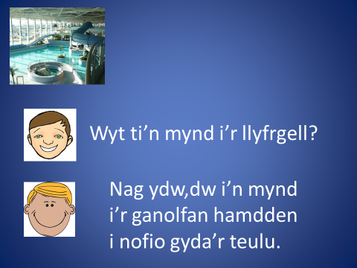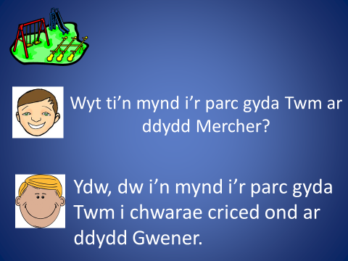
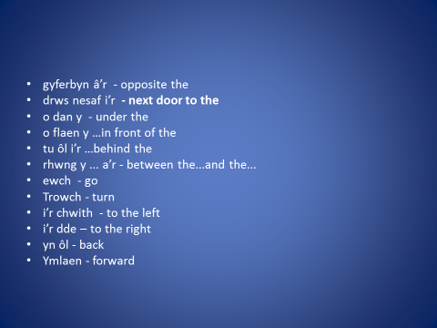

Translations
Slide 1: Are you going to the cinema?
Yes I’m going to the cinema with my friends on Saturday.
Slide 2: Are you going to the library?
No, I’m going to the leisure centre to swim with my family.
Slide 3: Are you going to the park with Twm on Wednesday?
Yes I’m going to the park with Twm to play cricket but on Friday.
Slide 4:
- Sam: Excuse me.
- Ceri: Oh, good morning. Can I help you?
- Sam: I’m looking for the school.
- Ceri: The school is opposite the supermarket.
- Sam: But where is the supermarket?!
- Ceri: Go straight forward, turn to the right, go under the bridge and the supermarket is on the left next door to the garage.
- Sam: Thank you very much.
- Ceri: Are you going to the cinema with Sara on Sunday?
- Sam: No, I’m going to the leisure centre to play hockey with Nia.
- Ceri: No problem! Bye!
- Sam: Bye!

ICT
I would like you to have a go at creating your own stop-frame or stop-motion animation. Here is a link to an example of Morph in action: https://www.youtube.com/watch?v=xvPaWTrJ3UE
In stop-frame animation characters are moved and a photo taken, they are then moved again and another photo taken. When all the photos are shown after another the viewer observes movement.
To create yours you will need to download ICanAnimateLite on the iPad. If this is not possible you can have a play around with the animate section on jit5 on Hwb (one of the J2easy apps). Here is a link explaining how to use the app on the iPad:
https://www.youtube.com/watch?v=Rm7DUrqAmFw&feature=youtu.be
Try getting used to animating simple objects like a pen, pencil sharpener, plasticine, Lego figure or another similar object that doesn’t easily fall over. Take two photos or frames and then move the object slightly. Don’t move the tablet between frames. Hold the tablet in place on a stand or tripod if you have one.
If you are successful with this I would love to see them – try uploading your final video to Twitter (you can export to Camera Roll on the app)!

Happy home learning! Hope you are all keeping safe and well,

Miss Densley

