School Closure Home Learning Pack
Mrs Jones’ Class, Year 3/4
Hello Y3 and Y4,
I hope you have all had a good Easter break. Here are some activities for you to do at home.
This term will be learning about what animals and plants need to, ‘Stay Safe & Stay Healthy.’ We will be looking at what we can do to stay healthy, as well as how animals and plants grow.
If you cannot print out the sheets, just write the answers down on a piece of paper or in a separate note book.
Best Wishes to you all and I hope to see you soon,
Mrs Jones x

Numeracy
This week in maths, I would like you to practice putting numbers in the right order. You need to make sure that you understand how a number is made up (Place Value), so that you can use different methods to add and subtract. In the corner of each worksheet it will say whether it is a year 3 challenge or a year 4 challenge.

Whole numbers – reading and writing numbers to 999

Hundreds | Tens | Ones
7 | 1 | 5

Whole numbers – reading and writing numbers to 9999
We read and write numbers in the order that we say them.
seven hundred
and fifteen
When we read numbers we go left to right:
In words, this number is one thousand, three hundred and twelve. We write it like this 1312. We put a comma between the thousands digit and the hundreds digit.

Thousands | Hundreds | Tens | Ones
1 | 3 | 1 | 2

Year 3
Year 3

Year 3
Year 3

Year 4

Year 4
Year 4

Year 4

Problem Solving task cards for Year 3 and 4.
These are tricky, but have a go. Draw a picture to help you.

Literacy
Reading.
I would like you to continue to read at home for 10 minutes a day. You can read any book, magazine or comic you like.
HFW Spellings
Due to the circumstances, we will not have individual group spelling tests until we are back in school. I have decided to attach the word sets up to set 3. Please could you work with your child to make sure they can spell as many words as possible? Next week, I will put the next three sets up. Please do not feel any pressure to complete them. It is important that your child tries to learn all the words in a set before moving on to the next. I know there are some children who will know all the words in these sets, please continue to practise picking out words from the books they are reading for them to practise spelling. When your child has learnt the word, ask him/her to write a sentence using that word.
SET 3
he
she
we
in
do
said
of
if
for
they

SET 2
this
have
went
like
are
can
be
by
and
you

SET 1
the
to
a
I
it
is
go
no
me
my

Punctuation – Capital Letters.
This week I would like you to recap when we use capital letters. Look at the poster below.
Can your children sort these words and phrases to identify those that should start with a capital letter and those that shouldn't?
Capital Letters and Full Stops
Year 3
Write the following sentances out correctly, remembering capital letters and full stops.
- yesterday, i fell over ben in the playground and hurt my knee

- i think that i’m very smart because my test score was better than tim’s

- jack and jill went up the hill to fetch a pail of water

- christmas day is the day that christians celebrate the birth of jesus

- jennifer and michael are best friends

- santa and rudolph are very busy in december

- saturday and sunday are days of the weekend

Year 4

Now look at the passage below. I have forgotten to put capital letters in it. Rewrite the passage with capital letters.

the children hurried home quickly. it was friday afternoon, and mr evans, the local shopkeeper, was waiting for them. it was very chilly on that december morning, and jack and emma had wrapped up warm. their mum was away working in london, so mr evans had offered to look after the children. in return, the children decided to help out in the shop.
“it’s not fair” jack groaned. “why do i have to do all the work, while you just sit there?” emma stood up and looked out over swansea bay with a smile. she turned to jack. “i spent all day on thursday tidying up the house jack, or have you forgotten about that?” “sorry” jack replied sheepishly.
the door opened suddenly. “oh hello mr evans, we were just tidying up.” jack declared proudly. there was a silence. the children looked up curiously, to see their mum standing in the doorway. “we thought you weren’t coming home until saturday” emma exclaimed. “i thought i would surprise you” mum answered cheerfully.

Hint: You should find 37 mistakes altogether

Phonics – Spelling using ‘ai’/’ay’
Please log on to the following website and have a go at the online game. When you have finished you can see if you can find any other games to play on Topmarks.
https://spellingframe.co.uk/

Put the link above into your search bar and then click on Year 1. Have a go at games 1 and 4.

Topic
Science

Health and Wellbeing
Watch the following video clips on BBC bitesize.
https://www.bbc.co.uk/bitesize/topics/z6882hv/articles/zx38wmn - This clips tells us what animals need to survive.
https://www.bbc.co.uk/bitesize/topics/z9yycdm/articles/zxvkd2p - This clip tells us what humans need to stay healthy
Can you create a mind map on what you need to survive and stay healthy?
Warm up
Aerobic
Exercise

Stretching
Humans
Expressive Art
Drawing leaves from observation
Ask your child to imagine that they are on an island. On the island there are two very similar plants growing (but not identical); one is very delicious, but the other is poisonous. They have to be able to identify the plants and be able to show and tell their friends the differences between the two plants so that they don’t poison themselves.
Tell the children that, to do this, they have to learn how to – and practise – looking at leaves closely and drawing them very clearly. But not to taste any!
Go outside and find a leaf. Try and choose a simple shape and make sure that it is not too small.
- Measure your leaf
Measure the widest part of the width of the leaf and the length. You will draw your leaf ‘life-size’ – the size it is in real life, so can use these measurements to check and plan your drawing.
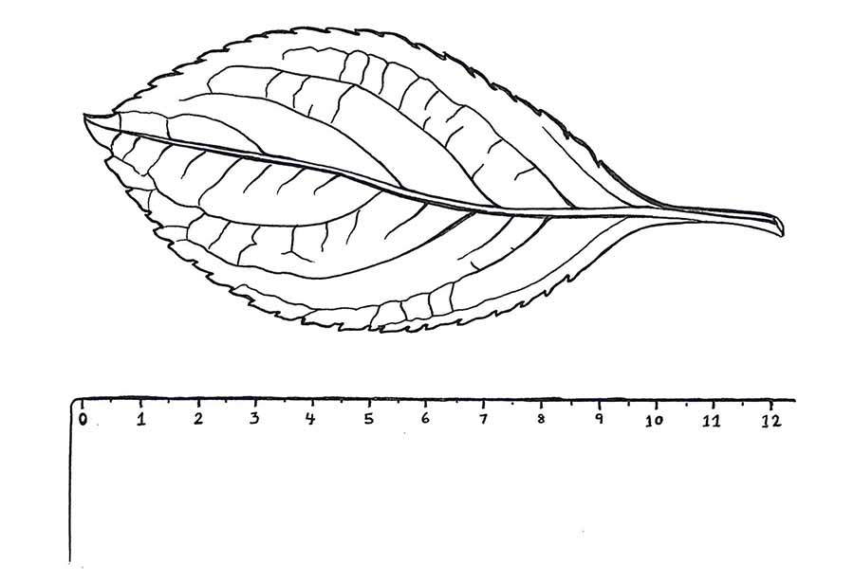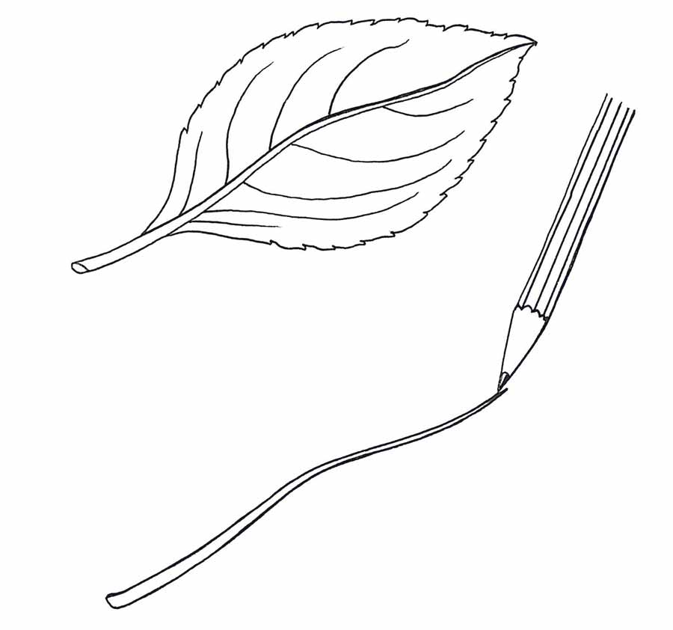
- Draw the midrib
Look at the biggest, middle vein the ‘midrib’. How does it go through the leaf? Does it go right to the tip or does it disappear? Is it raised or sunken? Draw this midrib first. This might seem strange but can help you draw your leaf right!

- Draw the tip
Notice the tip of the leaf. Is it rounded or pointy and if so, how much? Draw in the tip of the leaf.
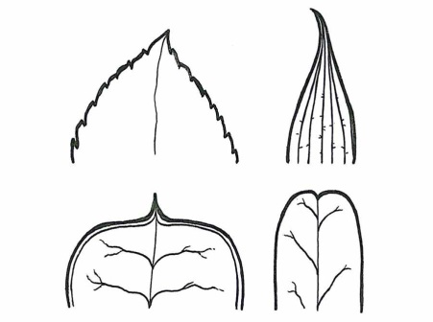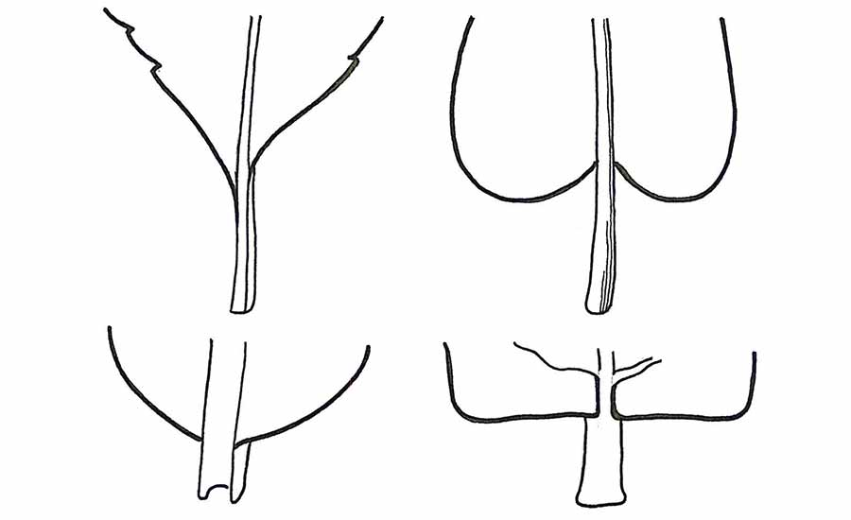
- Draw the base
Look carefully at the bottom of the leaf where the stem joins it. What is the shape of the leaf here? Draw it in.

- Draw the margins
What do the edges – the ‘margins’ – of the leaf look like? Are they smooth or do they have ‘teeth’? Are the margins flat or wavy? Draw in the shape of your leaf, paying special attention to the margins.
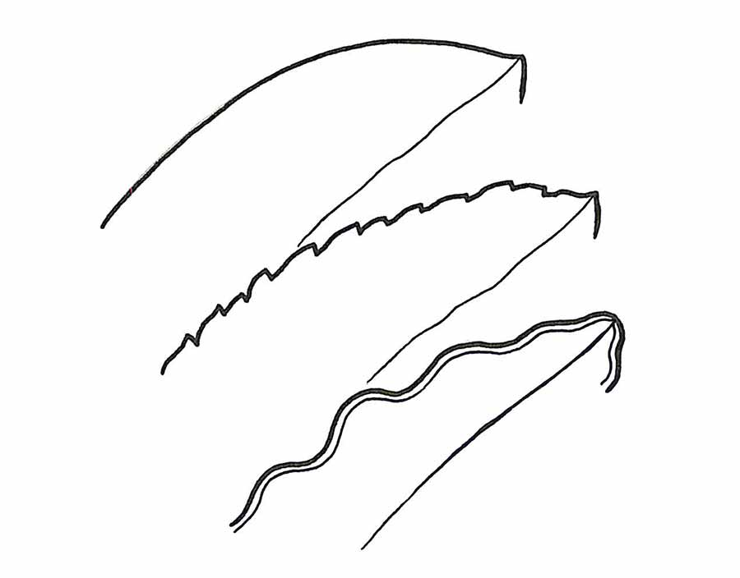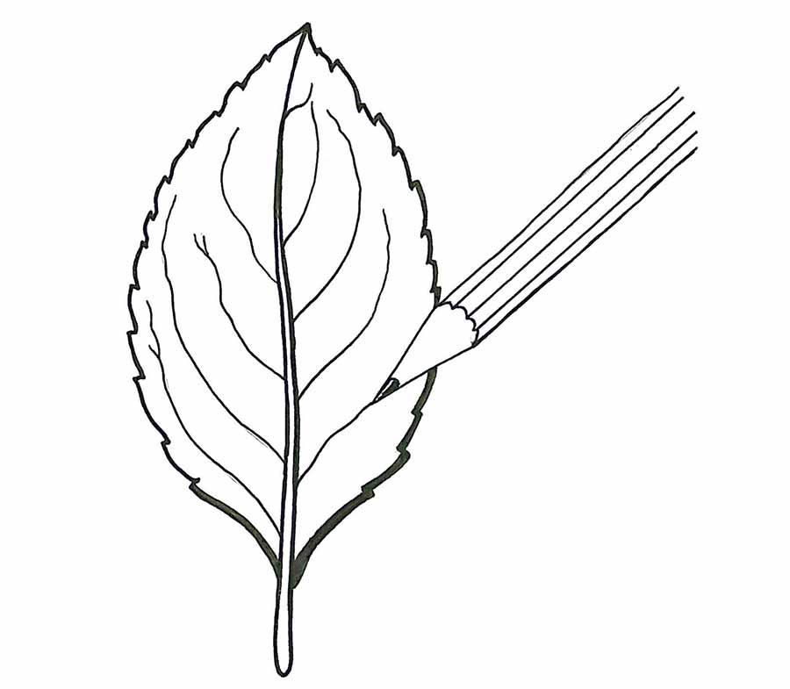
- Draw the smaller veins
Now look at the little veins. Are they coming out of the midrib? Are there lots or only a few? Are they big or small? Straight or wavy? Draw in the smaller veins carefully.

Well done! Have a go at another shaped leaf on your own.

Humanities
Habitat:
A habitat is the home of an animal or a plant. Almost every place on Earth—from the hottest desert to the coldest ice pack—is a habitat for some kinds of animals and plants. Most habitats include a community of animals and plants along with water, oxygen, soil or sand, and rocks.
See how many mini-beasts you can find in different habitats.

