Summer Term
Topic- The seaside

Hi,

A little note first of all to say how much we are missing you all and all of your lovely smiling facing. We. hope you had the best Easter possible and enjoyed eating all of those yummy chocolate eggs.

Myself, Mrs Lane and Mrs Chapman have been trying to keep in contact with all of you through a weekly phone call. If you have older brothers and sisters in school then their teacher will call you. We will be calling off an unknown number so please try to answer. If you are unable to, we will leave a message if this facility is available to us.
It has been lovely to hear you are all safe and the things you have been up to like, making rainbows and enjoying the garden.
This term after returning from our Easter break we would have be beginning our ‘At the Seaside’ topic. It is such a shame we cannot begin this together but we can defiantly make a great start on this learning from home.

General stuff:

- Please keep going over your sounds and practising forming them that is so, so important.
- Please keep practising your number formations from 0-9 as much as you can and addition to 5.
- Practise your reading with any books or signs you have at home, can you build words?
- Keep writing your name so you are confident in doping this when you return to school.

WEEK 3 WORK – AT THE SEASIDE:

Literacy:
TASK 1: Can you write (or get a grown up to write it for you) a list of things you might seat the seaside you could do it with different colours and in a bubble diagram. Try and think about. All the little things you might expect to see, I have done started one below to show you with a few starter ideas.
At the seaside I might see…

The sea Sand

seagulls Buckets and spades
Task 2: Can. You create a picture of all of these things you have listed. Can you create your own picture freeze frame of the seaside-here is an example.

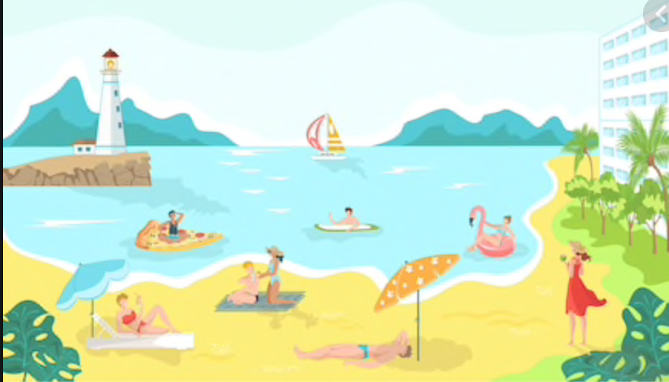

Numeracy

Task 1-
There is a seaside counting sheet on webpage -please do not feel you need to print you. Can simply touch count on ipad or screen. It you want to further this you can draw some ice creams and your child can count them- or they can draw some spades and you count them. We are looking for careful touch counting here!

Task 2-
We were due to start looking at money in maths during the summer term. The seaside is a great topic for this as we often set up a beach shop inside the classroom and an ice cream shop outside.
Where possible we use real money coins so the pupils can see what they look like in real life and feel the shape and weight.

We would start by looking at 1p pieces and learning these represent 1p. We would then have a selection and start counting them but always remembering the answer wouldn’t be 15 it would be 15p as we are using money.

The sheets on the webpage are counting the pennies and then it does go on to 2p’s but please don’t worry if you cannot do this bit. Can you get your child to count the pennies next to the ice creams and record their price- get your child to write the number amount followed by a p on a piece of paper. The more they can practise that p comes after this coin the better.

POINTS OF DISCUSSION

Here are some interesting discussion points to discuss with your class regarding the seaside and may lead to other self -led activities and some research online or on books. Or they could facetime a family member to ask them some questions.

- What do we mean by the seaside? Let’s look at geographical words. Where are the nearest seaside resorts?
- • What is sand? Where does it come from? What are shells?
- • What lives under the sea?
- • What are shipwrecks ?
- • What pirate tales do we know ?
- • Do mermaids really exist?
These point will lead to very interesting discussions.
Please do not worry about work do what you can- the general things at the top. Please. Try and keep them going they are so important.
We miss you all very much and thank you as families for your continued support at this really uncertain time.
Please remember even though we are not in school we do have a number you can call if you are struggling with anything and need support. I have this phone 24 hrs a day so if you need us it will be me who answers. The phone is for well-being emergencies and support, if you just need a chat with an adult and are feeling you need to talk to someone please phone. You are not alone. The number is: 07940 433991.
Take care and fingers crossed we may have news in the coming weeks about returning to school at some point during the summer term.
Lots of loves and hugs,

Mrs Brown, Mrs Lane and Mrs Chapman xxx

