Food Groups
Here are the 5 food groups. Read them carefully. Think about them and read them again.

Eat LESS of these
Fat
Choose good fats such as olive oil. Use only small amounts.

Eat LOTS of these
Fruit and Vegetables
These are good sources of vitamins, minerals and fibre.
Carbohydrates
These are important for giving us energy. Potatoes, bread, pasta rice and noodles are good sources.
Dairy
These are a source of calcium which is important for strong teeth and bones, for example milk, yoghurt and soya milk.
Protein
These are important for helping us to grow and build muscles. All fish, meat and Quorn are good sources of protein,

Sugar and Fat

Food and drinks high in sugar and fat should be eaten less often
and in small amounts.

Wow! There are so many facts to learn and some tricky words. Can you remember what you’ve read? Answer these 5 questions, there is no need to write them down but ask your parent or carer to check your answers.

- What foods should we be careful to limit?
- What type of food gives us energy?
- Which foods give us vitamins and minerals?
- In which foods will we find protein?
- Dairy foods contain what?

MR MEN
Now you’re very good at knowing your food groups and why each is important to our health, can you help these Mr Men with their diets?
Mr Mischief
Mr Mischief has spent the past year on a boat pretending to be a pirate. He has developed Scurvy, a deficiency disease caused by a lack of vitamin C.

Mr Strong
Mr Strong is a bodybuilder. He is competing in The World’s Strongest Man competition in a few months.
He would like to build as much muscle as possible.
He also needs lots of energy because he goes to the gym every day.

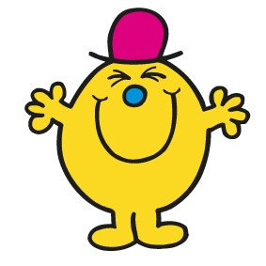
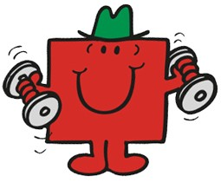

Mr Worry
Mr Worry is very worried about the welfare of animals. He does not eat meat or dairy, he is a vegan.

Mr Bounce
Mr Bounce hasn’t been very bouncy recently. He often feels very tired.
He has lost a lot of weight and has had sickness and diarrhoea.

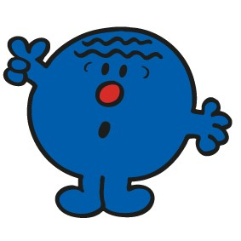
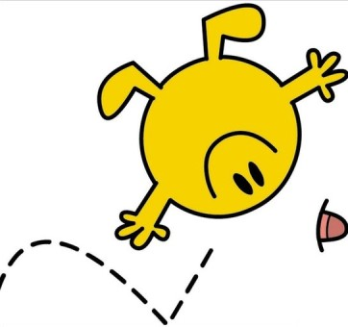

Mr Slow
Mr Slow is 80 years old today. He is interested in keeping his bones healthy and strong.

Mr Fussy
Mr Fussy will only eat one meal a day. He needs lots of calories because he enjoys a 10 mile run every day. He does not like cheese or potatoes.

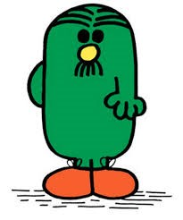
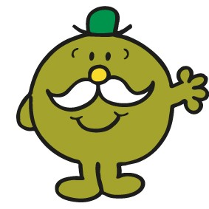

Write below your suggestions for helping each of the Mr Men.
Mr Men | My Advice
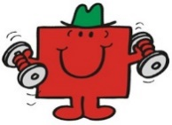
Mr Strong
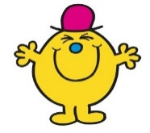
Mr Mischief
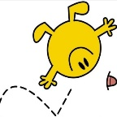
Mr Bounce
Mr
Worry
Mr
Slow
Mr
Fussy

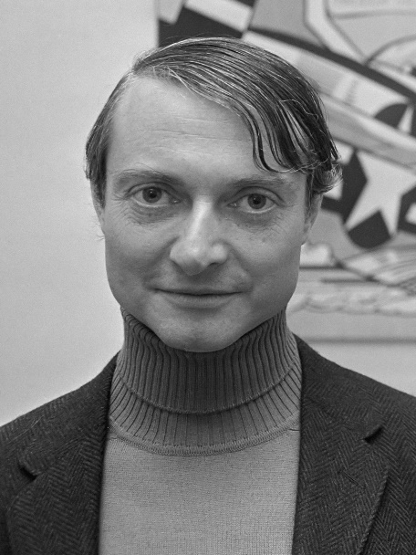
Roy Lichtenstein (1923 – 1997)
Roy Lichtenstein was an American pop artist. During the 1960s, along with Andy Warhol among others, he became a leading figure in the pop art movement.
Whaam! and Look Mickey are among Lichtenstein's most famous works. His most expensive piece is Masterpiece, which was sold for $165 million in January 2017 – this is approximately £135,500,000!
Oh my days!

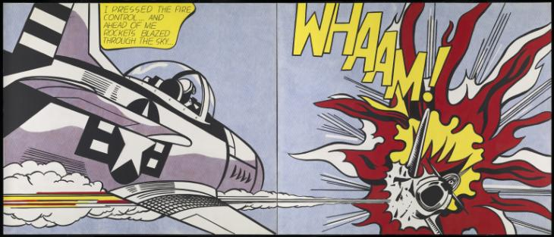
Whaam! (1963)

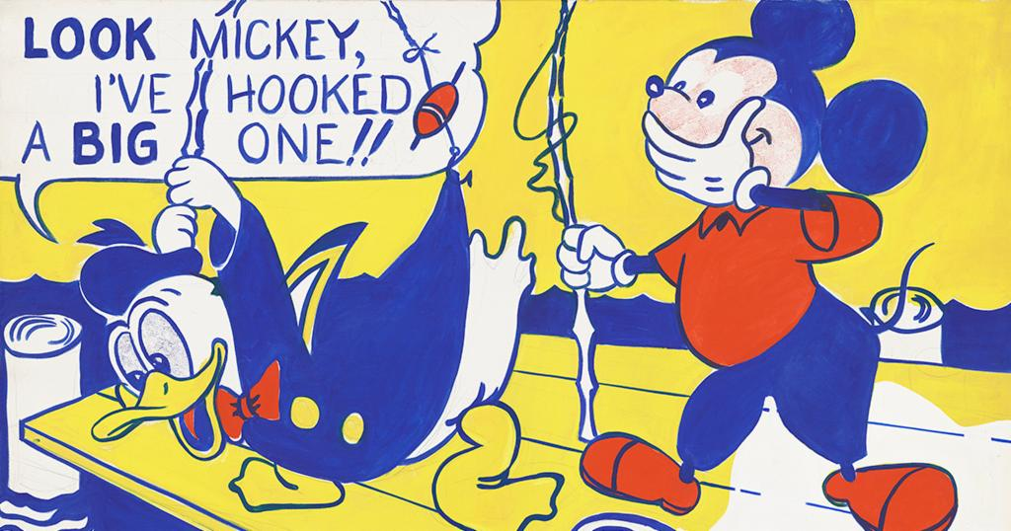
Look Mickey (1961)

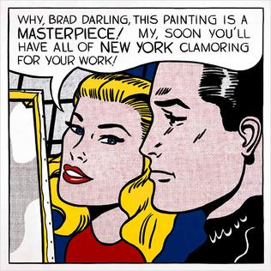
Masterpiece (1962)

Roy Lichtenstein chose his colours very carefully, to match the four colours of printer ink. Close up, his work looked like thousands of little dots and dashes.
What do you think of his work?
Does it look real to you?
Have you seen something like it before?

Your challenge:

Can you create a picture in the style of Roy Lichtenstein?
You can choose any person – one of our NHS heroes maybe - or any object you would like.

You need: four felt pens, ideally black, red, blue and yellow

Here are some examples

Remember: Use lots of dots and dashes and DO NOT WORRY if you have not got felt pens, use what you have and above all have fun!!!

Find out more at www.tate .org.uk/kids/explore/who-is/who-roy-lichtenstein
Just because….

Here’s a little kindness challenge for you, not only because we are in days of lockdown but just because kindness costs us nothing.
Send someone you haven’t seen in ages a letter or postcard, just to let them know you love them and are thinking of them.

Take care, enjoy learning and have a great week!

