Dear Families,
Attached are some literacy and numeracy activities for your child to do at home. Please encourage your child to do at least one activity each day Monday to Thursday. They could colour in the box once they have achieved the challenge!
On Fridays, your child can watch a film and choose an activity from the ‘Movie Day Menu’.
Please don’t forget that we recommend that children read at home every day to keep up with their literacy skills.
All the staff send our best wishes to you all at this difficult time and wanted you to know that we are all thinking of you.
Stay Safe,
Mrs Jones & Miss Thomas.

LEARN AT HOME MENU – WEEK 1
Draw a map of your bedroom, measure the distance between the furniture you drew with a ruler. Can you find out the perimeter of the room?  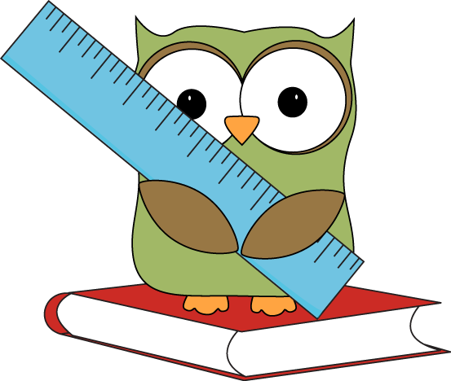 | Complete the ‘Emoji’ multiplication challenge. | Create a weather diary in Welsh.  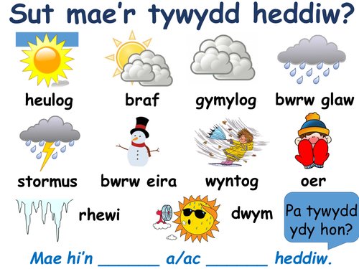
Write a letter or email to a family member. Tell them what you have been doing at home. Tell them how you have been feeling. | Make an under-water scene in a shoe-box  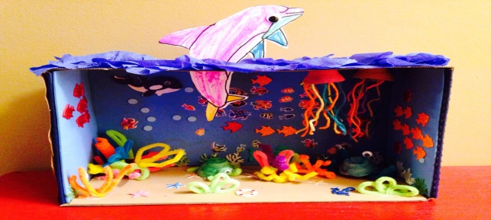 | Make a list of your favourite book characters. Then put them in alphabetical order.  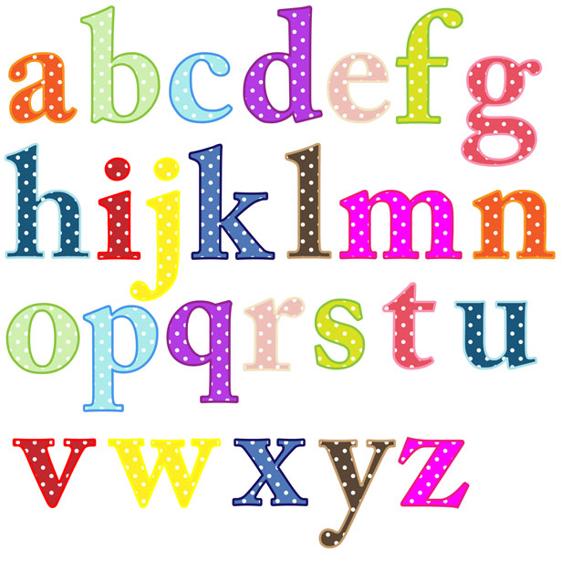
Make some paper airplanes and have a competition to see which one flies the furthest. Can you record the results on a table? You could use different types of paper! | Draw a comic strip of your favourite story. Make sure you include speech bubbles.  Wow! | Try some of the money problems on the sheet below. How many different ways can you make 18p. Draw the coins like we have been doing in school.

2 × 5 | 5 × 10 | 1 × 5 | 6 × 2 | 5 × 4 | 2 × 10 | 3 × 10 | 1 × 10 | 10 × 5
2 × 3 | 5 × 1 | 2 × 6 | 10 × 3 | 2 × 6 | 4 × 5 | 6 × 2 | 10 × 3 | 3 × 6
2 × 6 | 3 × 2 | 6 × 3 | 10 × 1 | 3 × 10 | 3 × 6 | 1 × 10 | 5 × 10 | 4 × 5
5 × 4 | 7 × 2 | 8 × 5 | 2 × 6 | 1 × 5 | 5 × 1 | 10 × 4 | 5 × 8 | 2 × 10
1 × 5 | 4 × 10 | 4 × 5 | 10 × 3 | 4 × 5 | 10 × 3 | 1 × 5 | 10 × 6 | 6 × 2
2 × 10 | 6 × 10 | 3 × 10 | 6 × 2 | 2 × 10 | 2 × 6 | 5 × 1 | 2 × 7 | 4 × 5
5 × 1 | 5 × 12 | 1 × 5 | 10 × 9 | 10 × 11 | 12 × 10 | 2 × 6 | 12 × 5 | 6 × 2
4 × 5 | 10 × 3 | 2 × 10 | 8 × 10 | 4 × 5 | 9 × 10 | 4 × 5 | 2 × 10 | 3 × 10
5 × 10 | 10 × 2 | 6 × 2 | 2 × 6 | 5 × 1 | 6 × 2 | 2 × 10 | 4 × 5 | 6 × 3
1 × 10 | 3 × 6 | 1 × 5 | 10 × 2 | 2 × 10 | 2 × 6 | 10 × 2 | 2 × 3 | 10 × 1
Emoji Multiplication Mosaic
Multiplication 2x, 5x and 10x tables
5, 12, 20, 30 = yellow
6, 18, 10, 50 = black
80, 90, 110, 120 = red
14, 25, 40, 60 = blue
5, 12, 20, 30 = yellow

Solve the maths problems to reveal the hidden picture. Each answer has a special colour:
5, 12, 20, 30 = yellow
6, 18, 10, 50 = black
80, 90, 110, 120 = red
14, 25, 40, 60 = blue
5, 12, 20, 30 = yellow

A pen costs 2p each. How much do nine pens cost? | 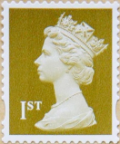  A stamp costs 10p each.  How much do eight stamps cost? | How much altogether is 5p and 10p and 10p?  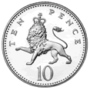  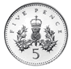
Lollipops costs 5p each. How much do six lollipops cost? | 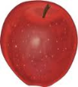  Adam spent 44p and 5p on apples. What did he pay altogether? | 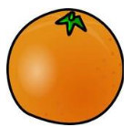  An orange costs 37p.  Which coins would pay for it?
Robert had a 50p coin. He spent 3p. How much change did he get? | Biff paid 32p for a yogurt.  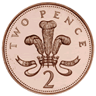  What coins could she use?  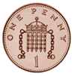  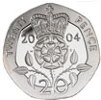 | Biff paid 18p for a yogurt.  What coins could she use?

