Williamstown Primary

Home School Learning Pack Year 3 W-C 18/5/2020

Useful Websites
TWINKL- free code 1 month = PARENTSTWINKLHELPS
BBC BITESIZE TOPMARKS- Hit the button
SCHOLASTIC HWB
Hello Year 3, I hope you are all safe and well, still working hard but also having as much fun as possible
Here is your new pack for this week including English work, spellings, maths challenges and topic work focusing on ‘Keeping Healthy’.
Remember to keep reading, stay safe and keep in touch with your friends when you can
I hope you all have a lovely half term next week!
Miss Thomas x

This week I would like you to write a positive letter to the school canteen cooks offering some advice about how we could make our school dinners healthier. In the letter I would like you to include:
- What you like about the dinners that Williamstown primary already offer.
- Are there any dinners that are your favourite? And why?
- Do you think there is good balance of diet within the school dinners? For example are there enough fruit and vegetable choices offered to you?
- Are there any improvements that can be made to the school dinners?
- Some healthy meal suggestions.

Remember to use capital letters, full stops, wow words, exciting sentence starters and adjectives in your work!

Example Letter Starter:
Dear dinner ladies at Williamstown Primary,
I am writing to you because…..

Practise your handwriting using this text:
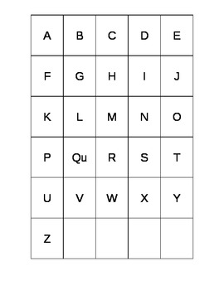
Use this ABC Grid to think of healthy foods beginning with each letter of the alphabet. You can have more than one in each box if you can think of more!
Here are your spellings for this week. Remember to practise them by writing them out and then using them in a sentence.

BBC Bitesize English
Copy and paste these links into your browser for some great online English activities.

https://www.bbc.co.uk/bitesize/articles/zk2c92p

https://www.bbc.co.uk/bitesize/articles/z4vxt39

Multiplication and Division Worded Problems

BBC Bitesize Maths
Copy and paste these links into your search browser to complete these online maths challenges.

https://www.bbc.co.uk/bitesize/articles/zb4gcqt
(Multiplying 2 digit numbers)

https://www.bbc.co.uk/bitesize/articles/z4gkwty
(Mental maths challenge)

Topic Challenge
This week I would like you to research how much sugar and salt are in your favourite foods and snacks. You can do this by checking the packaging or researching online. Record your results in a table.
For Example:
Food/Snack | Sugar (grams) | Salt (grams)

After you have completed this I would like you to research where in the world your favourite foods come from! Lots of them are made here in the UK but you may be surprised that lots of our food comes from different countries around the world!

Enjoy this mindfulness colouring activity!
Facetime!
If possible, facetime a friend this week and find out some things about them that maybe you didn’t know!
What are their favourite healthy foods?
Are they similar to yours?
You could compare your tables and see if you had any similar or different answers with your salt and sugar challenge!

Science link!
https://www.bbc.co.uk/bitesize/articles/z4m6hbk
(Animals)

https://www.bbc.co.uk/bitesize/articles/zjvj7nb
(Check out this Art lesson on BBC bitesize!)

